For more information, please contact Marta de Paco
On +34 670 780 664 or email press@comunicahair.com

Important:
These images are only available for editorial content.
Credits must be included.
Notification of their publication is expected.

KUMENHAIR
JOSÉ GARCÍA BENÍTEZ
JIANCHÁ Collection

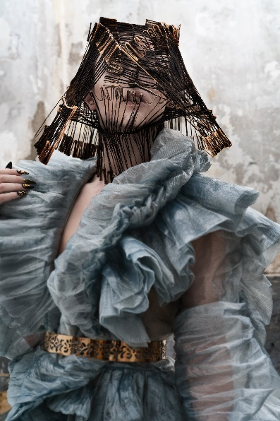
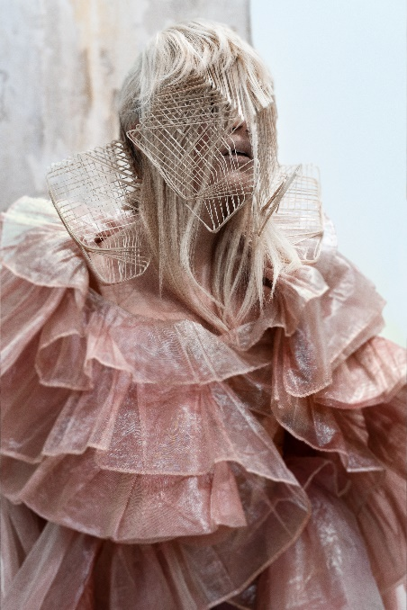
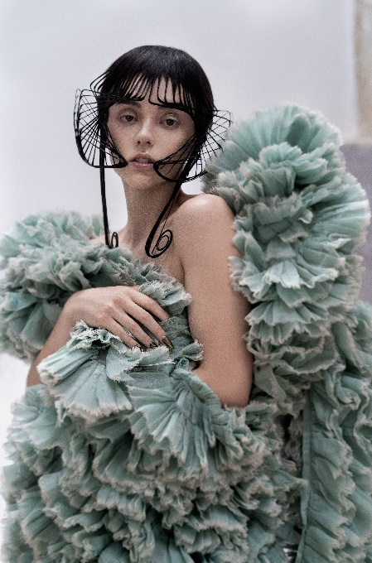

Hair: Kumenhair | @kumenhair
Hair Assistant: Yuleymi Sukeyna Boucif García | @yuleymi01
Photography: David Arnal | @davidarnalteam
MUA: Ana Paola | @anapaolamend
Styling: It Spain | @it_spain
Models: Miriam Alba
Andrea Orejudo
Products: Revlon Professional @revlonprofessional_es

KUMENHAIR
JOSÉ GARCÍA BENÍTEZ
JIANCHÁ Collection

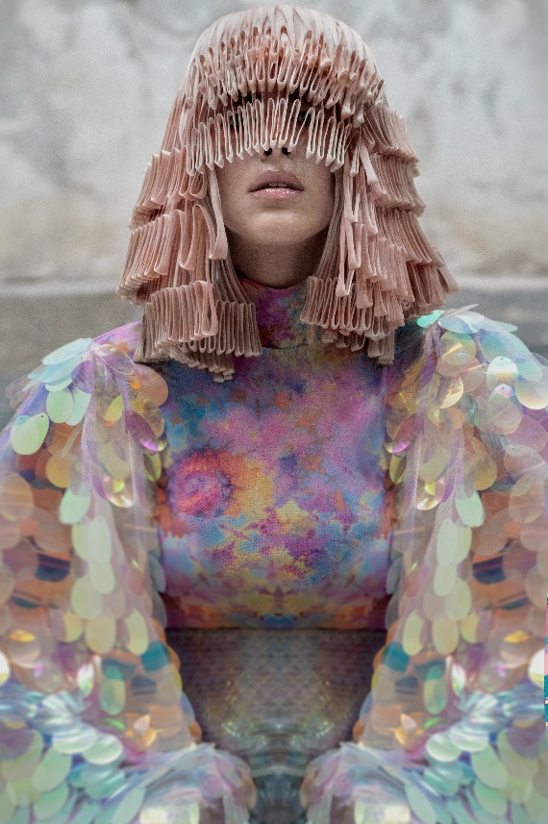

The collection explores architecture and geometry through the language of hair, which becomes a much more expressive material, demonstrating all its plasticity. Through the development of its own and original technique, UMA, hair fibers are treated as if they were a plant material full of life and flexibility, which shows an iconic, artistic and transcendental beauty.

