Sennheiser @ ISE 2023

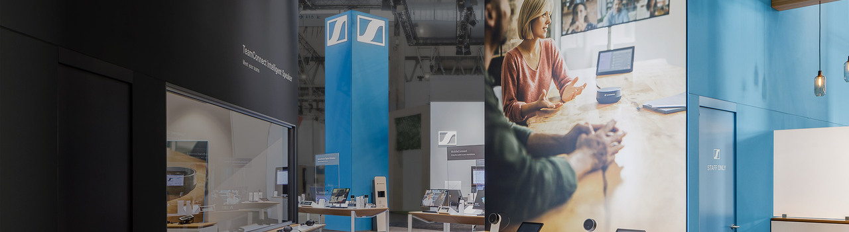
Sennheiser Ready to Kick Off Exciting Year of Audio Innovation at ISE 2023
Attendees are invited to circle around as Sennheiser unveils the newest addition to the TeamConnect Family, amongst other new products and features

Wedemark, January 26, 2023 – Sennheiser, the first choice for advanced audio technology that makes collaboration and learning easier, is excited to showcase its new products and industry partnerships at Integrated Systems Europe (ISE) 2023 in Barcelona, Spain on January 31 – February 3. The Sennheiser stand (3C600) is in Hall 3 of the FIRA Barcelona, Gran Via and will feature interactive demo spaces that give attendees the chance to get hands-on with Sennheiser’s latest audio solutions.

Hearing is Believing - The TeamConnect Solutions
Sennheiser’s ISE 2023 stand will once again feature two live demonstration rooms. In one room, the newest TeamConnect Family member will be demonstrated for the first time publicly. Visitors will have the opportunity to see its sleek design, while experiencing the trusted audio quality one has come to expect from Sennheiser.

The other demo room will feature the multiple award-winning and readily available TeamConnect Ceiling 2 (TCC 2), where it will again showcase its beamforming tracking capability with Sennheiser partner Q-SYS’ cameras. The TCC 2 demo will replicate a real-world meeting environment, allowing visitors the opportunity to experience the audibly superior ceiling microphone already trusted by thousands of our customers around the world.

TeamConnect Ceiling Solutions Warranty Extension
Starting later in Q1, the TeamConnect Ceiling Solutions will come with an extended warranty. By owning its manufacturing and maintaining strong relationships with its suppliers, not only has Sennheiser been able to maintain reliable delivery dates for these products, but their quality can be proudly certified. Additional details about the warranty extension, including its new length and who’s eligible, will be shared at ISE.

Assistive Listening and Beyond
MobileConnect is an award-winning assistive listening solution that enables inclusive meeting and lecture participation through the use of a smartphone. At this year’s ISE, Sennheiser will formally launch a set of new exciting features, including app customization and, most importantly, a talk-back feature that takes MobileConnect beyond just assistive listening.

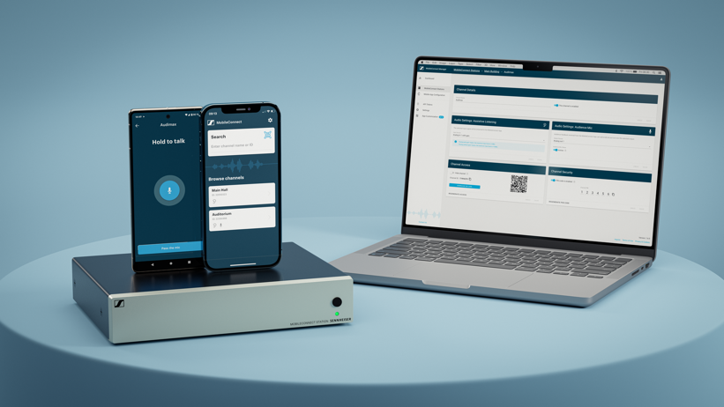
MobileConnect is an award-winning assistive listening solution that enables inclusive meeting and lecture participation through the use of a smartphone

Named Audience Mic, the feature transforms any smartphone into a microphone, allowing MobileConnect users the ability to communicate the way they want. Audience Mic takes MobileConnect from an assistive and personal listening solution to a bi-directional communication powerhouse. The speaker simply talks into their smartphone to have their voice brought directly to other participant’s phones in the room, over the room’s loudspeaker and to those who may be participating remotely.

The Sennheiser stand will showcase the full potential of MobileConnect. Visitors will be able to experience both app customization and Audience Mic features via on-demand demonstrations.

EW-DX Takes the Stage
For the first time at ISE, the latest member of the Evolution Wireless Digital family will be on display. Designed to make collaboration and learning easier, EW-DX is powerful and flexible enough for even the most demanding business and professional applications. With its straightforward installation and integration, the system easily scales across your existing Dante network, from the smallest meeting room or classroom to the largest educational and corporate campus installations. EW-DX and its components will be featured on a product table for visitors to experience firsthand.

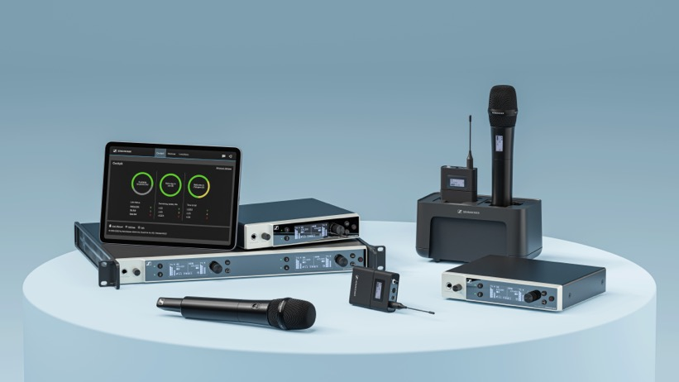
As the technological successor to evolution wireless G4, EW-DX is designed for the most demanding business and professional applications

New Online Room Planner
Sennheiser will also announce the first iteration of a new, browser-based room planner tool. The Sennheiser Room Planner is an intuitive room configuration tool that helps customers find the most suitable Sennheiser solution for their specific meeting room environment. Users will be able to identify the most appropriate solution and the optimal placement for it based on factors like room size and speaker positioning.

As further customer feedback is considered and new innovative solutions are added to the product portfolio, Sennheiser will develop additional versions of the tool. The initial version will be available at the Sennheiser booth, outside of each of the demo rooms​. Attendees can experience this new room planner and design their own meeting room right on the spot.

Global Partnerships Supporting Design Freedom
Unleashing design freedom - that's the goal of Sennheiser's intuitive, agnostic products and extensive partner ecosystem. Through a network of global partnerships, Sennheiser offers customers the flexibility to design their solutions with quality assurance and without restrictive ecosystems. At ISE this year, Sennheiser solutions will be featured in the booths of Bose Professional, Cannon, Creston, Kramer, Lumens, Maverick, Q-SYS, Xilica and Xilinx, as well as at the Sennheiser stand. These partnerships illustrate how various providers can come together to deliver audibly better solutions to make collaboration and learning easier.

More information about Sennheiser at ISE can be found here. To book an appointment during the show, please get in touch with the press contact listed below.

About the Sennheiser brand
We live and breathe audio. We are driven by the passion to create audio solutions that make a difference. Building the future of audio and bringing remarkable sound experiences to our customers – this is what the Sennheiser brand has represented for more than 75 years. While professional audio solutions such as microphones, meeting solutions, streaming technologies and monitoring systems are part of the business of Sennheiser electronic GmbH & Co. KG, the business with consumer devices such as headphones, soundbars and speech-enhanced hearables is operated by Sonova Holding AG under the license of Sennheiser.

www.sennheiser.com
www.sennheiser-hearing.com

Global Press Contact

Jeff Horan
+1 860-598-7539
jeffrey.horan@sennheiser.com

