NAMM 2020: Amphion Unveils the Next Generation of Precision Studio Amplification with Amp700

Amp700 pairs Class D power and performance with Class A buffer stage tonality for accurate, musical monitoring

Anaheim, CA -- December 18, 2019 – Finnish loudspeaker manufacturer Amphion [ACC North, Booth #16323] have announced that they will be showcasing Amp700, the latest iteration of their Class D power amplifiers, at the 2020 NAMM Show. Amp700 builds on Amphion’s existing high-performance amplifier technology while offering additional headroom and tighter controllability over its predecessors, showing Amphion’s continued commitment to accurate sound representation and precision design. Amp700 is currently shipping and is available for US$1800.

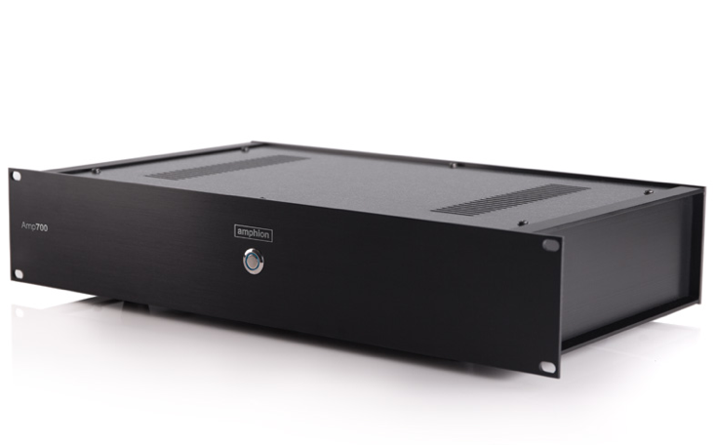
The heart of Amp700 is its robust Class-D power section which provides 2x350w at 8ohms and 2x700w at 4 ohms. The added power over its predecessor, Amp500, gives Amp700 improved accuracy and tonality across all frequency ranges and lower distortion at even its highest settings. Amp700 has also been synergistically designed with Amphion’s existing studio monitor lines and offers three step adjustments at 0db, -12db, and -24db for its input sensitivity, giving complete compatibility with all Amphion studio monitors as well as a wide variety of third-party speaker systems.

In addition to this, Amphion has also developed a proprietary Class-A buffer for Amp700 to bring a more pleasing musical character to the sound without sacrificing the amplifier’s accuracy or headroom. This translates to a more involving and fatigue-free listening experience for engineers working long hours in the studio while still preserving Amp700’s accuracy and power.

“Amphion’s philosophy has always been to develop innovative, high performance products with longevity,” explained Amphion Founder and CEO Anssi Hyvönen. “By designing Amp700 in synergy with our existing monitor lines, we’ve ensured that any engineer will have a versatile and long-lasting precision tool that will give them completely accurate audio in their studios for many years to come.”

For more information about Amp700, please visit: https://amphion.fi/amphion-amp700/

About Amphion
Amphion Loudspeakers Ltd. was established in 1998. We design and build loudspeakers that are characterised by honest and accurate sound reproduction. Precise driver integration ensures world-class imaging and phase coherency. Controlled dispersion technology helps achieve more stable results in a variety of room acoustics. All products are handmade in Finland (and the Amphion amplifiers are assembled in Finland) to ensure enduring listening quality.

Media Contact:
Steve Bailey
Hummingbird Media
+1 (508) 596-9321
steve@hummingbirdmedia.com

Jeff Touzeau
Hummingbird Media
+1 (914) 602-2913
jeff@hummingbirdmedia.com

