Testimony
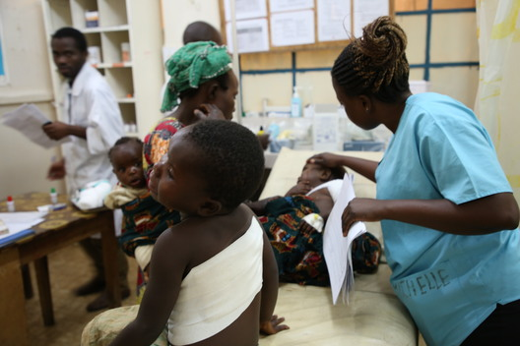
In late June 2017, BM’s two children, aged four and two, were admitted to the emergency room of Masisi general referral hospital with gunshot wounds. The older child had been shot in the back, the younger child in the neck.
“We live in a village in Walikale territory. One night I saw armed men in my house – I don’t know how they got in. As soon as I saw them I grabbed my two youngest children and tried to take cover under the bed. My eight-year-old son tried to do the same, but the men shot him. The bullet hit him in the chest and he fell next to the bed.
They fired towards the bed where we were hiding. My two-year-old son and his brother of four were hit by bullets. I shouted, ‘You’re killing me and all my children’, and they replied, ‘All you have to do is die!’
While some of the armed men were shooting, others were searching my house, looking for money or valuables. My husband had managed to flee the house.
I heard the men leave. Then I heard voices telling me to come out because the shooting had stopped. I was scared and wondered if it was still those thugs who were lying to get me out, or if it was my neighbours, kind people of goodwill. In doubt I stayed a while longer under the bed. I finally came out when I saw neighbours entering the house to help us.
My neighbours helped me carry my injured children to the health centre. The night was still dark and we walked for about an hour before reaching the centre. There they provided first aid to my children. Then they started asking me for money. I wasn’t in a position to pay what they were asking, so I decided to go to Maya health centre, where the MSF ambulance comes.
Before leaving for Maya, I went back home for the funeral of my son who was killed. We buried him, and I left for Maya with my two injured children. We walked from four in the afternoon until four the following morning. Then the MSF ambulance picked us up and brought us to the hospital.
My children received treatment at Masisi general referral hospital. They are a bit better now. I hope they can forget about this tragic incident. So far they haven’t talked about it. My four-year-old just told his older sister – who wasn’t living with us, she has just joined us here at the hospital – that their brother was killed, that he died because he was shot.
As soon as they are better, I will go back with them to Maya, the village where I was born. I don’t want to go back to Walikale territory – we moved there for my husband’s job. Now I absolutely don’t want to go back there.”
ENDS

