Embargoed until 23 November 2020, 10 a.m. CEST

Festive season promotion

A legendary gift: the HD 25 BLUE professional headphones

Wedemark, 23 November 2020 – Ever wanted to give a truly legendary Christmas gift? Sennheiser has released its iconic HD 25 monitoring and DJ headphones in a special limited edition with blue earpads. The HD 25 BLUE will be available from 23 November at just EUR 99 (MSRP) instead of EUR 149 (MSRP) for the standard HD 25. Please visit www.sennheiser.com/special-deals for a list of dealers offering this promotion.

The HD 25 is among the best-known headphones in the world. They are a firm favourite with DJs and engineers and are used for outside broadcasting and other professional monitoring applications.

A legendary gift: The HD 25 BLUE | 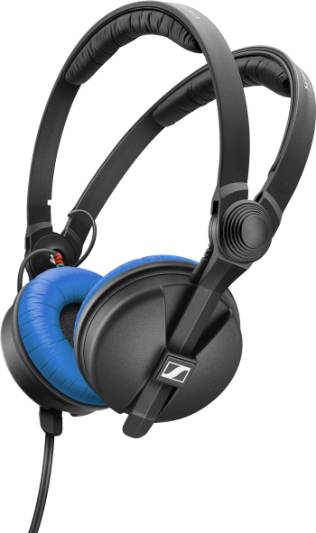

This special edition is limited to 30,000 items and comes with striking blue earpads. Standard black earpads are included too, as is a straight cable and a screw-on adapter to ¼” (6.3 mm) jack.

The images accompanying this press release plus additional photos can be downloaded at https://sennheiser-brandzone.com/c/181/3LRVW19q.

About Sennheiser
Founded in 1945, Sennheiser is celebrating its 75th anniversary this year. Shaping the future of audio and creating unique sound experiences for customers – this aim unites Sennheiser employees and partners worldwide. The independent family company, which is managed in the third generation by Dr. Andreas Sennheiser and Daniel Sennheiser, is today one of the world’s leading manufacturers of headphones, loudspeakers, microphones and wireless transmission systems. In 2019, the Sennheiser Group generated turnover totaling €756.7 million.
www.sennheiser.com

Global Press Contact

Stephanie Schmidt
Stephanie.schmidt@sennheiser.com
+49 (5130) 600 – 1275

