LEADING UNIVERSITY’S BROADCAST FACILITY INVESTS IN SENNHEISER

Marlow, February 20 2020 – The UK’s Middlesex University has recently made a significant investment in Sennheiser’s industry-leading Digital 6000 wireless microphone series to upgrade and future proof the systems used for its renowned media production courses.

The University’s BA Television and Digital Production degree has been developed with industry experts to give students one of the most practical and career-focused television production degrees in the UK. The programme boasts a high ratio of technicians to students, professional grade teaching facilities with an equipment catalogue that includes EVS video servers, Sony vision mixers, Allen & Heath dLive mixing consoles, and Sennheiser microphone systems. The facilities are state-of-the-art and the University has hired its television studio facility to many production companies for programmes such as Humans 3, Unforgotten, and Mother, Father, Son. Graduates have gone on to work for an array of industry leading organisations, including the BBC, Endemol, ITV, E4, Disney and Sky TV.


Middlesex University has made their systems future proof by investing in Sennheiser’s industry-leading Digital 6000 wireless microphone series used for their renowned media production courses.

The course comprises practical modules to plan and operate a range of productions from drama and sitcom, to documentary and chat shows, to film, across the spectrum of broadcasting, streaming, and video on demand media.

“The technical staff are all practitioners, so for a student looking for a hands-on degree that will fully equip them as technical operators from the get go, I don’t think you can top what we have to offer,” explains Aidan Delaney, technical manager in the Faculty of Arts and Creative Industries at Middlesex University. “One of our graduates won Best Music Video at the NME Awards in 2017, another has gone on to become a producer for the television series The Circle in just a few years since graduating, which is very impressive”.

To remain at the technological edge and cater for new elements in the degree programme, the department needed to upgrade and expand its range of microphones, replacing its existing stock of Sennheiser G3 500 series equipment.

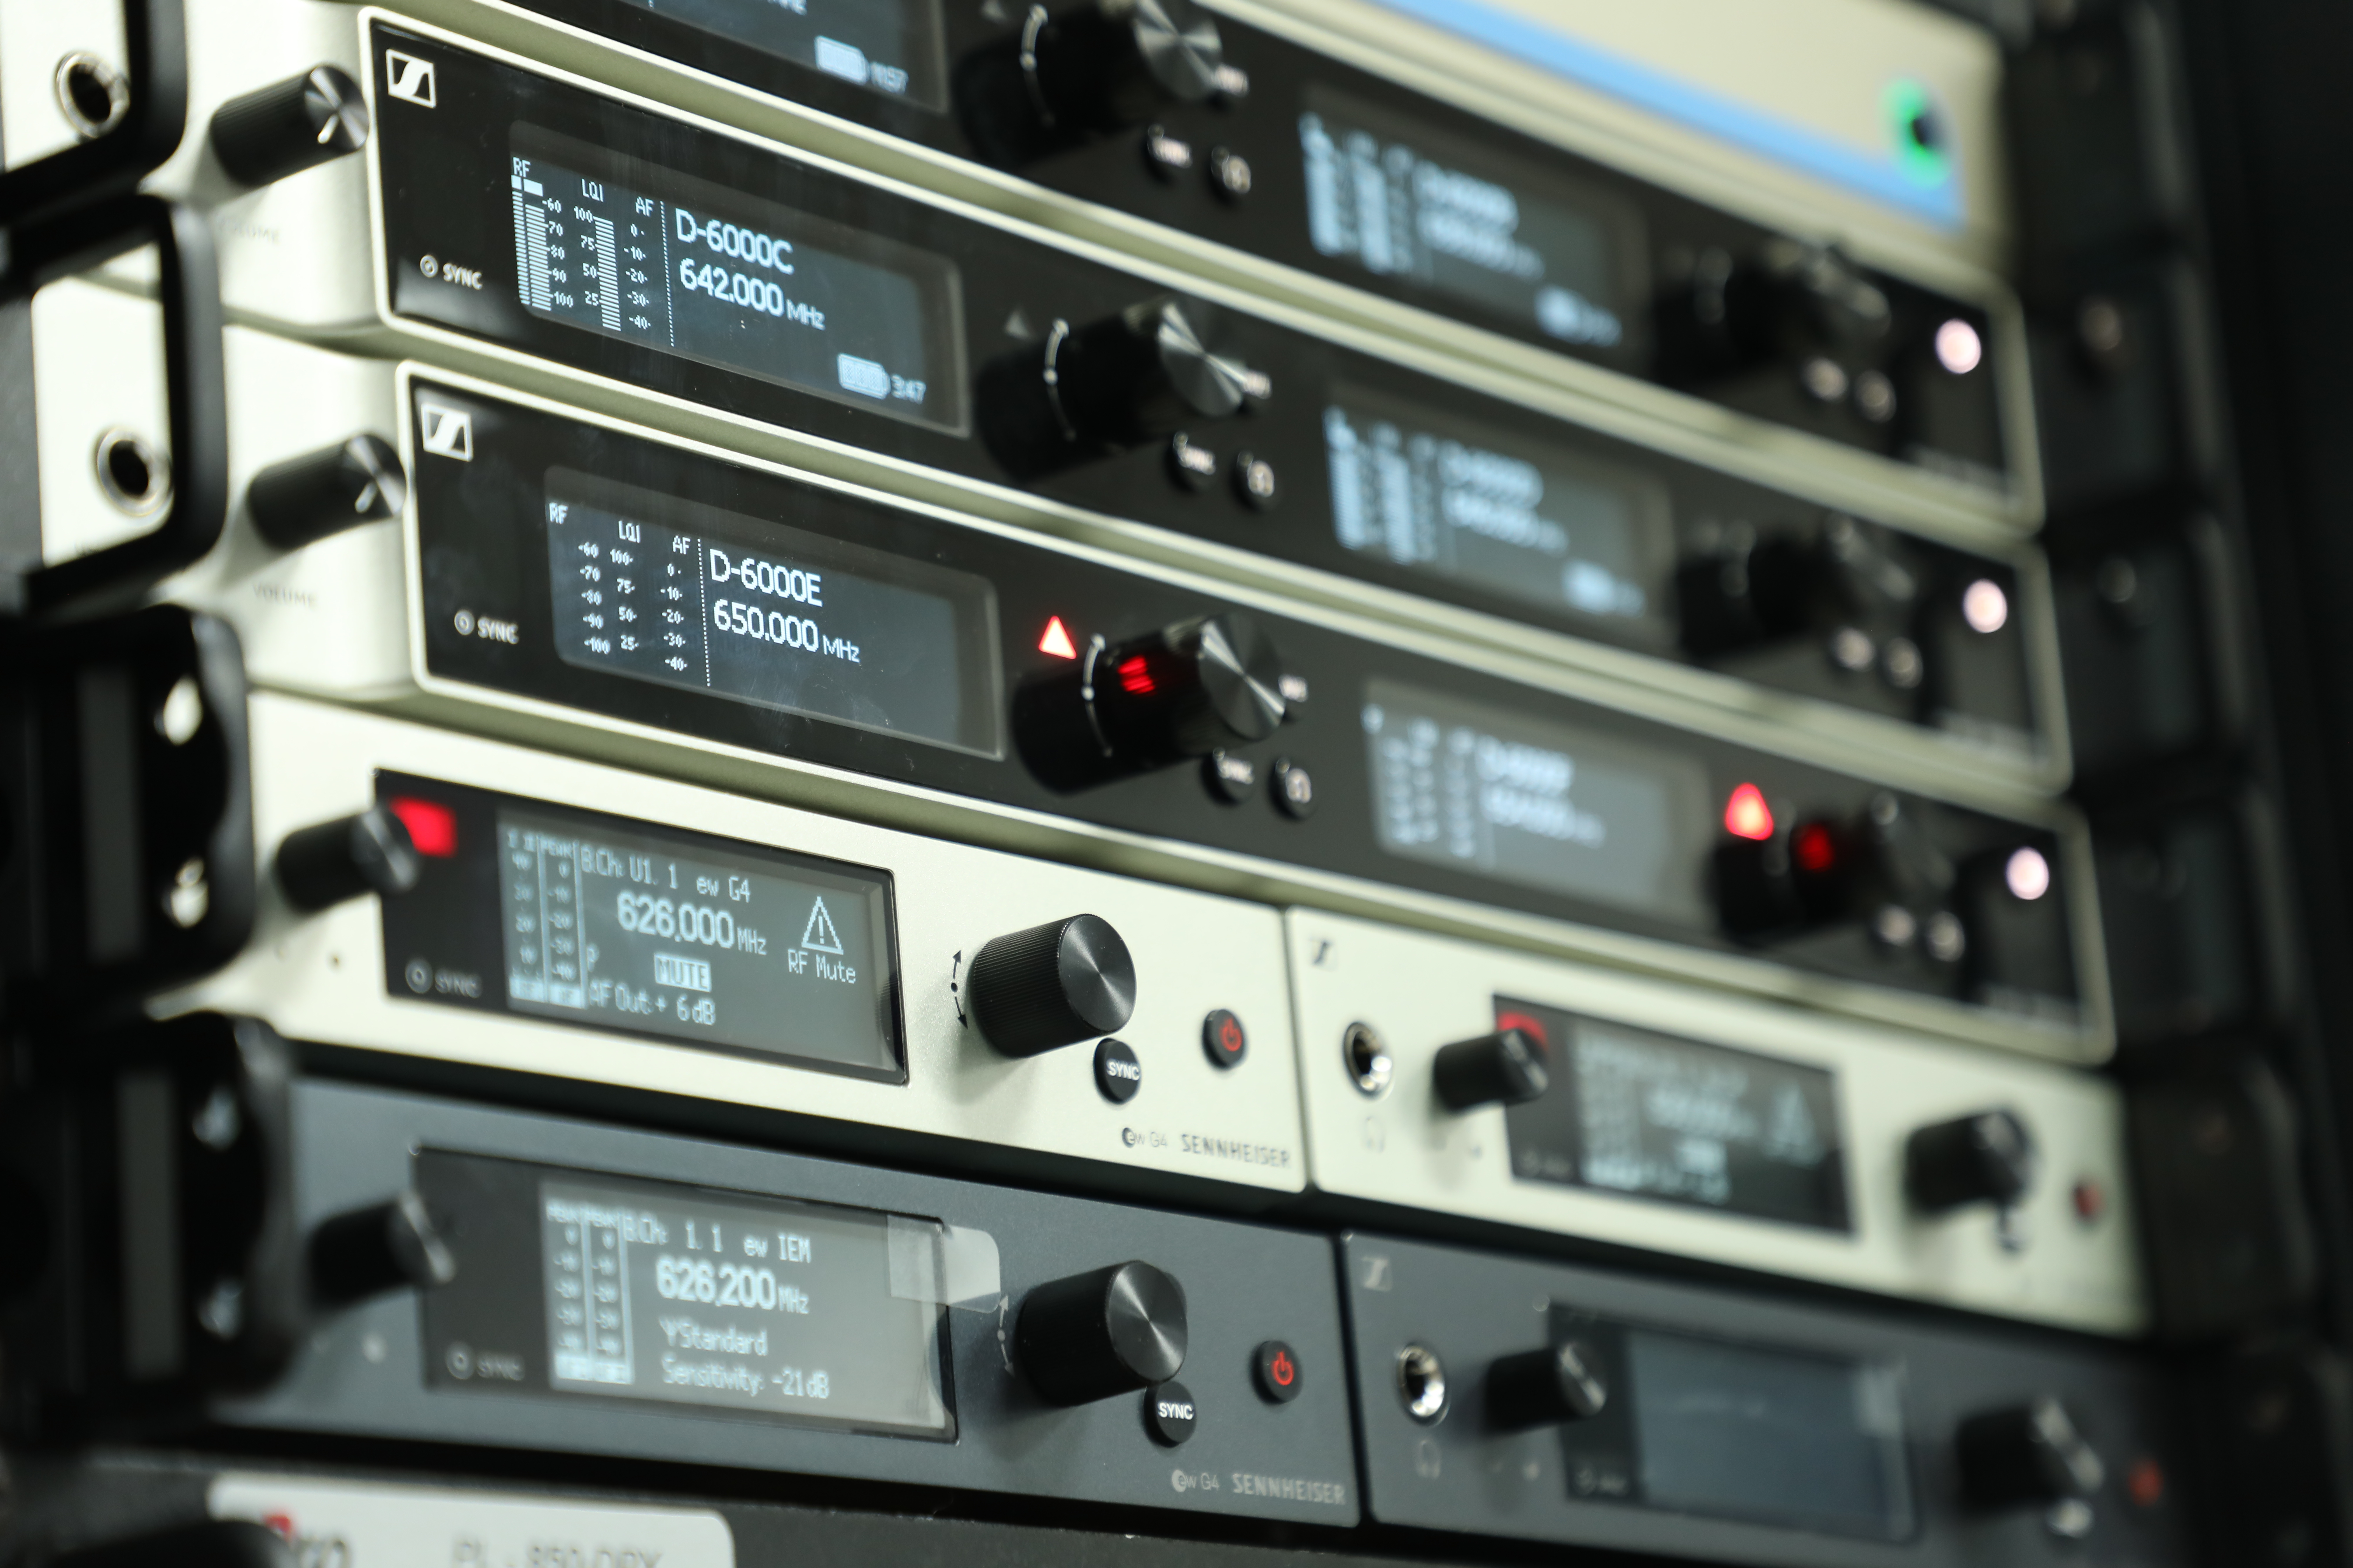
The team decided to mix their stock between digital and analogue solutions, by purchasing both Sennheiser evolution wireless G4 500 Series and Digital 6000 wireless microphone systems.

“Due to a significant budget opportunity, the University had undertaken an overhaul of its entire audio system infrastructure to help navigate the emerging technology landscape. We decided to migrate our audio systems to Dante, so it was important that the new microphone systems would be compliant and have the flexibility to connect via Dante across the board,” says Delaney. “Sennheiser was the obvious choice as it fits this mould and is industry standard, so we can familiarise students with the equipment they will be using in the field.”

Delaney and his team decided to mix their stock between digital and analogue solutions, selecting both evolution wireless G4 500 Series and Digital 6000 wireless microphone systems. The new investment was selected and sourced through leading pro audio supplier and integrator, Stage Electrics.

“Our initial contact with the University was through a long-standing relationship of mine with one of the team,” says Paul Roughton, Stage Electrics’ National Sales Manager. “We were asked for our advice on the best solution for the course, bearing in mind that they wanted to invest in industry standard radio mic solutions. We suggested Sennheiser Digital 6000 and then went to the university to give them a demo. It’s really exciting to be involved with such a forward thinking team who deliver an outstanding course and are keen to invest in the latest technology.”

“The University’s facilities are very impressive,” adds Kevin Gwyther-Brown, Channel Sales Manager – Pro Audio Solutions at Sennheiser. “By introducing us to the university, Stage Electrics gave us the opportunity to demonstrate our latest technology. It’s great to see this being offered by the University to the future personnel of our industry.”

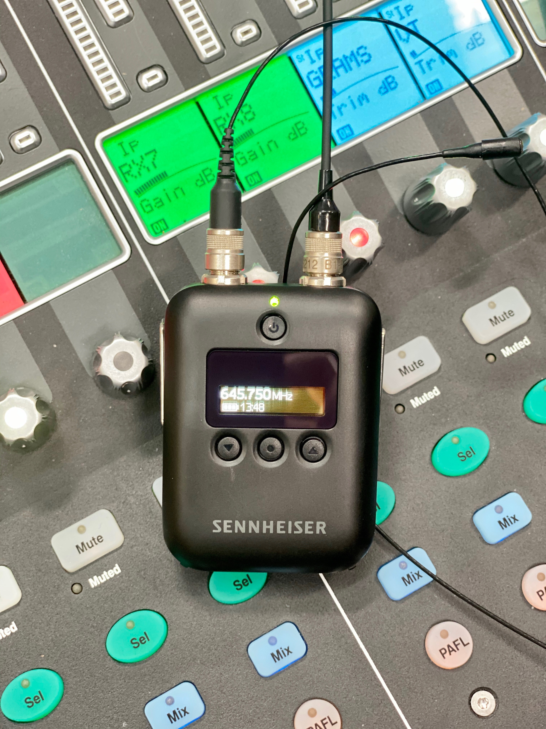
The Sennheiser G4 500 Series and Digital 6000 systems, including the mini bodypack SK 6212, offer students the opportunity to work with a wide variety of products.
The Sennheiser G4 500 Series and Digital 6000 systems, including the mini bodypack SK 6212, offers students the opportunity to work with a variety of products, and also teaches them about analogue processes, whilst learning about new digital technology at the same time.

“Technically, one of the main attractions for me was the wide band tuning, which enables us to future proof the system if there is another Ofcom clearance, and commercially, the mixed system also offered us more teaching opportunities,” continues Delaney. “Stage Electrics offered us a hands-on and complete customer service, introducing us to Sennheiser, who supported us pre and post-sale. Long may the relationship continue!”

Along with its investment into Sennheiser products for the television studio, the University is now planning to invest in further Sennheiser products with the addition of MKE1 compact clip-on mic for its equipment loan store.

“Based on our experience in the TV studio, the MKE1 sounds great at lower levels, it’s really transparent with a full, natural sound, and excellent presence, and compact in size,” Delaney concludes. “It’s very discrete, and I’m really impressed with the size in comparison to other offerings on the market. They will make a great addition to our equipment stock, which I am proud to say is looking very impressive, and comprehensive, with the recent additions from Sennheiser.”

The investment is paying dividends for students and staff alike.

“I really like how easy it is to pair the transmitters and receivers and the bodypacks are tiny which makes them a breeze to hide in actor’s clothing,” comments second year television production student, Amy Moran.

“The depth of control and visual feedback on the receiver unit, combined with the lack of intermodulation makes things much easy during a challenging production with high channel counts,” concludes technician, Martin Baxter. “Getting the Digital 6000 has made my work easier.”

About Sennheiser
Shaping the future of audio and creating unique sound experiences for customers – this aim unites Sennheiser employees and partners worldwide. Founded in 1945, Sennheiser is one of the world’s leading manufacturers of headphones, loudspeakers, microphones and wireless transmission systems. Since 2013, Sennheiser has been managed by Daniel Sennheiser and Dr. Andreas Sennheiser, the third generation of the family to run the company. In 2018, the Sennheiser Group generated turnover totaling €710.7 million. www.sennheiser.com

Local Press Contacts

Sarah James Maik Robbe
sarahj@gasolinemedia.com maik.robbe@sennheiser.com
+44 (0) 1483 223333 +44 (0) 7393 462484

