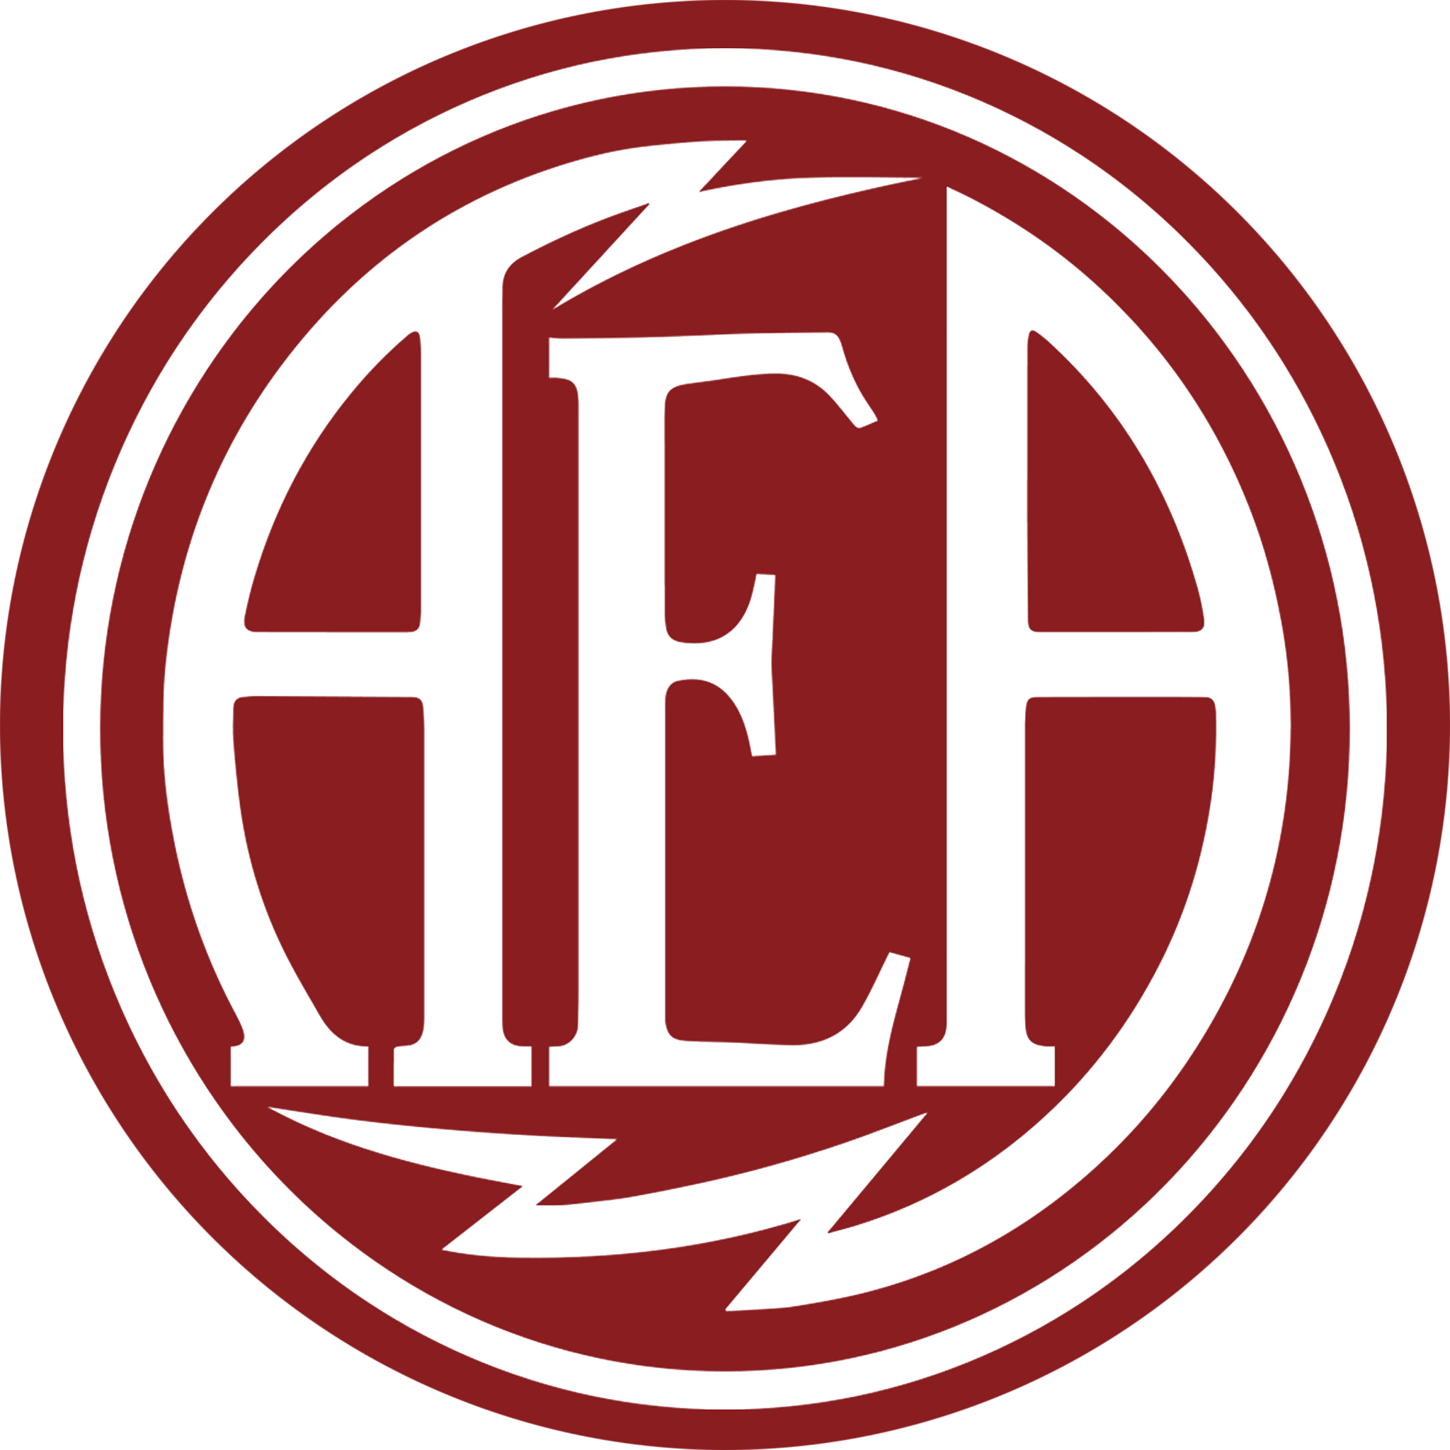

AEA Limited-Edition KU4A Ribbon Microphone Supports Musicians and Music Programs Through the Guitar Center Music Foundation

Featuring 24-karat gold accents and a numbered Certificate of Authenticity, the limited-edition KU4A benefits the Foundation's ongoing instrument grant and donation efforts

Pasadena, California, October 21, 2026 — AEA Ribbon Mics has partnered with the Guitar Center Music Foundation (GCMF) through its limited-edition KU4A ribbon microphone, with a portion of proceeds benefiting the Foundation’s work.

The collaboration began in the aftermath of the 2025 Los Angeles wildfires. As GCMF worked to replace instruments and equipment lost in the fires, AEA joined the effort by creating a special run of limited-edition KU4A microphones. Initially, a portion of proceeds supported the Foundation's wildfire relief initiative. With that effort now complete, proceeds from the remaining microphones continue to support GCMF's ongoing instrument grant and donation programs.

"AEA was founded in Pasadena and remains based here today. Our offices are located within the evacuation zone, several of our team members were displaced for weeks after the fires, and many of us have friends who lost their homes," said Julie Tan, CEO of AEA Ribbon Mics. "Partnering with the Guitar Center Music Foundation allowed us to give back to our community while continuing to raise awareness of what Southern California experienced in January 2025. The Foundation was one of the first major organizations to step in and support the music community while the fires were still burning. We deeply value its leadership within the music industry and its impact through music education, philanthropy, and support for musicians."

The wildfire relief initiative reflects GCMF's broader mission of expanding access to music through instrument grants and donations. Since 2005, the Foundation has supported hundreds of music education and therapy programs and reached more than 300,000 people. In 2025 alone, GCMF supported 141 music programs across 39 states, reaching more than 15,000 people through its grants.

“Access to music can change the trajectory of a life, and partnerships like this allow us to put that belief into action,” said Valeisha Butterfield, CEO & Executive Director of the Guitar Center Music Foundation. “We’re grateful to AEA for standing with the music community during a moment of tremendous need following the Los Angeles wildfires and for continuing that commitment beyond the immediate crisis. Their support helps us place instruments and equipment directly into the hands of schools, nonprofit organizations and music programs across the country, giving more people the power to create and express themselves through music.”

The KU4A traces its design lineage to RCA’s KU3A, a high-sensitivity unidirectional ribbon microphone developed for Hollywood film studios. The KU3A combined the smooth sound of a ribbon with a wide sweet spot and reduced proximity effect, giving engineers greater flexibility in microphone placement. It was RCA’s most expensive ribbon microphone, and fewer than 600 were manufactured.

Building on that legacy, AEA's limited-edition KU4A is the active version of the KU4, incorporating a JFET buffer amplifier and custom 1:110 Lehle transformer to provide 12 dB more output. Its supercardioid pattern offers focused rear rejection, while a subdued proximity effect and smooth high-bandwidth response support close placement across a range of sources. The microphone is distinguished by 24-karat gold accents and a numbered Certificate of Authenticity. Each microphone is handcrafted at AEA's Pasadena facility.

The limited-edition AEA KU4A is available exclusively through Guitar Center and its family of brands for $8,700, with a portion of proceeds benefiting GCMF's ongoing instrument grant and donation programs. For more information, please visit:
https://www.guitarcenter.com/AEA-Microphones/Limited-Edition-KU4A-Active-Supercrdioid-Ribbon-Microphone-1500000459056.gc

About AEA Ribbon Mics
Founded in 1964, AEA began as a record label and mobile recording studio before expanding into microphone repairs and full-scale manufacturing. In 1998, AEA introduced the R44C — an evolution of the iconic RCA 44BX — and has since developed a full range of microphones and preamps inspired by classic designs and built to modern standards. With a commitment to ultra-low noise circuitry, musical sound, and expert craftsmanship, AEA continues to push ribbon technology forward while honoring its legacy. All AEA products are proudly handcrafted in Pasadena, California.

Learn more at aearibbonmics.com

About The Guitar Center Music Foundation:
For some, music may be just a hobby. But for others, music serves as a crucial lifeline – a path to healing, an opportunity to nurture untapped talent, an escape from the grim realities of everyday life, a break from generational trauma, or the start of a social revolution. The Guitar Center Music Foundation (GCMF) is an independent non-profit organization dedicated to the healing, transformative power of music. Thousands of individuals nationwide benefit yearly from GCMF’s grants and other efforts aiding veterans, hospital patients, the unhoused, and those affected by natural disasters, as well as youth in both schools and after-school programs. By providing these programs with all types of instruments and advocating for the benefits of music education and music therapy, GCMF furthers its mission of giving people the chance to create and express themselves through music. For more information about The Guitar Center Music

Foundation, please visit http://guitarcenterfoundation.org/

