For immediate distribution

Ferrofish to Showcase PULSE16, PULSE16 MX Recording Interface at NAMM 2018
The cost-effective 16x16 interface features ADAT connectivity, latest AD/DA conversion and optional MADI — making it ideal for live or studio applications

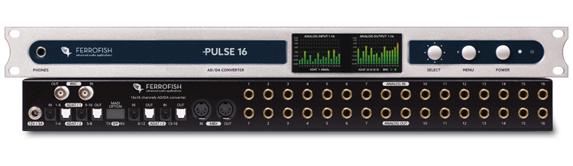
Anaheim, CA, January 23, 2018 — Ferrofish, German manufacturer of premium conversion solutions for the pro-audio, broadcast and integration markets, has announced it will showcase its PULSE16 and PULSE16 MX recording interfaces at booth 14701, during the 2018 NAMM Show. The PULSE16 boasts 16 channels each of analog input and output in a single rack space chassis. The full I/O is deliverable via ADAT at up to 96 kHz, while the PULSE16 MX adds MADI connectivity. The PULSE16 and PULSE16 MX adopt the latest features and AD/DA conversion of the company’s popular A32 Converter, resulting in a powerful, compact interface at an enticing price.
“We are looking forward to showcasing the PULSE16 and PULSE16 MX at this year’s NAMM show,” said Mathias von Heydekampf, managing director of Synthax, distributor of Ferrofish. “With 16 channels of input and output, the PULSE16 will more than meet the needs of home and project studios for multitrack recording and routing to outboard signal processing. The units also serve as a cost-effective I/O expansion option for larger studios via ADAT or, in the case of PULSE16 MX, MADI. The latest generation conversion chip from Cirrus Logic joins our own active jitter reduction circuit to ensure that your audio sounds smoother and more natural than ever before in the digital realm.”
Feeling the Pulse
The PULSE16 and PULSE16 MX’s 16 analog inputs and 16 analog outputs are available on TRS connectors and are capable of handling levels up to +20dBu, allowing easy integration into any studio environment. At the core of both models is the latest generation Cirrus Logic conversion chip, providing pristine 24 bit/96 kHz AD/DA conversion. Dual ADAT I/O pairs handled by the PULSE16’s four TOSLINK ports enable digital delivery of the full 16x16 analog channel count even at 96 kHz. MADI I/O, available on the PULSE16 MX or PULSE16 via an expansion card, expands the unit’s connectivity options further. Included Wordclock I/O ports enable synching both PULSE16 models with other digital equipment, and MIDI I/O ports enable full remote control of interface functionality.
The PULSE16 and PULSE16 MX sport full signal monitoring and comprehensive routing control via dual TFT LCD displays on the front of the unit. The displays can also provide detailed signal level readings for each channel, while a front-panel headphone output is available to allow easy monitoring of any stereo or mono signal passing through the interface on the fly. The innovative always-on contextual help feature, made popular in Ferrofish’s A32 interface, is also available to make menu navigation a snap.
For more information, please visit Ferrofish at booth 14701, Anaheim Convention Center North or visit ferrofish.com.

About Ferrofish
Known for its precision-engineered German technology, Ferrofish manufacturers high quality, innovative advanced audio applications. From its class-leading A16 MK-II and A32 AD/DA converters to its Verto Series of intuitive Dante converters, Ferrofish is known for its premium conversion solutions that are ideal for a wide range of applications. For additional information, visit the company online at http://www.ferrofish.com.

About Synthax, Incorporated
Synthax Inc. is the exclusive USA distributor for RME digital audio solutions, Ferrofish advanced audio applications, myMix audio products, and ALVA cableware. We supply a nationwide network of dealers with these products for professional audio, broadcast, music industry, commercial audio, theater, military and government applications. For additional information, visit the company online at http://www.synthax.com.

Media Contacts:
Jeff Touzeau
Public Relations
Hummingbird Media
+1 (914) 602 2913
jeff@hummingbirdmedia.com

Katie Kailus
Public Relations
Hummingbird Media
+1 (630) 319-5226
katie@hummingbirdmedia.com

