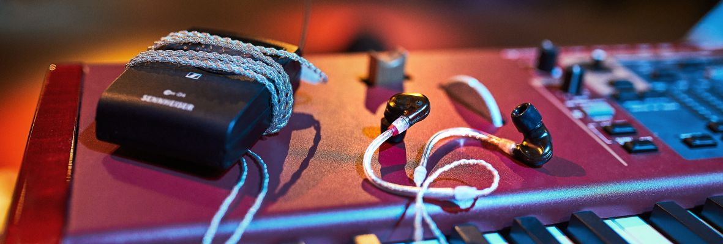

Sennheiser Joins the In-Ear Monitor International Trade Organization
Setting new standards in audio quality and industry leadership

Anaheim, January 16, 2020 – As one of the market leaders in the personal monitoring space, Sennheiser has joined the In-Ear Monitor International Trade Organization (IEMITO) as a founding member in order to help set industry standards and to better serve artists, engineers, and music lovers.

“The mission of IEMITO is to promote the use and enjoyment of in-ear monitors,” said Mike Dias, Executive Director for the Trade Organization. “Sennheiser has always been an industry pioneer and they continue to support both the live sound reinforcement community and hi-fi music lovers.”

“We are delighted to work with IEMITO and actively contribute to the promotion of in-ear monitoring,” said Juergen Kockmann, who heads the Pro Portfolio Management at Sennheiser. “The introduction of IEMs has been one of the most fundamental developments in live audio over the past decades, not only freeing the stage of clutter and saving the hearing of many artists, but also providing the impeccable sound and accuracy that is required for high-profile live performances.”
Sennheiser has joined the In-Ear Monitor International Trade Organization (IEMITO) as a founding member
Sennheiser IEM solutions
When the need for wireless monitoring solutions emerged in the 1990s, Sennheiser was ideally placed to deliver solutions: With its expert background in RF wireless technology, the audio specialist started to custom-design IEM systems for both bands and soloists. With the advent of Sennheiser evolution wireless in 1999, the company offered its first series-produced wireless monitoring systems. Sennheiser’s IEM systems have been valued for their natural and clear sound ever since. The portfolio also includes the bestselling IE 40 PRO, IE 400 PRO and IE 500 PRO in-ear phones, which have been designed to come as close to custom molds as possible, in respect of both sound and fit.

Visit Sennheiser at NAMM, Anaheim Convention Center North, Level 1, Booth No. 14108.

The images accompanying this press release can be accessed here: https://sennheiser-brandzone.com/c/181/yfbtZBom.

About the In-Ear Monitor International Trade Organization (IEMITO)
Founded by Mike Dias, an industry expert in custom in-ear monitors, IEMITO brings together in-ear manufacturers, dealers, suppliers, and end-users to shape the future of the global headphone market. The trade organization serves as a platform to aggregate the best and brightest developments within the in-ear space. Its website is a repository of unbiased information and acts as a directory for all members with features such as industry best-practices, job placement assistance, trade show participation and others. www.inearmonitor.org

About Sennheiser
Shaping the future of audio and creating unique sound experiences for customers – this aim unites Sennheiser employees and partners worldwide. Founded in 1945, Sennheiser is one of the world’s leading manufacturers of headphones, loudspeakers, microphones and wireless transmission systems. Since 2013, Sennheiser has been managed by Daniel Sennheiser and Dr. Andreas Sennheiser, the third generation of the family to run the company. In 2018, the Sennheiser Group generated turnover totaling €710.7 million. www.sennheiser.com

Local press contact Global press contact

Daniella Kohan Stephanie Schmidt
daniella.kohan@sennheiser.com stephanie.schmidt@sennheiser.com
+1 (860) 222 – 4226 +49 (5130) 600 – 1275

