The Sennheiser Treasure Hunt
The holidays are coming earlier this year, so don’t miss the chance to score more ultimate audio treasures

Sydney, Australia, 2 November, 2021 – It’s time to go treasure hunting! Sennheiser has buried some secret codes across the web, and you could win some seriously superior audio treasures – whether for yourself or someone on your gift list. The more codes you uncover, the higher your chance of winning.
Sennheiser has been working together with some of its key retailers to organise the 2021 Sennheiser Treasure Hunt. This activation lets you embark on a virtual treasure hunt to win ultimate aural pleasures. The hunt is open for you if you’re from one of the following countries: US, Germany, France, Australia and New Zealand.

Time to go hunting for some secret codes across the web: The Sennheiser Treasure Hunt

Crawling the web for codes
To play, you need to search for secret codes hidden all over the web. You won’t just find them on Sennheiser.com, they’ll be on the headphone product pages of selected retail partners’ websites too. For the Sennheiser Treasure Hunt, you can find the full list of participating retailers on the Treasure Hunt website.
So, start browsing around and uncovering those codes! But keep your eyes peeled: The codes can be anywhere – hidden in images or even in between text. Here’s a hint for you, codes will look like this: ‘HUNTUSUXA’.
And listen closely, too. Sennheiser know how much you love a superior audio experience – maybe some codes are hidden in audio tracks. For even more hints and clues, you can follow our social media channels.
Entering the draw
Just collecting codes won’t cut it; you will need to enter them, too. Once you find a code, head to the Sennheiser Treasure Hunt landing page to enter and add your code and name into the online entry form. The more codes you submit, the better your chances are of winning.
Every week, Sennheiser will add new codes. For you, that means even more prizes can be won!
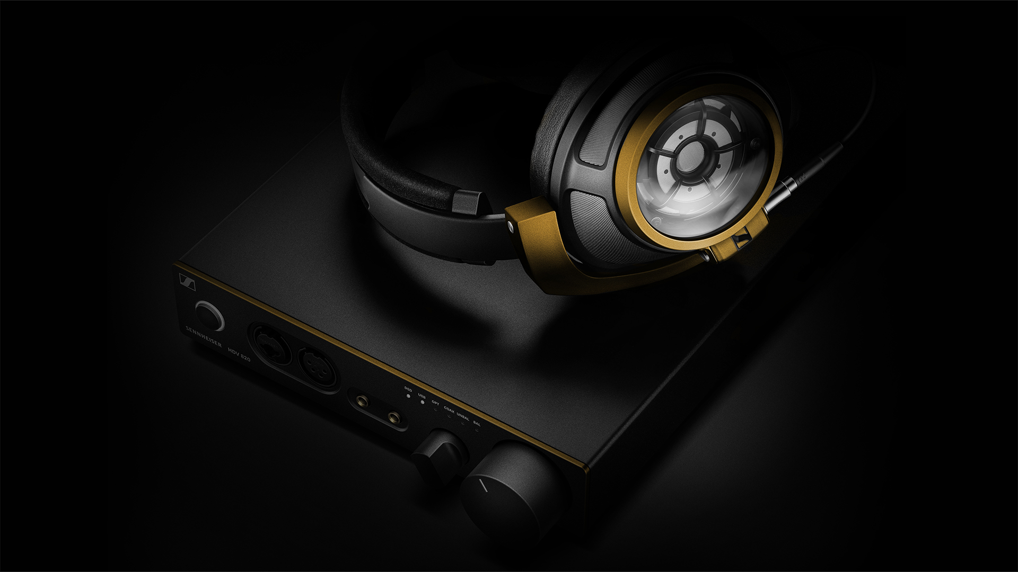 | The grand prize: The golden version of the HD 820 & HDV 820 combo

Drawing the winners
The Sennheiser Treasure Hunt will run from November 1 to 22, 2021. Every Tuesday, Sennheiser will announce the winners of the week, giving away many exclusive audio treasures. A few audio delights include the Sennheiser CX True Wireless, MOMENTUM True Wireless 2, HD 560S, and MOMENTUM Wireless. So, you just might be getting an early present.
But the grand prize? Drum roll please! The ultra-exclusive, one-of-a-kind, custom-made, golden version of the HD 820 & HDV 820 combo. To learn more, visit the Sennheiser Treasure Hunt landing page.

Conditions apply, see sennheisertreasurehunt.com/anz. Open to AU & NZ res 16+. Max 1 entry p/Access Code. Starts: 1/11/21. Ends: 11:59pm AEDT 22/11/21. Draws: Suite 5, 210 Central Coast Highway NSW 2250 on 9/11/21, 16/11/21 & 23/11/21 at 10AM AEDT. Winners published at sennheisertreasurehunt.com/anz from 23/11/21. Weekly Minor Prizes: 2 x 1 pair of Sennheiser MOMENTUM 3 Wireless over-ear headphones valued at AUD$599.95/NZD$649.99 RRP ea; 2 x 1 pair of Sennheiser MOMENTUM True Wireless 2 earbuds valued at AUD$499.95/NZD$549.99 RRP ea; 2 x 1 pair of Sennheiser HD 560S over-ear headphones valued at AUD$319.95/NZD$339.99 RRP ea; and 2 x 1 pair of Sennheiser CX True Wireless earbuds valued at AUD$199.95/NZD$219.99 RRP ea. Major Prize: 1 x Sennheiser HD 820 audiophile headphones with customised gold details valued at AUD$3,499.95/NZD$3,999.99 RRP and 1 x Sennheiser HDV 820 amplifier with customised gold details valued at AUD$3,799.95/ NZD$3,999.99 RRP. Promoter: Sennheiser Audio Australia Pty. Ltd (ABN 82 651 492 929) of The Zenith Building, Tower A, Level 14, 821 Pacific Highway Chatswood NSW 2067 (Ph: 02 9910 6700). NSW Authority: TP/01405. Permits: ACT: TP21/01842. SA: T21/1658.

ABOUT SENNHEISER
Shaping the future of audio and creating unique sound experiences for customers – this aim
unites Sennheiser employees and partners worldwide. The independent family company,
which is managed in the third generation by Dr. Andreas Sennheiser and Daniel Sennheiser, is
today one of the world’s leading manufacturers of headphones, loudspeakers, microphones
and wireless transmission systems. In 2020, the Sennheiser Group generated turnover totaling
€573.5 million. www.sennheiser.com

Global Press Contact
Sennheiser electronic GmbH & Co. KG
Paul Hughes
Head of PR and Influencers
T +49 (0) 162 2921 861
paul.hughes@sennheiser-ce.com

