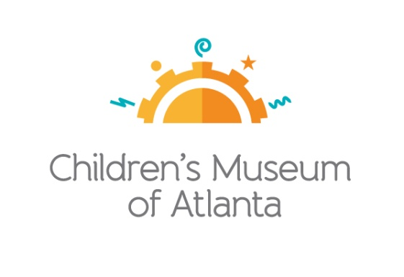

CONTACT
Alison Wentley
BRAVE Public Relations, 404.233.3993
awentley@emailbrave.com
*MEDIA ADVISORY*
Children’s Museum of Atlanta offers discount to Hurricane Dorian evacuees
Attraction welcomes families to displaced by storm $3-off walk-up tickets

ATLANTA (September 3, 2019) – Children’s Museum of Atlanta is offering a $3 discount on admission to Hurricane Dorian evacuees from Florida, Georgia and South Carolina on Tuesday, September 3; Thursday, September 5; and Friday, September 6. The attraction hopes to provide those impacted by the storm with an educational escape where children and families can experience the power of play. Guests will also have the opportunity to participate in the highly-interactive exhibit based on Disney Junior’s Peabody Award-winning television series, “Doc McStuffins.” This offer is valid for walk-up guests only with proper identification from an evacuated area.
WHAT: $3 discount for Hurricane Dorian evacuees

WHEN: Tuesday, September 3; Thursday, September 5; and Friday, September 6
Tuesday: 10 a.m. – 4 p.m.
Wednesday: Museum is CLOSED
Thursday – Friday: 10 a.m. – 4 p.m.

WHERE: Children’s Museum of Atlanta
275 Centennial Olympic Park Drive, NW
Atlanta, GA 30313

HOW: Offer valid for walk-up guests only with a valid driver’s license from an evacuated area.

MORE INFO: To learn more, please visit childrensmuseumatlanta.org

For more information or to support Children's Museum of Atlanta, visit childrensmuseumatlanta.org
or call 404.659.KIDS [5437]

###

