Catch a Sound Wave: Sonarworks Brings its Revolutionary True-Fi Headphone Calibration Software to CanJam SoCal 2018
Award-Winning Headphone Calibration Software Now Supports over 130 Headphone Models
Los Angeles, April 5, 2018 – European audio software developer Sonarworks announced that it will be exhibiting at CanJam SoCal 2018, scheduled to take place at the JW Marriott Los Angeles L.A. Live this weekend. During the exhibition, Sonarworks will facilitate in-person demonstrations of True-Fi: its revolutionary consumer software platform that delivers 'studio reference sound' to more than 130 supported headphone models.

CanJam SoCal 2018, part of Head-Fi's CanJam Global, showcases the latest innovations in headphones and personal audio electronics in all price ranges while featuring interactive product demos. Exhibition hours are Saturday, April 7th between 11:00 a.m. and 6:00 p.m., and Sunday, April 8th between 10:00 a.m. and 5:00 p.m. and JW Marriott Los Angeles L.A. Live is located at 900 West Olympic Blvd., Los Angeles, CA 90015.

During CanJam NY in February, Sonarworks announced the addition of ten new headphone models to its software platform. The headphone profiles, which now include a total of more than 130 models including favorites from Audio Technica, Beyerdynamic, Bose, Plantronics, Sennheiser and others, are each meticulously measured and and included for all True-Fi software users, costs just $79 and is available on the Sonarworks website for purchase and download.

True-Fi: Making Waves in LA
Sonarworks' True-Fi technology, which made its debut in the consumer market in November of 2017, removes unwanted sound coloration from headphones so consumers can experience the artists' true intentions — on a sonically balanced listening canvas. The consumer-based software — which is available on both Mac and PC platforms — was awarded 'Best in Show' in the music listening category at CanJam Europe in Berlin last November.
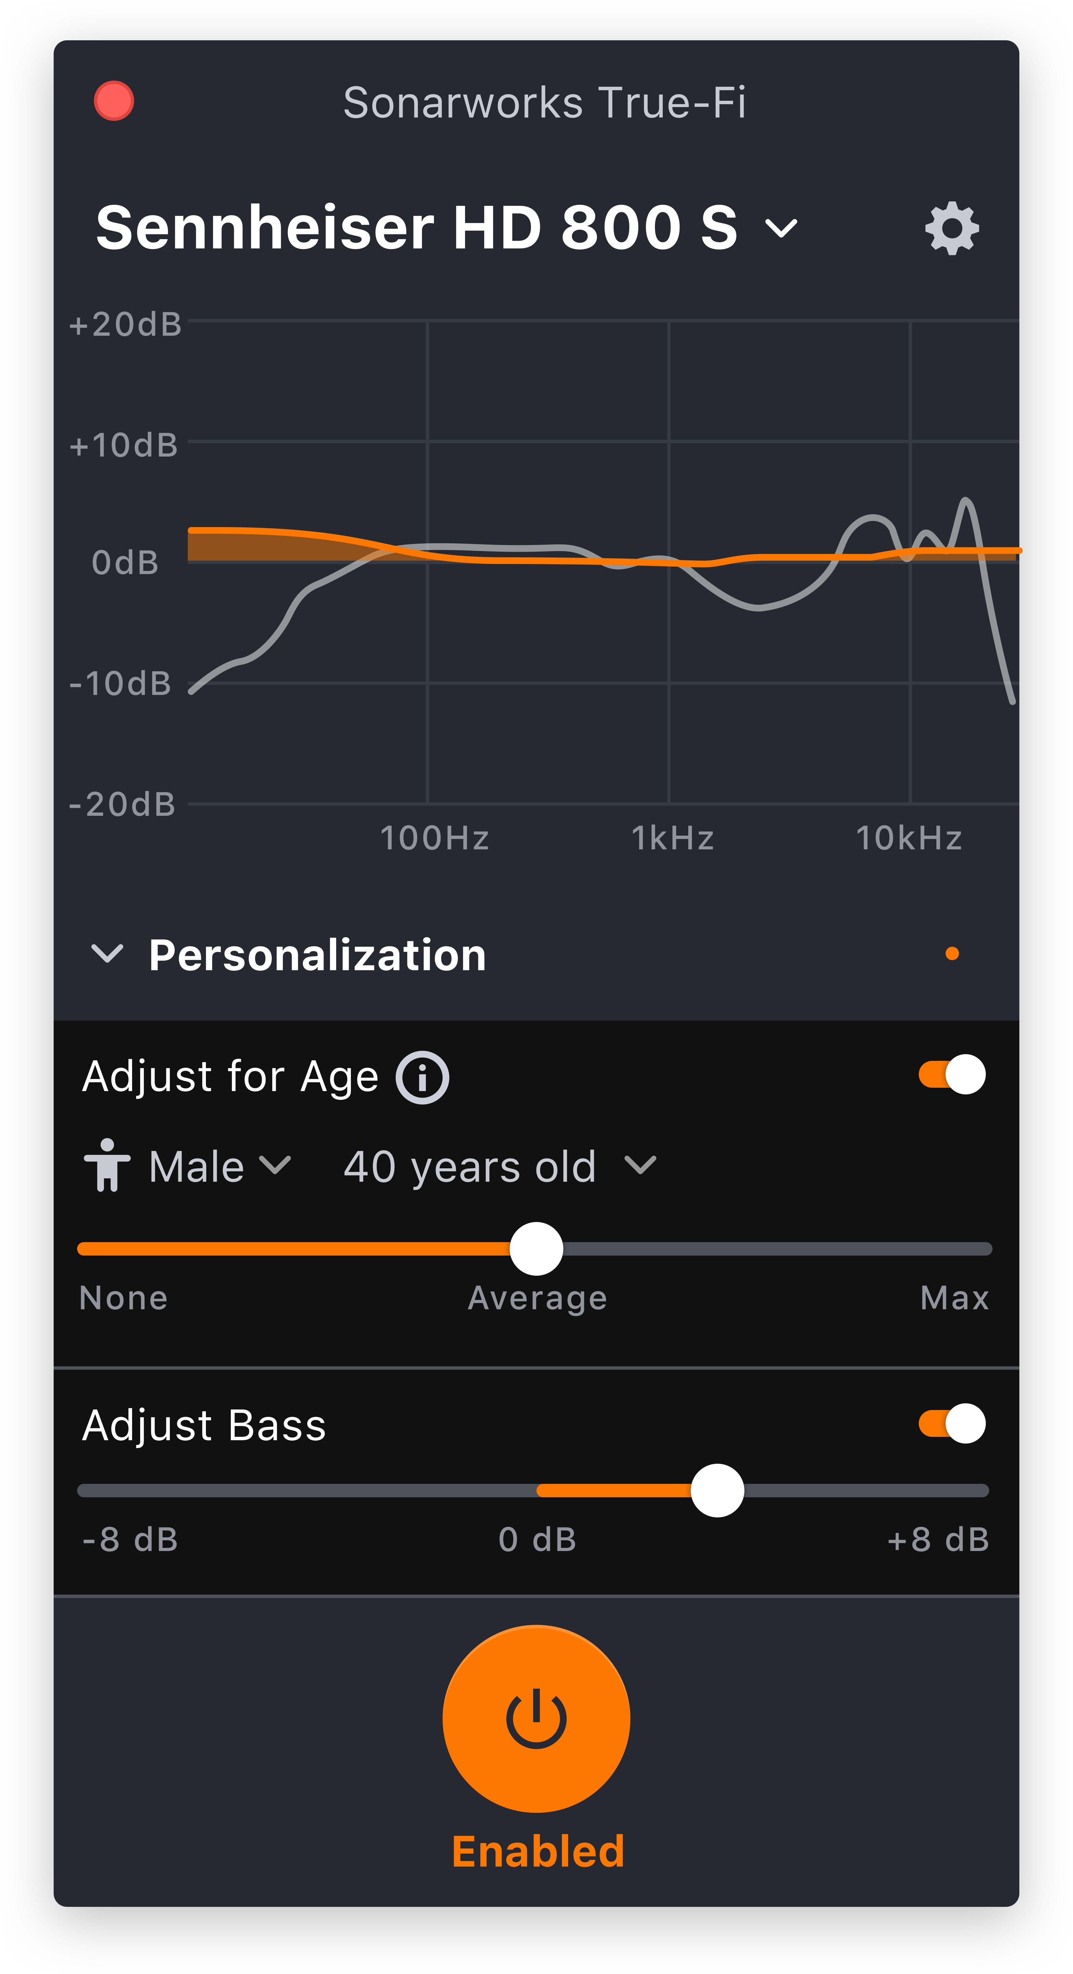
True-Fi takes just seconds to configure and employs measurement-based compensation profiles to correct tonal discrepancies that are caused by the headphones' physical construction. The result is 'studio reference sound' — closer to the artist's intentions and resulting in an emotionally engaging listening experience.

Pro audio heritage
The recent launch of True-Fi reflects Sonarwork's deep expertise in the recording studio industry. Currently, the company's professional software is installed in thousands of recording studios and relied on by top studio mixers and mastering engineers around the world. In 2015, the company's professional audio software offering, Reference 3, received an 'Editor's Choice' award from respected UK-based publication Sound on Sound. Recently, the company launched its latest professional software offering: Reference 4.

Coming soon to a mobile device near you
Sonarworks, which is constantly adding new headphone models to its calibration profiles, will soon be available on mobile devices at no additional charge to existing users. Further, new features such as personal listening profiles and age-based hearing compensation, will be introduced in the coming months. Currently, the software supports sample rates of up to 96kHz and the company plans to announce support of higher sample rates in the near future.

"The biggest problem music listeners experience today is not in the file and stream quality, but the playback," commented Helmuts Bēms, CEO and co-founder of Sonarworks. "True-Fi uses proprietary, research-driven technology to audibly improve the performance of loudspeakers and headphones. True-Fi stays true to the promise in its name, helping listeners experience the artists' true intention."

True-Fi is available for purchase on Sonarworks' website. For more information about Sonarworks' True-Fi, please visit https://www.sonarworks.com/truefi.
About Sonarworks
Sonarworks is a Europe-based audio software development company specializing in acoustic calibration and DAW plugins. Accurate sound is our passion. The company was founded in 2013 and entered the pro audio market in 2015. Sonarworks software is relied upon by many Grammy winning artists and engineers around the world.

Media Contact:
Jeff Touzeau
Hummingbird Media
+1 (914) 602-2913
jeff@hummingbirdmedia.com

