ALEXIS FERRER

ANNA FERRER

A child who wanted to be a biologist and comb the birds.
A visionary who drew the echo in a mane.
An artist inside of thousand heads.

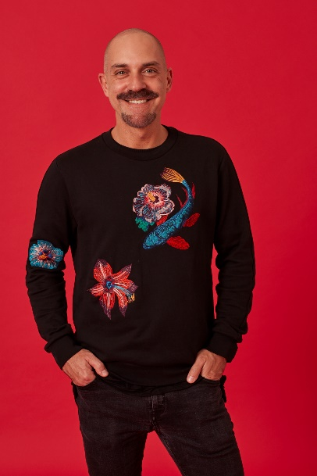
Alexis Ferrer is a child of the Barcelona Avant Garde fashion scene, one which has inspired in him the freedom to dream the impossible and to push the limits of infinity and design for the world of his imagination. First published in Paris magazine Metamorphosis at 17, Alexis has now worked in over 1000 catwalks across the globe, across all cultures, and collaborated with industries as diverse and enriching as haute couture, audio-visual and theater. This vast spectrum of influence has been further enriched thanks to his studies in stylism with Vidal Sassoon in London and Los Angeles, making Alexis a veritable cutting-edge influencer in the world of stylists.
Working in collaboration with Wella over the last 20 years through Anna Ferrer company. Since 2012 is part of the Wella Global Creative Artist and is considering one of the ten best hairdressers of the worldwide. Working on Wella International Team participating on shows in Spain, Austria, Turkey, Romania, Russia, as well as Berlin, Dubai, London and Paris. Alexis Ferrer is the Creative Director of Anna Ferrer's company leading five salons and a team of 57 employees.
Permanently collaborating with several Visionary programs in the fashion world, to continue to expand the Anna Ferrer label in and out of Europe. All the initiatives being supported by the lab of new ideas with the support of Wella, to investigating and looking for innovative products using new technologies.
In parallel is collaboration with some designers such Josep Font, Manuel Bolaño or Txell Miras in Barcelona, Paris, Milan and London Fashion Week.
He is got the ability to cross the limits of the beauty such as printing photos on hair, creating impossible up-dos, painting the hair like a canvas or using wearable technology on the hair. Innovating is edgy and applies his motto: no limits.
His natural state: work and imagine. His vocation: to thrill the audience. With this intention comes to his new salon in Barcelona, in a unique area which houses art and inspiration.
Alexis is SLOWHAIR, a new concept of hairdressing.

