For more information, please contact Marta de Paco
On +34 670 780 664 or email press@comunicahair.com

Important:
These images are only available for editorial content.
Credits must be included.
Notification of their publication is expected.

IVAN RODRÍGUEZ
MÉXICO
Heaven Collection

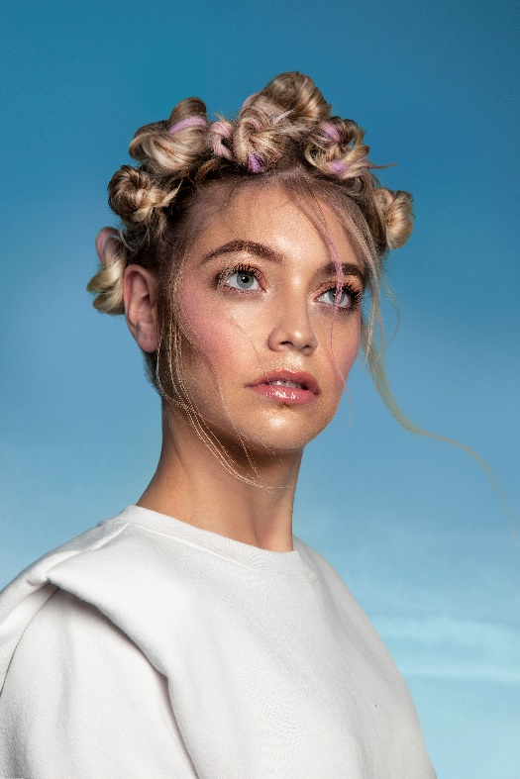
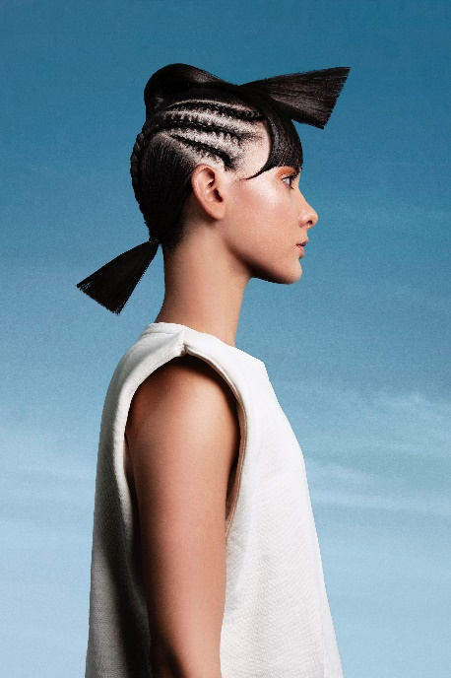
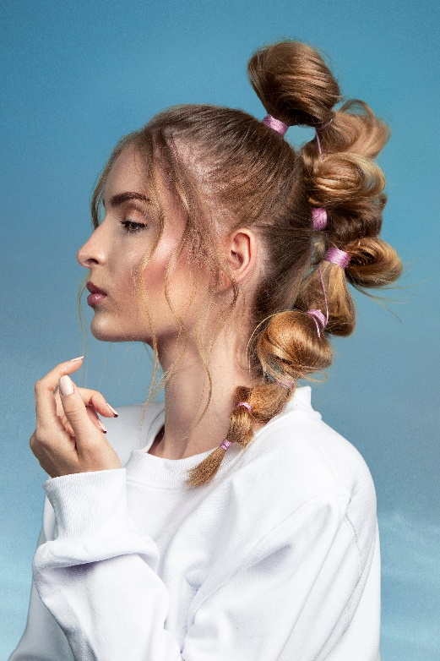

Hair: Ivan Rodríguez @ivanrohair
Photography: Jesús Herrera @jesusherrerag
Make up: Thessa Peralta & Greg del Toro @thessaperalta_mua
Styling: Ivan Rodríguez

#ivanrohair #ivanrodriguezhairdresser

IVAN RODRÍGUEZ
MÉXICO
Heaven Collection

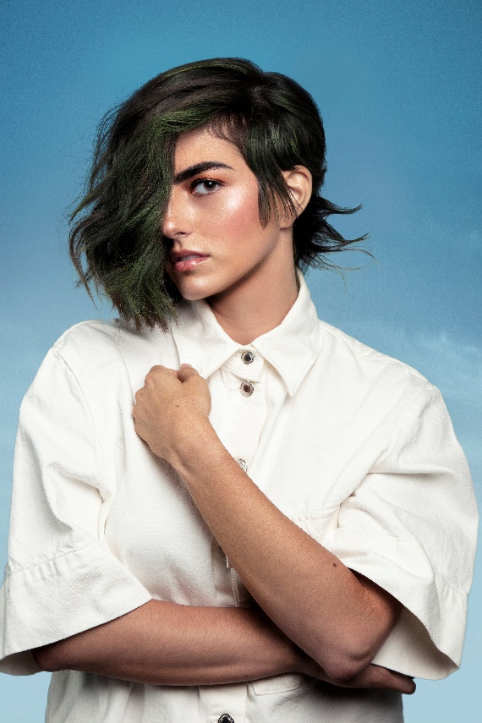

We place our dreams, desires and hopes in heaven. In its blue we keep the most alive energy, that which boils in the desire of youth and rises upwards. That is the inspiration for a collection in which contrasts, textures, and nuances are fresh and daring. Hair becomes a surprising living matter with unevenness, flashes of color and unusual shapes in a demonstration of creativity, beauty and life.

