March 2, 2018
Toyota Motor Corporation
GAZOO Racing Company

Rally Mexico: Preview
TOYOTA GAZOO Racing hopes to reach new heights in Mexico

The first gravel round of the season awaits the TOYOTA GAZOO Racing World Rally Team on Rally Mexico from March 8 to 11. On what is one of the toughest events of the season for the cars, the team hopes to demonstrate the progress made with the Toyota Yaris WRC and build upon a promising start to the year: the team sits second in the manufacturers’ championship (just one point behind first place) with Jari-Matti Latvala, Esapekka Lappi and Ott Tänak all within the top five in the drivers’ standings.
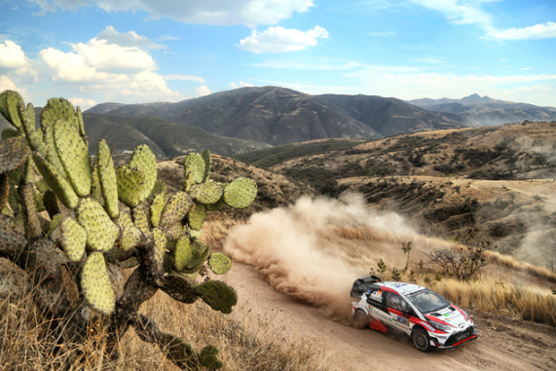

Yaris WRC Rally Mexico 2017

Rally Mexico is characterised by high ambient temperatures in the region of 30°C, as well as the altitude of the rally route. This reduces the amount of air available to the engines, which in turn cuts power by as much as 20 per cent.

The rally will begin in spectacular fashion on Thursday with a stage on the streets and through the tunnels of Guanajuato. Further spectator-friendly stages will be held on Leon’s streets and at the local racing circuit on both Friday and Saturday. Friday’s schedule also includes two runs of the El Chocolate stage: the longest stage of the rally at 31.44 kilometres and also featuring the highest point of the season at more than 2700 metres above sea level. The rally will conclude with three stages on Sunday, with the second pass of Las Minas serving as the Power Stage.

Quotes:
Tommi Mäkinen (Team Principal)
“We have done quite a lot of work to improve from last year, when Mexico was quite tough for us with our new car. Since then we have analysed everything that happened. We have improved the cooling, and we have improved the engine. We have even been in an altitude dyno in Japan. We have put quite a lot of effort into these areas and I hope that altogether, it will be enough to give us a competitive package, but we will only know for sure once the rally gets underway.”

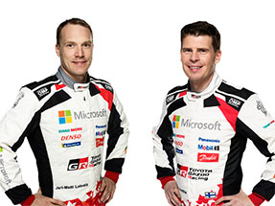
Jari-Matti Latvala (Driver car 10)
“I always like going to Mexico and enjoying the warmth and the sun for the first time after the winter. The stages have sections that are very fast and sections that are very slow, and there are a lot of loose rocks off the line so you have to be precise with your driving. If we can finish on the podium that would be really good for the championship. It’s clear that the performance is there in the car. We had a good gravel test in Spain last week: of course in Mexico it is going to be warmer but it is the best you can do in Europe at this time of the year. We had some updates to the suspension and I could feel that the traction and the grip under braking are better than what we had at the end of last year.”
Jari-Matti Latvala and Miikka Anttila

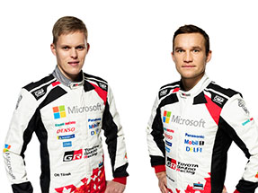
Ott Tänak (Driver car 8)
“Rally Mexico will be my first event on gravel in the Yaris WRC. I have many new things to learn, but we had two days of testing in Spain last week which were very useful. We tried as many different things as possible, just to understand how the car reacted. The early feeling with the car on gravel is quite good: there are still some things to get used to and some things that we can develop. In Mexico we will have a better road position, starting fifth. The road sweeping has a big effect there, so this should help us. I have quite a bit of experience in Mexico now, so I feel comfortable going there and I think we have a good chance to fight for the top positions.”
Ott Tänak and Martin Järveoja

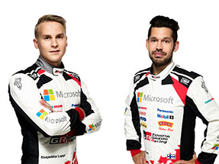
Esapekka Lappi (Driver car 9)
“This will be the first time that I have competed in Mexico, although I did do the recce last year so I have some idea of what to expect. The surface is similar to the gravel roads in Spain, where everybody has done their pre-event testing, but I think the stages will be much rougher on the second pass. The altitude will also make a big difference: I have never driven those kind of conditions where the air is really thin. It means there is less power from the engine, so you may have to drive in a slightly different way. I am quite happy with how my season has started and hopefully we can continue that in Mexico. The main target for me though has to be to do every stage and gain that experience for the future.”
Esapekka Lappi and Janne Ferm

The statistics (Rally Mexico):
Year | Jari-Matti Latvala | Ott Tänak | Esapekka Lappi
2017 | 6 | 4 | -
2016 | 1 | 6 | -
2015 | 15 | 22 | -
2014 | 2 | 15 | -
2013 | 16 | - | -
2012 | DNF | 5 | -

What happened last year?
Last year’s Rally Mexico began in style with a stage in Mexico City and featured a dramatic finish, with the winner coming close to losing the victory in the final moments. In the first gravel rally for the Toyota Yaris WRC, the heat and altitude took its toll and caused overheating issues, but despite having the penalty of sweeping the road during the first day, Jari-Matti Latvala made the finish in sixth and Juho Hänninen was just behind in seventh: the first time that both cars finished in the points.

Press release
URL: https://toyotagazooracing.com/release/2018/wrc/rd03-preview.html

Pictures will be uploaded here during the event
URL: https://www.tgr-dam.com

Follow us!
Follow TOYOTA GAZOO Racing WRT:
∇Facebook: https://www.facebook.com/TOYOTAGAZOORacingWRC
∇Twitter: https://www.twitter.com/TGR_WRC (@TGR_WRC)
∇Instagram: https://www.instagram.com/tgr_wrc/ (@TGR_WRC)
∇YouTube: https://www.youtube.com/channel/UCCtALHup92q5xIFb7n9UXVg

<Contact>

TOYOTA GAZOO Racing PR Office
Email: tgr_pr @rights-apartment.com

TOYOTA GAZOO Racing Official website
http://toyotagazooracing.com/

TOYOTA GAZOO Racing World Rally Team is supported by following partners:

