Xytech Announces MediaPulse Transmission, Automation Releases for Broadcast Operations

Best-in-class operational platform simplifies transmission and automation workflows, streamlining operations for facilities management

New York, October 23, 2017 — Xytech, the leader in facility management software for the broadcast, production, media services and video transmission industries, demonstrated its new MediaPulse Transmission and Digital Order Automation features at the NAB Show in New York last week following a strong showing at IBC 2017 in Amsterdam last month.

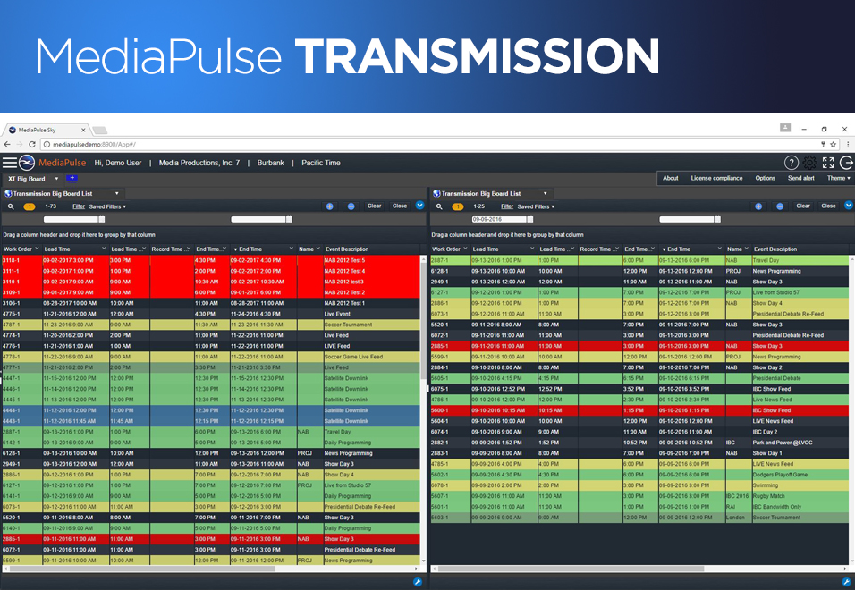
MediaPulse Transmission offers enterprise-class operations and robust financial management tools designed specifically to streamline transmission and automation functionality across multiple broadcast platforms. This latest release of MediaPulse makes it easy for broadcast personnel to reserve, provision and monitor specific feeds, while simplifying the process of booking routes. Available as both on-premise and cloud installations, the new release also has a notification engine, personalized feed dashboards and a Big Board list of feeds appropriate for publication to the entire facility.

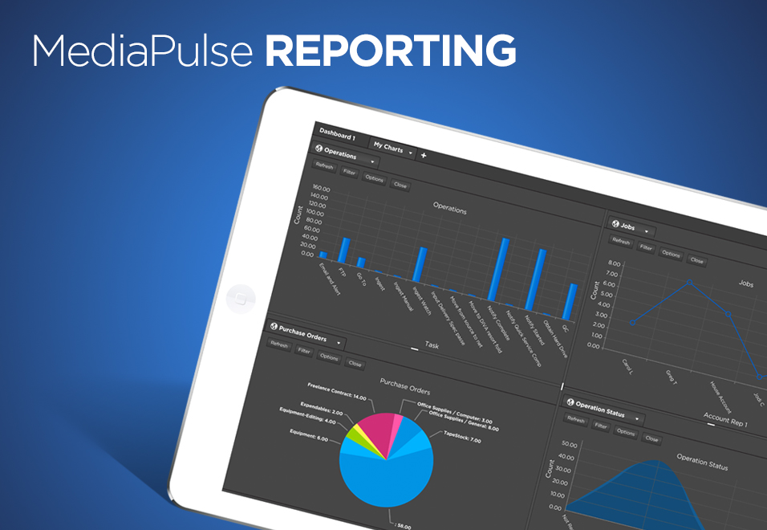
“After years of refinement, we have created a transmission module not only competitive in the marketplace, but completely superior,” comments Greg Dolan, COO of Xytech. “The module features top-of-the-line functionality. For example, the system can become 'network aware' automatically — making a software-defined network easily configured and it’s completely localizable. The new MediaPulse Transmission makes the entire process of transmitting a broadcast signal between any two points more efficient while removing any uncertainty the end-user may have.”

MediaPulse: Master of Workflows
MediaPulse Reporting — the company's automation module — captures an order and drives the required tasks to ensure a seamless order process. The new Digital Order Automation module in MediaPulse streamlines the complex, expensive and time-consuming workflow processes all media servicing and broadcast facilities face. The software also integrates with third-party applications through an open adapter technology so order automation and multi-system workflows are truly seamless. The result is a workflow elegantly navigating multiple dependencies across a range of possibilities.

“MediaPulse is the master of workflow management, making even the most complex path dependencies or multi-system automations look easy," Dolan said. "We are the 'workflow of workflows' for our customers so they can easily kick off a new sequence of required events and report on its progress or troubleshoot it as necessary. This can lead to vast operational savings, while reducing costly mistakes."

About Xytech Systems: For over 25 years, the world’s premiere media companies have depended on Xytech to run their businesses. MediaPulse is the only end-to-end solution for the complete content lifecycle. MediaPulse provides scheduling, automation, asset management, billing and cost recovery for broadcasters, media services companies and transmission facilities in a scalable platform-independent solution.

For more information, visit xytechsystems.com.

Media Contacts:

Media contact
Jeff Touzeau
Public Relations
Hummingbird Media
+1 (914) 602 2913
jeff@hummingbirdmedia.com

Katie Kailus
Public Relations
Hummingbird Media
+1 (630) 319-5226
katie@hummingbirdmedia.com

