Conductor Roger Nierenberg presents InSight Concerts, an immersive experience that places audience members in the midst of a symphony orchestra

Created for both the classical newcomer and aficionado alike, the initial performances will take place on September 17th and 18th at The DiMenna Center, featuring music by Wagner, Britten, Ravel and more.

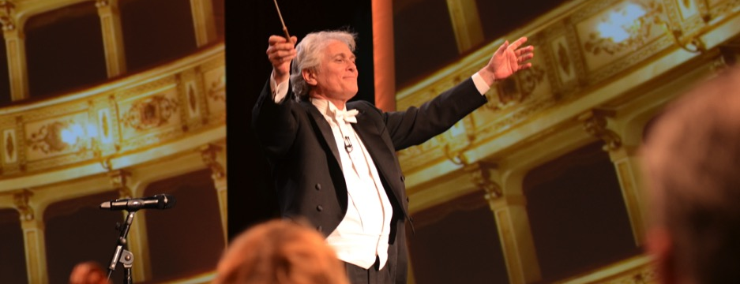

It took precisely six seconds for my skepticism to be blown away…The sensation of hearing music from within an orchestra is remarkable. I may never be able to sit in an auditorium again.
- The Guardian

“I had witnessed far too many slick, self-serving attempts to use musical pap as a tool for spiritual uplift or personal motivation, and Mr. Nierenberg, I thought, might as well have been selling snake oil…But no, I quickly realized, he was making real music and making good sense…what the live session so brilliantly conveyed is what Mr. Nierenberg calls the driving force of the Music Paradigm in the first place, ‘the power of music.’”
- The New York Times

New York, NY – Over the past twenty years, conductor Roger Nierenberg has led hundreds of sessions with his company The Music Paradigm, taking executives from organizations such as Google, AT&T, Pepsi, Wal-Mart and more, and placing them amidst a symphony orchestra in order to draw parallels between leading a rehearsal and leading a workforce.

Now, Maestro Nierenberg will take his immersive experience from the boardroom to the concert hall, presenting InSight Concerts. The performances will place audience members next to the musicians, allowing them to watch the interactions as the conductor shapes the performance, even offering a chance to stand behind the podium themselves.

Nierenberg believes this is also one of the best ways to introduce newcomers to classical music, saying of the experience: “I’ve noticed time and again how incredibly curious people get about the inner workings of the orchestra – the way the musicians communicate, the role of the conductor, the meaning of those puzzling gestures. And people get so excited to listen and observe from the place where the conductor stands, as well as to sit side-by-side with a musician. This concert is designed to provide all those opportunities, free from any distractions, and to provide the audience a chance to feel a real bond with the performers.”

The two InSight Concerts will take place on Saturday, September 17th at 7PM and Sunday, September 18th at 3PM, at the DiMenna Center for Music in New York City. The performances will be free, but require attendees to RSVP here: https://www.eventbrite.com/e/insight-concerts-tickets-25856043121
About Roger Nierenberg
Maestro Roger Nierenberg made his New York conducting debut at Avery Fisher with the Pro Arte Chorale and Orchestra, followed by his leading operas in two successive seasons at the Mostly Mozart Festival at New York’s Lincoln Center. Thereafter followed long, successful tenures as Music Director of both the Stamford Symphony in Connecticut and the Jacksonville Symphony in Florida, with guest conducting invitations from the National Symphony, the Opera Theatre of Saint Louis, the Detroit Symphony, the Saint Louis Symphony, the Baltimore Symphony, the Indianapolis Symphony, the San Diego Symphony, and many other great American orchestras. Abroad he has recorded with the London Philharmonic and conducted at both the Prague Spring Festival and the Beijing Festival. He has collaborated with many of the most renowned solo artists and composers of our time.

In 1996, he created The Music Paradigm, and since then has taken the podium of over ninety different orchestras, before hundreds of different organizations in twenty-three different countries. Many of the lessons learned on this journey are presented in his book Maestro: A Surprising Story About Leading by Listening which was honored in 2009 as the Best Leadership Book from 800-CEO-READ.

About The Music Paradigm
The Music Paradigm is an innovative program led by veteran orchestra conductor Roger Nierenberg, that places high-level executives within a professional orchestra. Providing an unexpected perspective, Nierenberg guides participants through fascinating and engaging demonstrations and interactive exercises specifically designed for them, on topics such as communication, organizational dynamics, and leadership.

Hundreds of top-level organizations (including many Fortune 100 companies) in the fields of healthcare, technology, finance, education and more, have engaged The Music Paradigm to gain fresh insights and new perspectives on an extensive range of topics. (Read about one organization’s story in this New York Times article).

