AES NY 2022: Sennheiser / Neumann demo room to feature immersive presentations by Grammy award-winning producers and engineers
Nine accomplished guests to present during two-day conference

Old Lyme, October 11, 2022 – Visitors to AES NY 2022 are invited to experience the latest solutions from Neumann, Dear Reality and Merging Technologies at demo room 3D01. The two-day exhibition will feature nine guests who will discuss their own works as well as the immersive audio medium — including Grammy Award-winning producers and engineers. Sennheiser and Neumann will also have product experts on hand to discuss the latest solutions from Sennheiser, Neumann, Dear Reality and Merging Technologies.

On Thursday, October 20th at 10:00 a.m., Ulrike Schwarz and Jim Anderson of Anderson Audio New York will present Nataly Dawn’s [Pomplamoose] latest solo project Gardenview - Immersive Edition, which was mixed at Skywalker Sound and features five songs from her latest album. Additionally, Schwarz and Anderson will present a Grammy-nominated recording of “Clique” featuring Patricia Barber and her working band from Chicago playing “Barbered” standards as only she can interpret them. as well as tracks from Jane Ira Bloom’s “Picturing the Invisible: Focus 1”.

Jim Anderson and Ulrike Schwarz mixing at Skywalker Sound (photo courtesy Anderson Audio New York) | 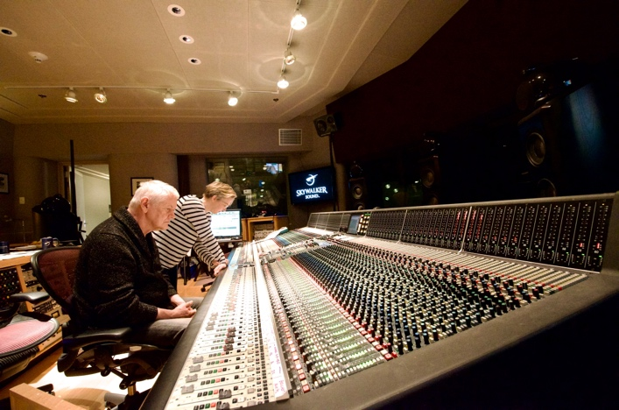

The Sennheiser / Neumann demo room will be outfitted with a full 7.1.4 immersive system, including several stereo pairs of monitors for demonstrating the new AMBEO 2-Channel Spatial Audio, complemented by products from Dear Reality and Merging Technologies. Neumann monitors in use will include the KH 310, KH 420 and KH 870 monitors in the 7.1.4 set up, and stereo pairs including the KH 80, KH 120, KH 310 and the new KH 150 monitors.

The bi-amplified, DSP-controlled Neumann KH 150 features the same high-resolution tweeter as all Neumann studio monitors and a newly developed 6.5” woofer with ultra-low distortion and high SPL capability | 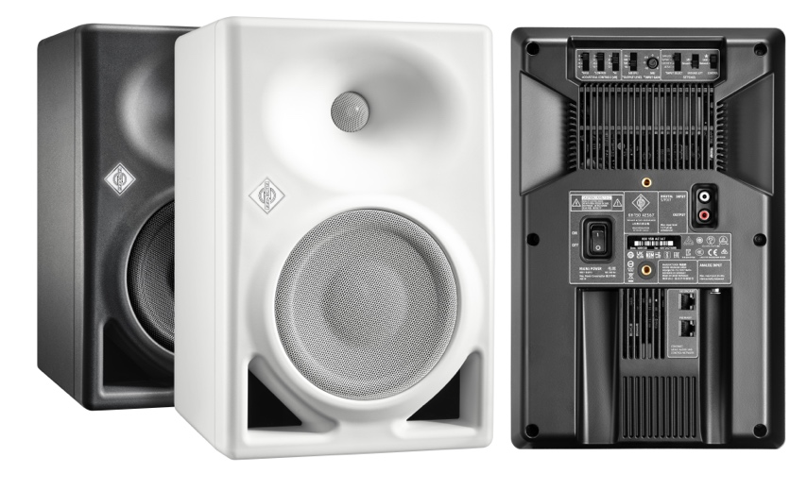

Demo room visitors will be able to gain insights from guests and presenters each hour between 9:00 a.m. and 6:00 p.m. through Neumann monitoring systems. There will also be select product demonstrations from Merging Technologies, Dear Reality and Sennheiser AMBEO. Dear Reality’s software tools will be operating in a fully-fledged studio environment with Neumann monitors.

Among the engineers and producers presenting will be Richard King, Fab Dupont, J Clark, F Reid Shippen, Michael Romanowski, George Massenburg, Eric Shilling, Darcy Proper and Ronald Prent. For a complete demonstration schedule, please visit https://en-de.neumann.com/aes-2022. Presentations are open to all AES attendees on a first-come, first-served basis.

About the Sennheiser Group
Building the future of audio and creating unique sound experiences for our customers - this is the aspiration that unites the employees of the Sennheiser Group worldwide. The independent family-owned company Sennheiser was founded in 1945. Today, it is managed in the third generation by Dr. Andreas Sennheiser and Daniel Sennheiser, and is one of the leading manufacturers in the field of professional audio technology. Within the Sennheiser Group are Georg Neumann GmbH (Berlin, Germany), manufacturer of studio-grade audio equipment; Dear Reality GmbH (Düsseldorf, Germany), known for its binaural, Ambisonics, and multichannel encoders with realistic room virtualization; and Merging Technologies SA (Puidoux, Switzerland), specialist in high-resolution digital audio recording systems.
sennheiser.com | neumann.com | dear-reality.com | merging.com

Local Press Contact
Jeff Touzeau
jeff@hummingbirdmedia.com
+1 914 602 2913

