JAMIE WILEY

SALON HP

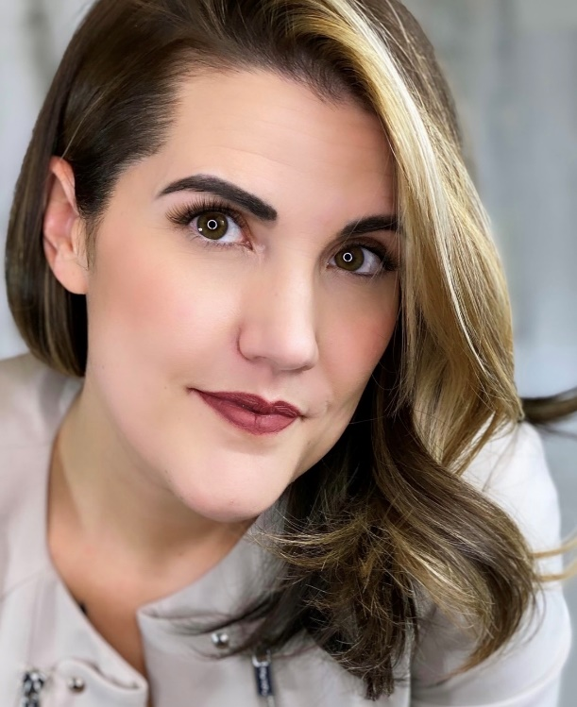
Jamie Wiley is a Louisville-based hairstylist and the daughter of a hairdresser. Her early education equipped her with the intuition of a seasoned stylist. Including that with her five-year service in the United States Army, she brings integrity, gallantry, and selfless service to all of her projects.
She has been recognized internationally for creating elaborate avant-garde concepts, intricately braided looks, and editorial stories.
Her creations have graced the runway of over 70 designers - keying fashion shows and presentations such as Walter Collection, Ryan Patros, and MATTE Collection.

Besides this, she has contributed to publications like ‘’Vogue’’, ‘’Marie Claire’’, ‘’Elle’’, and ‘’Cosmopolitan’’, and has been featured on ‘’60 Minutes’’.
Jamie’s work has received industry recognition with two North American Hairstyling Nominations in Editorial and Avant-Garde Categories, multiple Behind the Chair One Shot Nominations, and Global Image Awards; as well as being named Next Generation of Influencers by American Salon.
Wiley has also collaborated on advertising campaigns for Target, Maidpro, Zildjian, and Hottools Pro. Additionally, she is the creator and author of HAIRBOSS™: A Hairstylists Guide to Owning Their Career.

