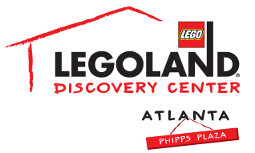
For more information:
Katie Clark
BRAVE PR
404.233.3993
kclark@bravepublicrelations.com

**MEDIA ADVISORY**

LEGOLAND® Discovery Center Atlanta offers Kids Go Free Coupons to kids wearing University of Georgia or University of Alabama gear, January 6 – 8
Themed builds, LEGO® football helmets and more!

ATLANTA (January 5, 2018) – To get ready for the National Championship game this Monday, LEGOLAND® Discovery Center Atlanta is offering Kids Go Free coupons to guests representing University of Georgia or University of Alabama from January 6 – 8! Kids can learn how to build football themed creations in the Master Builder Academy and the attraction will also have LEGO® football helmets in support of each team available for photo opportunities.

Only sportswear representing University of Georgia and University of Alabama qualify for this offer. Kids Go Free coupons received may be used same day or at another day, and this offer is valid for walkup purchases only.

WHAT: National Championship Offer
Guests receive Kids Go Free coupon if wearing sportwear representing University of Georgia in honor of the National Championship!

WHEN: January 6 – 8, 2018

WHERE: LEGOLAND Discovery Center Atlanta
Phipps Plaza | Buckhead
3500 Peachtree Road NE
Atlanta, GA 30326

HOW: Tickets can be purchased at the door.

For more information, visit facebook.com/LDCatlanta or atlanta.legolanddiscoverycenter.com.

###

