Testimonials gathered during Doctors Without Borders (MSF) mobile clinic in Ranobe, Ambosary district, Anosy region, Madagascar (April 2021)
#1 Vitasoa
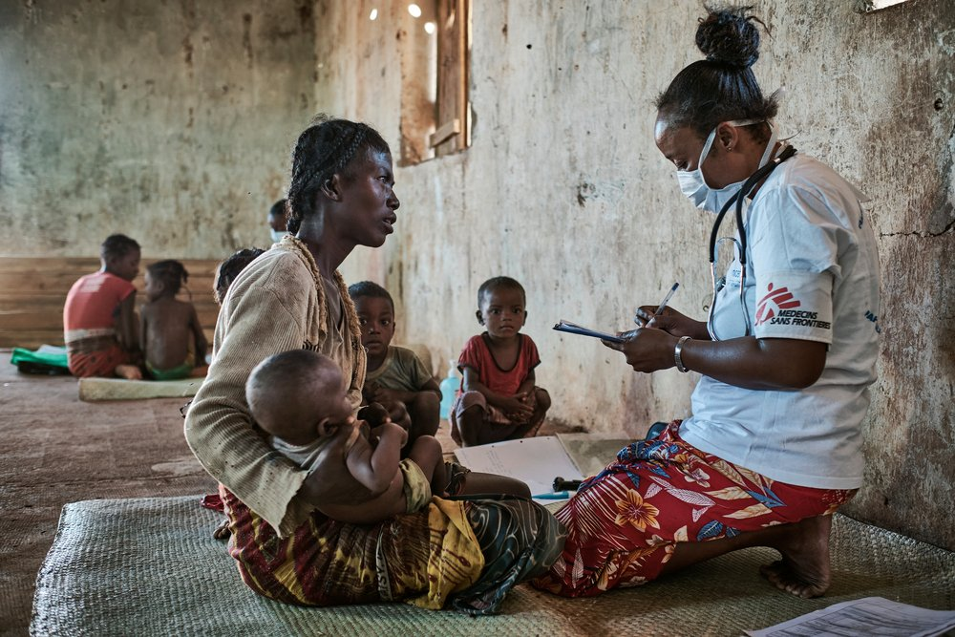
42-year old Vitasoa has six children. She’s brought four of them to the MSF mobile clinic. All the children are included in the nutrition program launched at the end of March in response to the food and nutrition crisis in Southern Madagascar.
“We live in Fenoarivo, and it took us five hours to walk to Ranobe. During the rainy season, we live off cassava, mangoes and edible leaves. But, nothing’s growing because there’s been no rain. We make do with manioc tubers but we find in the forest, cactus fruit and leaves. We have to dig in the sand for water as there’s also less surface water. Every day we pray for rain. We’re staying positive, but we really hope it’ll come soon”.
*

#2 Maraignavy
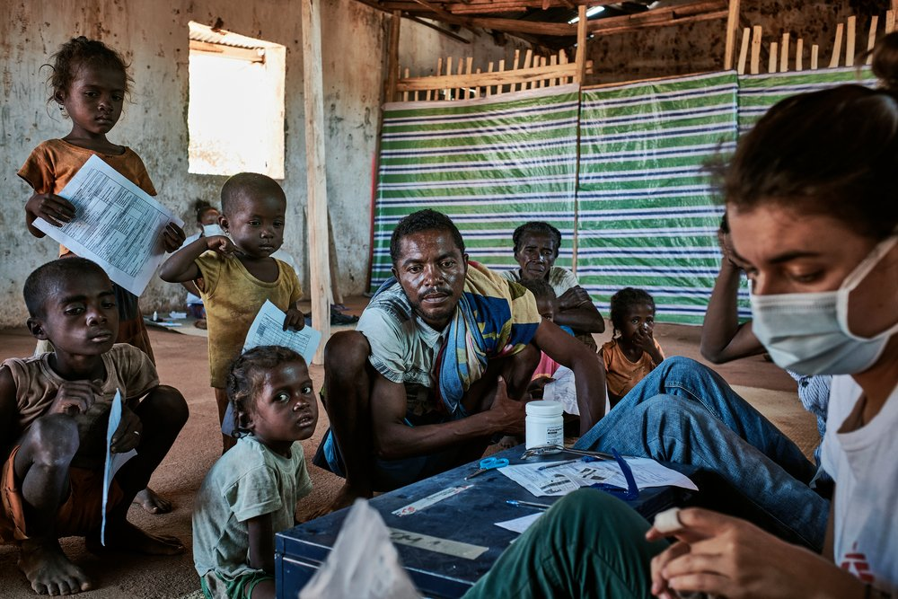

37-year old Maraignavy and his five children walked for four hours to get to Ranobe from Ambohimaivo. They’ll go back with bags crammed full of Plumpy’Nut, because all the children are suffering from malnutrition.

“Five years ago, our zebus were stolen. Ever since, all I have to feed my family is what I manage to cultivate. When we’re able, we grow cassava, watermelons and potatoes, but we can’t now. We make do with tubers and share pili-pili (local name for Plumpy’Nut). Water is hard to find. We get it from the Mandrare (the river crossing the region), but depending on how much it rains, the riverbed shifts. When the water is at its lowest point, we have to dig, and hope for the best”.

*
Maraignavy, 37 ans, et ses cinq enfants ont marché quatre heures pour rejoindre Ranobe depuis Ambohimaivo. Ils repartiront les sacs pleins de Plumpy’Nut, car tous ses enfants souffrent de malnutrition.

#3 Sonambinina
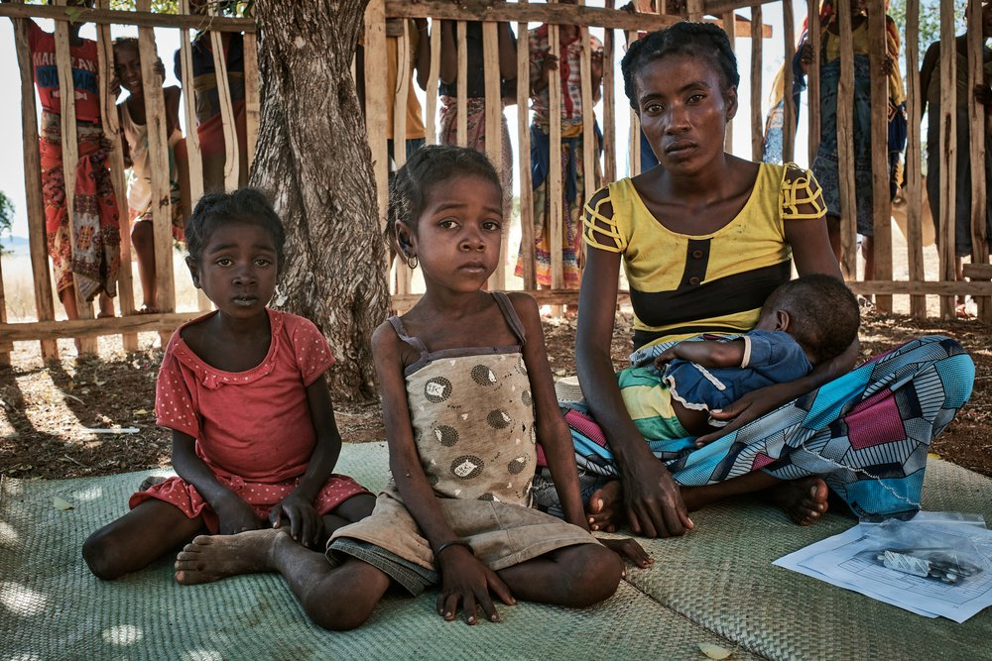
Like most of the villagers who’ve come to the mobile clinic today, Sonambinina has arrived on foot from Fenoarivo. After walking for around five hours, they got to Ranobe late this morning.
« I’ve brought my four children. Three are suffering from malnutrition, and they’re now on MSF’s nutrition programme. We don’t have livestocks and nothing grows. All we eat is tubers. Going elsewhere would be pointless. I haven’t got any money, and anyway, where would we go? And if I do leave, it won’t be any different. The whole of the south is affected by the kéré (Malagasy name for the chronic food insecurity in Southern Madagascar)”
*

#4 Vasaotse
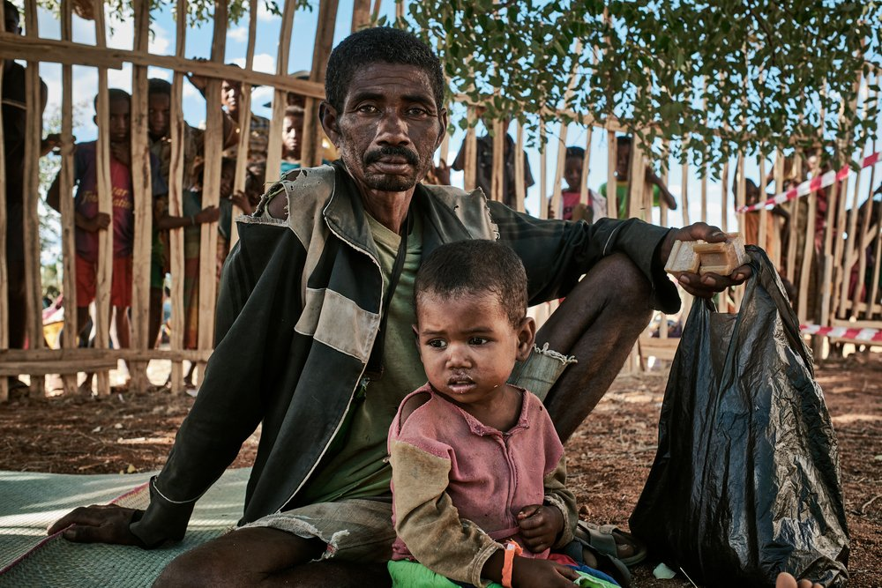
Ankamena is on the other side of the Mandrare River. The villagers come to Ranobe to go to the market and the MSF mobile clinic. It took 51-year old Vasaotse two hours to get here with 3-years old Noriza.
“I have five children, and three are on Médecins Sans Frontières’ programme. The other two couldn’t come because they’re sick. There’s no health centre in Ankamena. We used to come here to Ranobe, but the doctor left two years ago because of the Dahalo (Malagasy term used to designate cattle rustlers and thieves in the region). Our only solution is to go to Ebelo, but medical care there has to be paid for. I’ve got no money, so we rely on traditional medicine.
After the Dahalo attacked Ankamena four years ago, I lost everything. They stole my zebus, and looted and torched my house. I’ve had to re-build it all from scratch.”
*

#5 Metee
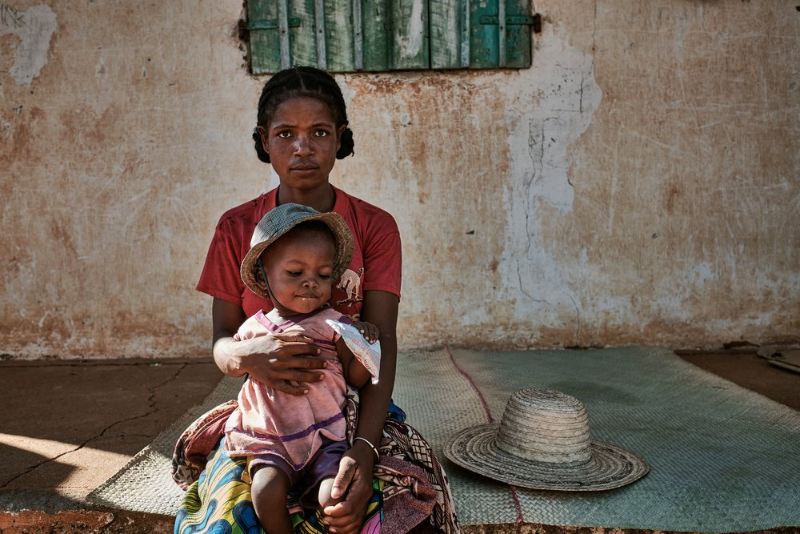
“There’s no medical care available in Beraketa” says Metee who has brought her daughter to the MSF mobile clinic in Ranobe. “It takes us hours to get to the nearest health centre (in Ebelo). They charge for medical treatment, and that isn’t an option for me and my family. We have to sell things like our crockery and kitchen tools at the market to pay for treatment”
The children are often sick, partly because we drink water from the river (the Mandrare). Our food doesn’t vary much. We make do with the few tubers we find. Rain is our only hope, because then we’ll be able to start growing food again. Everything depends on rain, and that’s a rare commodity. Without it, we could well die.”

#6 Mize Soafinoro
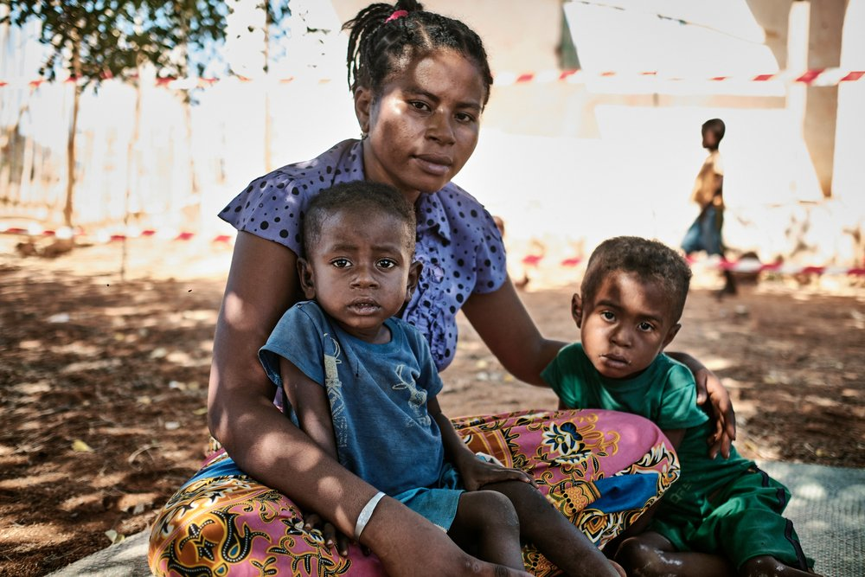

“It takes us three hours to walk to Ranobe from Beraketa. It’s a long way. I’ve brought my two sons, Christian and Christophe, because they’re malnourished. Getting hold of food in Beraketa is so hard. All we eat are tubers we find in the forest, and my children eat cassava leaves. They fall sick a lot, because of what they eat and the poor quality water we get from the river. They suffer from diarrhoea. The nearest health centre is in Ebelo, but treatment has to be paid for and we can’t afford the drugs or the medical examinations ».

*

#7 Fanny Taudierer
MSF Medical doctor
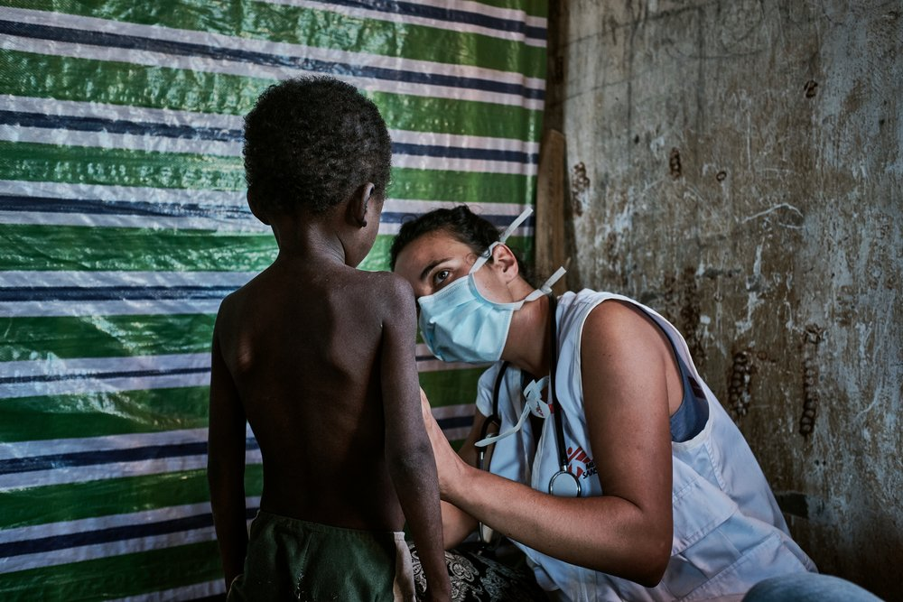
Fanny, 29, is on her first mission as a doctor with MSF. She is the only medical doctor on the mobile clinic in Ranobe.
“Patients with urgent medical issues, but who aren’t included in the nutrition programme, also receive treatment. This is a medical desert, and often there’s no health care available or people can’t afford it. We’re seeing more and more cases of malaria.
All in all, the situation is dire. We have entire families, all of them undernourished, arriving at our mobile clinics. Even when we think we’ve covered an area, people keep coming. They walk here from further and further away and sleep overnight so that they can get treatment.
I remember one patient in particular, a mother who came with her 6-month old baby. Her daughter was suffering from acute severe malnutrition and medical complications. She weighed 3.2 kilos – less than half of what a baby her age should weigh – and her mid upper arm circumference was 75mm, which is tiny. She was also extremely dehydrated. A child in her condition should be hospitalised in an intensive nutritional rehabilitation centre, as outpatient care in our mobile clinic with one consultation every 14 days isn’t enough. But, the centres are a long way from the villages where we work and, when we suggested organising her referral to hospital, her parents refused, which compromised her chances of survival. Transport is provided, but families can’t afford to spend several days away from their villages and activities to live near the centres – food especially is a problem – the time it takes for the treatment. So, they rejected the offer, which was really hard to accept.”
*

