The Essence of MOMENTUM in a truly wireless form
Sennheiser introduces MOMENTUM True Wireless at IFA

Wedemark/Berlin, August 30, 2018 – Sennheiser’s iconic MOMENTUM range of headphones continues to change the game through its fusion of advanced technology, uncompromised sound performance and the highest quality materials. At IFA 2018, held in Berlin from August 31 to September 5, the audio specialist brings the MOMENTUM ethos to an exceptional new product, the MOMENTUM True Wireless: these exquisitely crafted Bluetooth earphones set new standards for audio quality, with characteristic MOMENTUM style and comfort.

The first model in a new generation of the iconic MOMENTUM family redefines the audio benchmark for true wireless earphones with superior stereo sound performance that is guaranteed by Sennheiser’s audiophile 7mm dynamic drivers. With the latest Bluetooth technology, AAC codec support, and Qualcomm® aptXTM compatibility, this exceptional hi-fi sound is delivered without any compromise. “The MOMENTUM range has always stood for a fusion of excellent sound, progressive technology and craftsmanship. We are pleased to now introduce the newest member of the family, which brings the essence of MOMENTUM to a truly wireless form for the first time”, said Frank Foppe, Product Manager at Sennheiser.
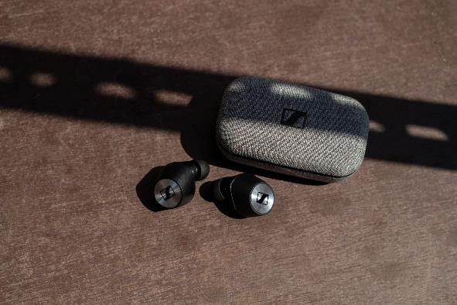

Sennheiser’s new MOMENTUM True Wireless earphones set new standards for audio quality, with characteristic MOMENTUM style and comfort.

Sense your world
Thanks to its Transparent Hearing feature, MOMENTUM True Wireless gives listeners the option of blending ambient sounds into their listening experience for improved situational awareness, or to participate in conversations without removing the earphones.
A smart, connected wireless experience
MOMENTUM True Wireless offers effortless interaction with one’s digital eco system by enabling direct voice access to smart assistants such as Apple Siri or Google Assistant. Be entertained, communicate, and stay informed - all via a simple tap of the intuitive touch interface and natural voice commands. Noisier environments present little challenge thanks to the two-mic-beamforming technology, which optimizes voice pick-up for crystal clear phone calls and voice assistant interaction. The MOMENTUM True Wireless experience can also be personalized via the free Sennheiser Smart Control app, allowing fine-tuning of the sound according to personal preference via the earphones’ built-in audio EQ. The app will be released once the product is available. Additionally, aptXTM Low Latency compatibility enhances gaming or video content by keeping audio transmission perfectly in sync with the visuals.

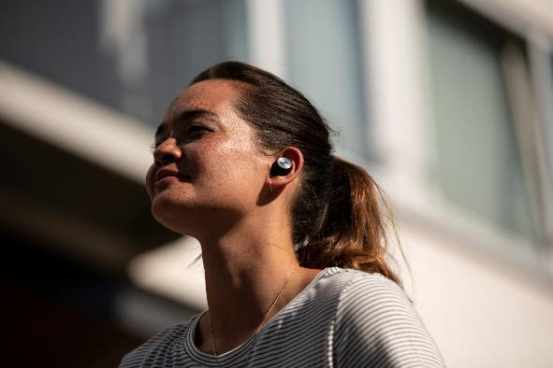

The MOMENTUM True Wireless allows users to be entertained, communicate, and stay informed - all via a simple tap of the intuitive touch interface and natural voice commands.

Enjoy true wireless freedom in style
MOMENTUM True Wireless has a 4-hour battery life that can be recharged via its compact case with integrated power bank for more than 12 hours of all-day enjoyment. Designed for a perfect fit and all-day comfort, the splash- and sweat-resistant earphones have been meticulously crafted to offer a sense of timeless elegance and durability. On opening the fabric-wrapped case, one discovers finely sculpted earphones that have been beautifully finished with metallic details on the outer face as well as gold-plated charging pins and magnets.

MOMENTUM True Wireless will be available from mid-November for 299 EUR (MSRP).

about Sennheiser
Shaping the future of audio and creating unique sound experiences for customers – this aim unites Sennheiser employees and partners worldwide. Founded in 1945, Sennheiser is one of the world’s leading manufacturers of headphones, microphones and wireless transmission systems. With 21 sales subsidiaries and long-established trading partners, the company is active in more than 50 countries and operates its own production facilities in Germany, Ireland, Romania and the USA. Since 2013, Sennheiser has been managed by Daniel Sennheiser and Dr. Andreas Sennheiser, the third generation of the family to run the company. In 2017, the Sennheiser Group generated turnover totaling €667.7 million. www.sennheiser.com

Regional Press Contact
Hummingbird Media, Inc.
Jeff Touzeau
Public Relations
+1 (914) 602-2913
jeff@hummingbirdmedia.com

Global Press Contact
Sennheiser electronic GmbH & Co. KG
Jacqueline Gusmag
Public Relations Manager Consumer Electronics
T: +49 (0)5130 600-1540
jacqueline.gusmag@sennheiser.com

