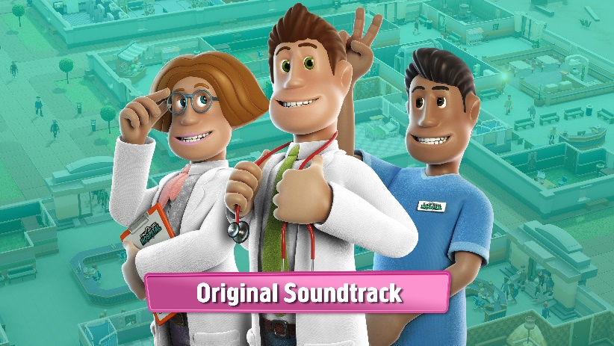

THE OFFICIAL TWO POINT HOSPITAL SOUNDTRACK IS AVAILABLE NOW ON STEAM
To celebrate, get up to 66% discount on the base game and its DLC

Turn up your speakers (or headphones) and enjoy the catchy sounds from the world of Two Point Hospital, with the release of the official soundtrack on Steam for £5.99. This soundtrack contains an eclectic mix of tracks, from atmospheric background music to some absolute bangers that topped the Two Point County charts for weeks. Featuring timeless classics from in-game superstar Jasmine Odyssey, such as “Fish Whispers” and “Nice Smelling Face”, the latter of which was described by Two Point County critics as “a mesmerising, soul-nourishing force that overloads the senses and grabs your face by the ears… in a good way.” Two Point Radio fans can now kick back and relax with some very familiar tracks, like ‘The Waiting Room’, ‘Frosty Bells’ and ‘Needle in the Hay’. The full soundtrack includes 44 songs and even offers some Halloween throwbacks.

Two Point Hospital also sees an extension to the game’s popular R.E.M.I.X mode, with the free update R.E.M.I.X Volume 2 available now. With this update players can revisit three levels from the game and play these in new and interesting ways by completing new objectives with new conditions. You can read more on R.E.M.I.X Volume 2 from the devs in the blog article here.

New players can now purchase Two Point Hospital for 66% off or check out the Two Point Hospital Healthy Collection, which offers a 55% discount on the entire bundle* from 14 – 21 May. For more information about Two Point Hospital on PC and the full list of tracks that are available, head over to: Steam link. For everything else Two Point Hospital visit www.twopointhospital.com or follow the game on YouTube, Facebook and Twitter. For more information about SEGA Europe, log on to www.sega.co.uk, follow us on Facebook or on Twitter.

*Notes to Editors
Available Steam discounts when purchasing content separately:
66% Two Point Hospital base game
50% Bigfoot and Pebberley Island
33% Close Encounters and Retro Items Pack
10% Off the Grid and Exhibition Items Pack
‘The Healthy Collection’: consumers will receive a total of 55% discount when purchasing all content above (exc. the two Items Packs) as a bundle.

