For more information, please contact Marta de Paco
On +34 670 780 664 or email press@comunicahair.com

Important:
These images are only available for editorial content.
Credits must be included.
Notification of their publication is expected.

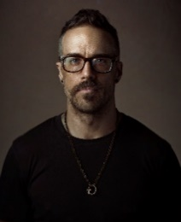
KEITH BRYCE
MODERN RENAISSANCE Collection

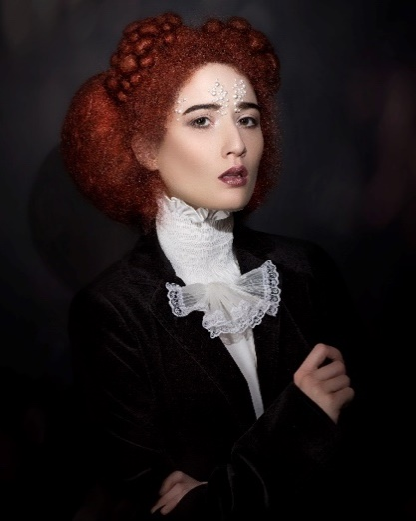
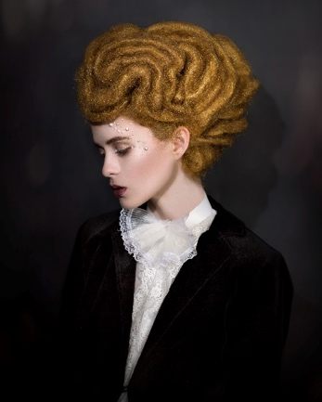
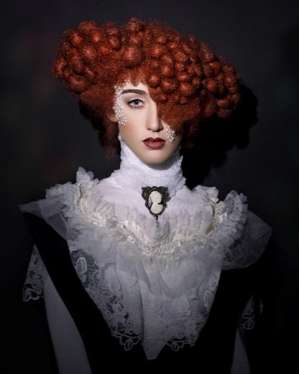

FINALIST NAHA 2021
STYLING & FINISHING Category

FINALIST INTERNATIONAL VISIONARY AWARDS 2021
AVANT-GARDE Category

Hair: Keith Bryce @keithbryce_
Hair Assistant: Marie Fuentes @hairmother
Photography: Keith Bryce @keithbryce_
Retouche: Adam Nelson
MUA: Marie Fuentes @hairmother
Styling Keith Bryce @keithbryce_
Models: Mariah Angela Karg - @Mariahxangela
Taylor Lorna Murphy - @moonladytay
Julia Pruett - @Juliaa.Pruett
Isabella M Jacinto - @bellamjacinto
Sage Halstead - @SaleenNigma
Products: Bio Ionic @ @bioionic_pro
The Wet Brush @thewetbrush

KEITH BRYCE
MODERN RENAISSANCE Collection

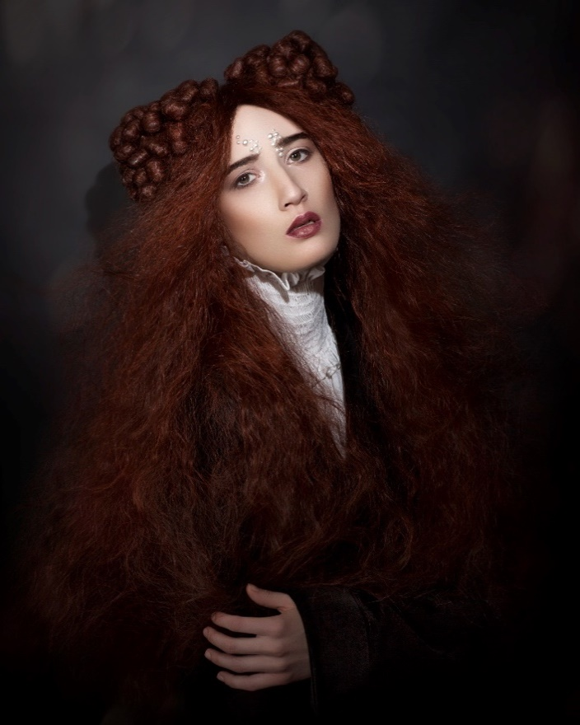

Modern Renaissance by Keith Bryce is inspired by the classic beauties of the Renaissance, its sophistication and attention to detail, providing a modern and fresh touch through interesting textures and shapes, worked with avant-garde techniques, without renouncing to the essence and refinement. of the time. He opted for a masculine side of Renaissance fashion to complement and contrast with the hair. Colour, between copper and gold, seeks to preserve the authenticity of the tones and shades, ensuring that they are daring, stimulating and striking but still keeping their naturalness.

This collection is reminiscent of the Renaissance aesthetics, but the textures and shapes are different. Using coppers and gold he wanted to represent rich and authentic colours that were stimulating and eye-catching yet authentic.

It is a tribute to the classic stylists under the avant-garde prism that inspires the current stylists through creative experimentation with textures, structures, shapes and volumes. A call to rethink classic hair techniques, the refinement of a polished work and impeccable detail, a collection to inspire —why not? — directors of period films.

