Spend Time With Fritz

The current Neumann contest offers the chance to spend time with Mr. Fritz!
Berlin, October 2023 – Neumann.Berlin has initiated an exciting social media campaign called "Spend Time With Fritz," inviting producers, sound engineers, and musicians to participate and showcase their creativity. Neumann is offering its renowned KU 100 reference microphone, also known as "Fritz," to support various binaural audio and music projects.

Do you know Fritz? Fritz is an artificial head microphone and one of Neumann's most valuable microphones. Recordings made with the KU 100 are incredibly realistic and precise, with a three-dimensional spatial imaging effect that can greatly enhance music and radio productions. With Fritz, anyone can create immersive recordings without any prior technical knowledge.

To be part of the "Spend Time With Fritz" competition, all you need is a creative idea and a project description. Send your entry to social@neumann.com with the subject line "Spend Time With Fritz," before Dec. 31, 2023.

A jury comprising Neumann's portfolio, marketing, and social media managers will select the most interesting projects every month. The winners will receive a KU 100 microphone free of charge for three weeks to implement in their project. The winners' projects will later be showcased in pictures and videos on Neumann's social media channels. This is an excellent opportunity for creatives to showcase their talent and receive recognition from a renowned brand like Neumann.

All further information, the exact terms and conditions and a trailer video for the campaign can be found here: https://en-de.neumann.com/newsroom/spend-time-with-fritz

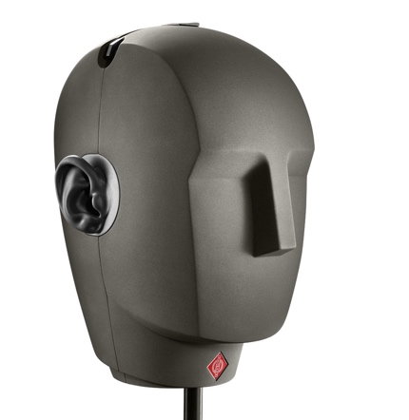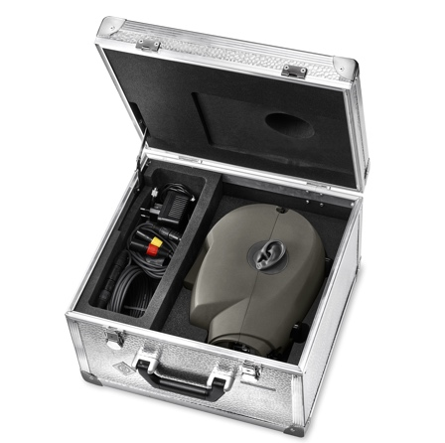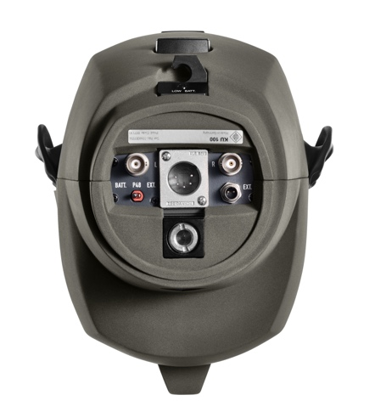

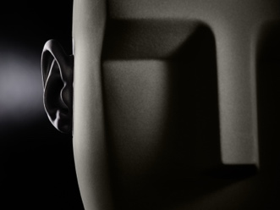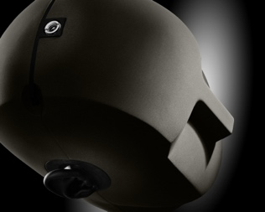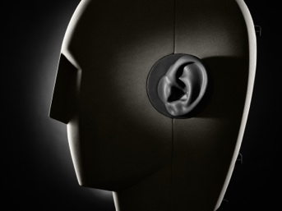
About Neumann
Georg Neumann GmbH, known as “Neumann.Berlin”, is one of the world’s leading manufacturers of studio-grade audio equipment and the creator of recording microphone legends such as the U 47, M 49, U 67, and U 87. Founded in 1928, the company has been recognized with numerous international awards for its technological innovations. Since 2010, Neumann.Berlin has expanded its expertise in electro-acoustic transducer design to also include the studio monitor market, mainly targeting TV and radio broadcasting, recording, and audio production. The first Neumann studio headphones were introduced in 2019, and since 2022, the company has increased its focus on reference solutions for live audio. With the introduction of the first audio interface MT 48, and its revolutionary converter technology, Neumann now offers all the necessary technologies needed to capture and deliver sound at the highest level. Georg Neumann GmbH has been part of the Sennheiser Group since 1991 and is represented worldwide by the Sennheiser network of subsidiaries and long-standing trading partners. www.neumann.com

Press Contacts Neumann:

Raphael Tschernuth
raphael.tschernuth@neumann.com
T +49 (030) 417724-67

Andreas Sablotny
andreas.sablotny@neumann.com
T +49 (030) 417724-19

