RYUTA TOMONO

Ryuta Tomono considers himself a contemporary hair artist, the fruit of a groundbreaking and advanced vision of hairdressing. He feels such true passion and pride in his profession that it has led him to focus on it as one more artistic discipline that is expressed through hairstyles, makeup and fashion.

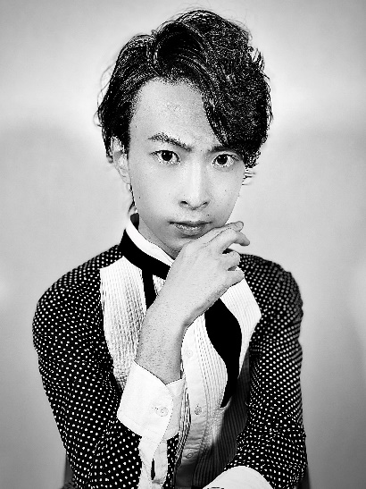
His life trajectory has led him to live in different parts of Japan, his native country. He was born in 1994 in Chiba Prefecture, although he discovered his vocation for the profession at 15 during a trip to Tokyo. There he first visited a top-notch hair salon in Harajuku, MINX, a favorite of young people in Japan and one of the brightest spaces he has ever known. The impact was such that he wanted to start fighting for the dream of being a hairdresser instantly. However, in addition to discovering his vocation, he felt that he not only wanted to be a hairdresser, he also wanted to be the best. During that momentous visit, one of the things that most caught his attention was the strong link between the most demanding hairdressing and the happiness that it made customers feel. From there he began to train as a hairdresser at Yamano Beauty College, one of the best universities in Asia, obtaining the best grades. When he finished his training in 2014, he had already worked at the prestigious MINX salon, the most important in Japan, in the Ginza neighborhood of Tokyo, the city where he currently resides and where since 2019 he has been an art director and hairdresser. It is in this same year that his project "Madness and Art. The last avant-garde" saw the light and since that moment he began to create works of art collaborating with make-up artists and photographers who share with him a very unique vision of hairdressing, giving rise to its international projection. Currently, he collaborates in a salon with the most talented hairdressers in Japan, with which he won an Alternative Hair International Visionary Award Cut & Color (2018), being considered at the moment one of the best beauty salons in all of Asia.
For the last two years he has been creating works of art, dreaming of getting artistic pieces that stand out from the rest. He has just passed the SABFA exam, where the academy organized by Shiseido is located, and the center where professional makeup artists from Asia become benchmarks in the sector.

RYUTA TOMONO

His totally groundbreaking vision of hairdressing has led him to create extraordinary designs that have received recognition from all corners of the planet. For Ryuta Tomono, positioning hair as an artistic material allows him to work with it without limitations, with greater freedom. In his words, as an artist "I strive to be the deep sea, without limits or end". This concept gives his work refreshing and warm nuances at the same time and allows him to explore hairdressing as a process of discovering wonderful images that are yet to be seen. Working with hair as a material presents technical difficulties determined by physical factors, such as gravity, which must be overcome in order to capture ideas and shape an image that is the fruit of imagination. However, overcoming all these obstacles is a magical process and the result is "more than surreal," says Ryuta Tomono.
For the hairdresser, art should not be just beauty, it should also be emotional, regardless of whether it suggests surprise or joy. The important thing is that it does not leave you indifferent and that it produces an inner reaction. In addition, for him art should not be a calm lake without waves, but the reflection of the source of life and sometimes an ocean that devours everything and turns it into algae. At the same time, it can contain all the beauty, but by taking a step forward it places himself in confrontation with the reality of the outside world, a reality that sometimes provokes rejection. For this reason, he invites us to imagine true beauty in those moments in which we want to connect with it, allowing us to feel the artistic pieces as rays of light.
Ultimately, his perception of hair and hairdressing as superior art creates a space of madness, one that emerges between sensitivity and creativity, fascinated by its delicacy and exceptional set of skills.
He is also part of IAVA (International Associations of Visual Artists) since 2020. He also works as a teacher since 2021 as a special professor at the Kyogoku Academy and from April 2021 to March 2022 at the Academy of Beauty, Fashion and Art Shiseido.
Regarding recognition, he has received:
- Winner of an Alternative Hair International Visionary Award in the Cut & Color category (2018)
- Finalist Hair of the Year Japan (2019)
- Finalist at the Bangstyle at the Supremes Awards (2020)
- Finalist Best Avant-garde at the TCT Awards (2020)
- Elected official member of the International Association of Visual Artists (2020)
- Finalist in the Avant-garde category in the Alternative International Visionary Award (2020)
- Finalist in the Best Hair Art Avant-garde and Hair Art categories at The International Beauty Industry Awards (2020)
- World presentation "New Visionaries" at the Alternative Hair Show (2021)
RYUTA TOMONO

He has also collaborated in fashion and makeup events such as:
- Shibuya Stream Hair Show (2019)
- Fashion Editorial for Anna Choi (2019)
- Fashion editorial for Maimi Sadai (2019)
- Fashion Editorial Yui Enomoto (2020)
- Fashion Editorial for Anna Choi (2020)
- Photography editorial for Gosia Dittmar (2020)
- Fashion editorial for Miki Ogu (2020)
- Fashion editorial for Mai Sudo (2020)
- Make-up editorial for Anne Pagis (2021)
- Makeup Editorial for Asuka Takei (2021)
- Makeup Editorial for Hirurgi (2021)
- Art Director for BLGV (2021)
- Editorial photography for Daiki Nakamura (2021)
- Hair and Makeup Director for the Mikage Shin catwalk at Milano Fashion Week (2021)
- Hair and Makeup Director for the KoH T catwalk at Milano Fashion Week (2021)

