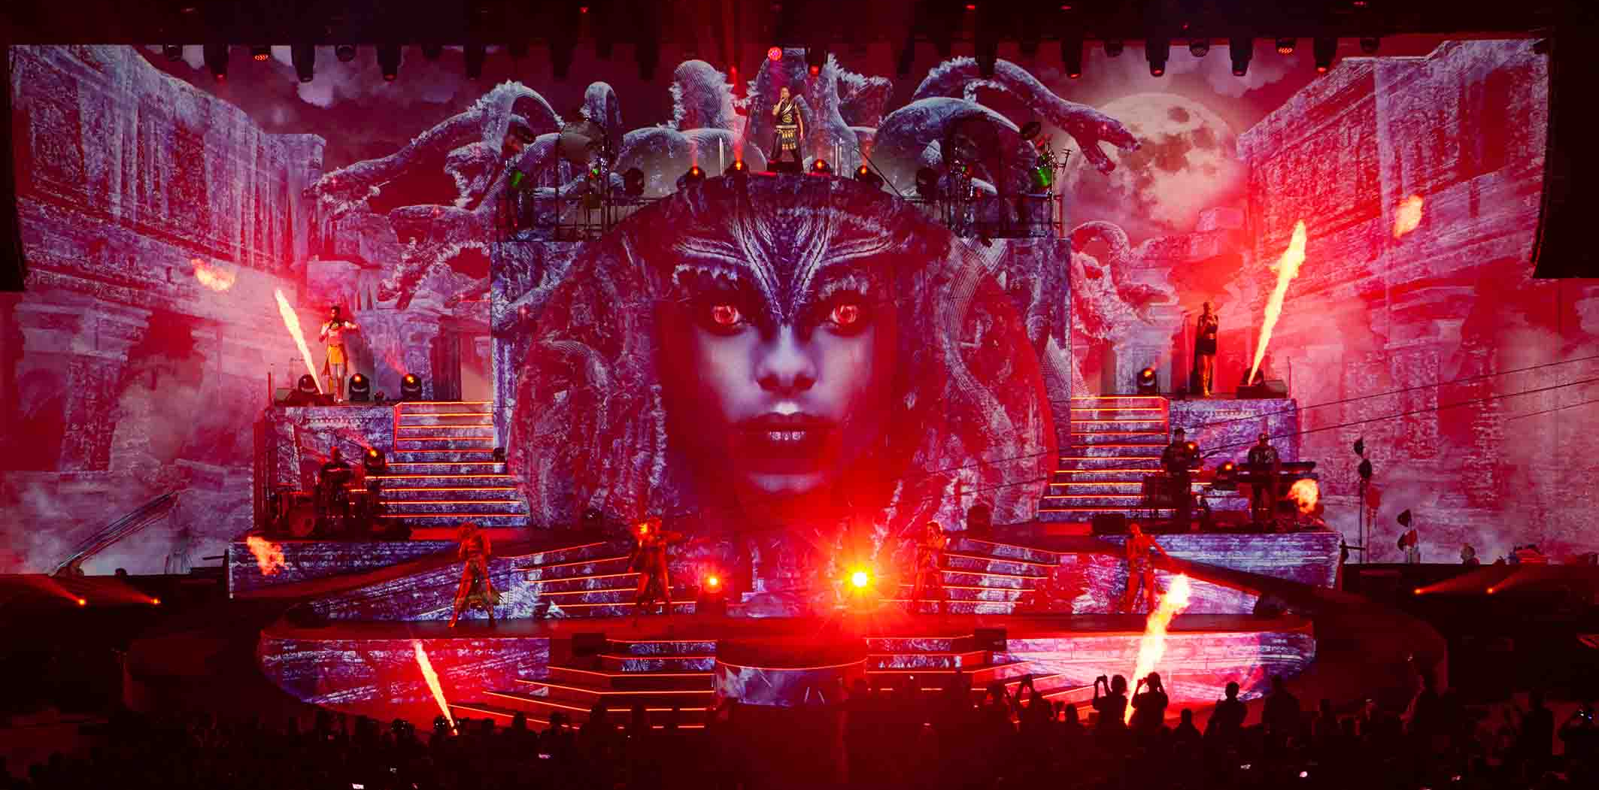
Photo credit: Yes Music / Bôregard Photos

DJ BoBo – 30 years on stage
Brilliant EVOLUT30N stage show with Sennheiser

Wedemark, 16 March 2023 – For three decades, DJ BoBo has been enriching the music landscape with his catchy pop songs and spectacular live shows. To celebrate thirty years on stage, the highly popular artist gave a series of guest performances at the Europa Park Arena in Rust, Germany, from 13 to 15 January 2023. In the Arena, the theme park’s biggest event venue, DJ BoBo and his crew staged four sell-out concerts under the moniker EVOLUT30N, with Sennheiser microphones an integral part of his audio system. The fans were ecstatic, especially because three stages made sure the star could get up close to his audience.

A gold-plated Sennheiser handheld transmitter has become DJ BoBo’s trademark  Photo credit: Yes Music / Bôregard Photos | 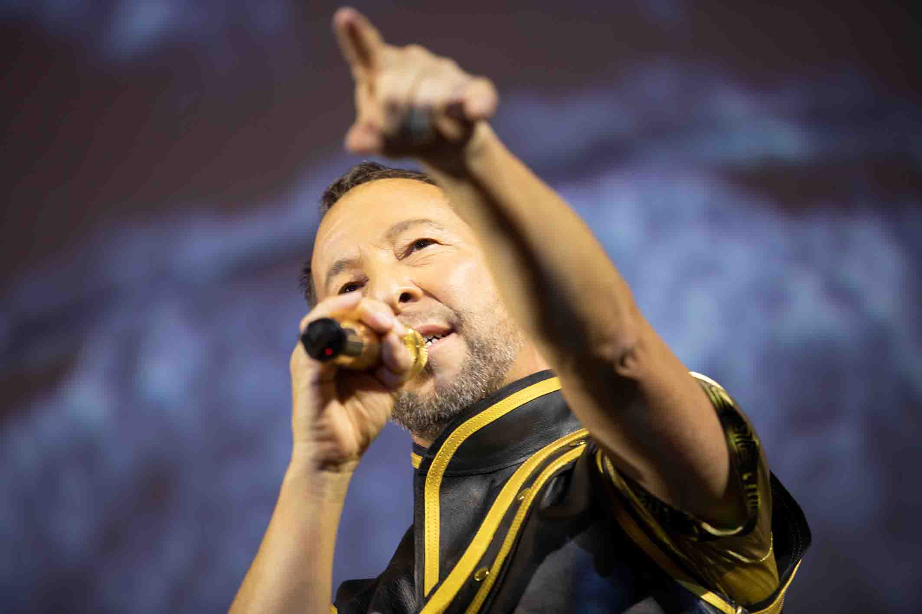

Handheld transmitters in a gold and diamond look
Wireless and wired Sennheiser microphones have played a key role in DJ BoBo’s live shows for many years. A Sennheiser SKM 2000 handheld transmitter is one of the trademarks of the “King of Dance”, and its gold-plated shaft and capsule basket make it a real eye-catcher. A similarly designed special model is also used by vocalist Nancy Baumann, while the voices of Kate Matl and Jesse Ritch are picked up by black handheld transmitters. As a special feature, these are embellished with hundreds of sparkling Swarovski crystals that effectively reflect the stage lights – a particular highlight in the TV camera images. The handhelds are all fitted with Sennheiser MMD 945 (super-cardioid) microphone capsules.

A total of six SKM 2000 handheld transmitters (four vocals, two spare) send their signals to three EM 2050 true diversity twin receivers. The receivers’ integrated active splitters make it possible to loop the RF signal, thus allowing systems with up to 16 channels to be conveniently operated without the need for external splitters. For DJ BoBo, the EM 2050s are connected to two Sennheiser AD 3700 broadband directional antennas with integrated AB 3700 antenna boosters. Wireless transmission takes place in the BW band between 626 and 698 MHz, which works perfectly even in heavily used RF environments thanks to frequency management that is tailored to local conditions with the support of Sennheiser’s WSM (Wireless Systems Manager) software. To ensure that DJ BoBo’s handheld transmitters operate absolutely reliably at all positions on all three stages without drop-outs, the transmission power is set at 50 mW. “The high-quality Sennheiser products with their perfect sound have enabled us to deliver flawless performances for many years,” says DJ BoBo, whose real name is René Peter Baumann.

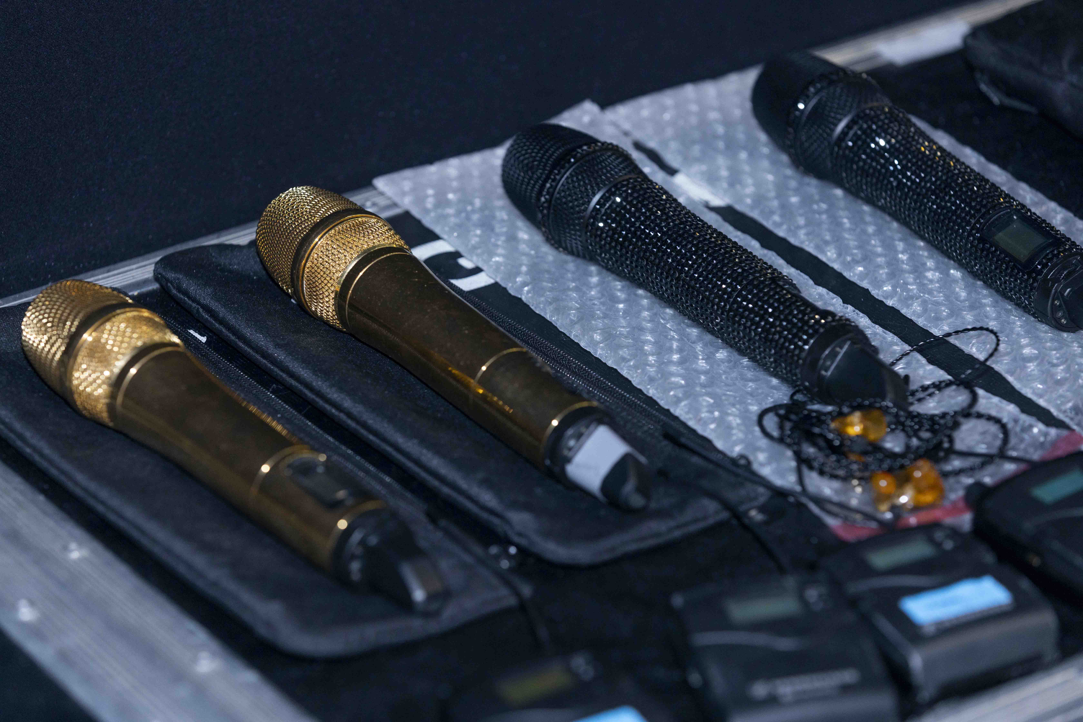 | Sennheiser handheld transmitters and in-ear monitors  Photo credit: Yes Music / Bôregard Photos

Wireless in-ear monitoring
For DJ BoBo’s live performances, the musicians and vocalists plus some members of the crew use in-ear monitors that receive their signals via compact Sennheiser EK 2000 bodypack receivers. Twelve in-ear channels operated in the AW band (516 to 558 MHz) are available for the EVOLUT30N concerts. The transmitters are Sennheiser SR 2050 IEM, assigned to two A 5000-CP circularly polarised antennas. Positioned on the stage near the keyboards, they are used with two Sennheiser AC 3200-II active antenna combiners, and provide complete coverage of the extraordinarily large performance area. An AC 3200-II enables up to eight transmitters to access a single shared antenna. The dancers are not equipped with in-ear systems due to their numerous costume changes, so conventional monitor wedges are also positioned on stage.

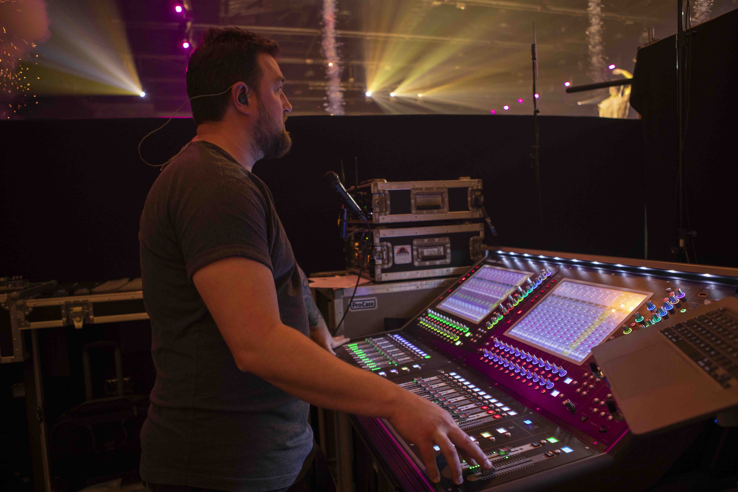 | Monitors were handled by Benjamin Mengler  Photo credit: Yes Music / Bôregard Photos

Wired microphones: EVOLUT30N with evolution
Under the musical direction of Thomas J. Gyger (keyboards), the accompaniment for DJ BoBo’s performances is provided by Andreas Sigrist (guitar) and Tom Beck (drums), as well as four musicians from the percussion ensemble greenbeats. The musicians performed live, with time code ensuring perfect timing. Around 60 channels are managed at the FOH console by Andre Mussong, and the monitoring console, manned by Benny Mengler.

Various microphones from Sennheiser’s evolution series are used for the drum kit – EVOLUT30N with evolution, so to speak. The bass drum has an e 901 condenser boundary microphone, while the piccolo snare is miked using a Sennheiser e 905. Sennheiser e 914 serve as overheads, with a further e 914 for the hi-hat. Four percussionists play a key role in making this dynamic show as attractive as possible for the audience, and for their solo part on the B stage, as sparks shoot into the air, their instruments are miked with Sennheiser e 604 fitted to practical clip-on mounts.

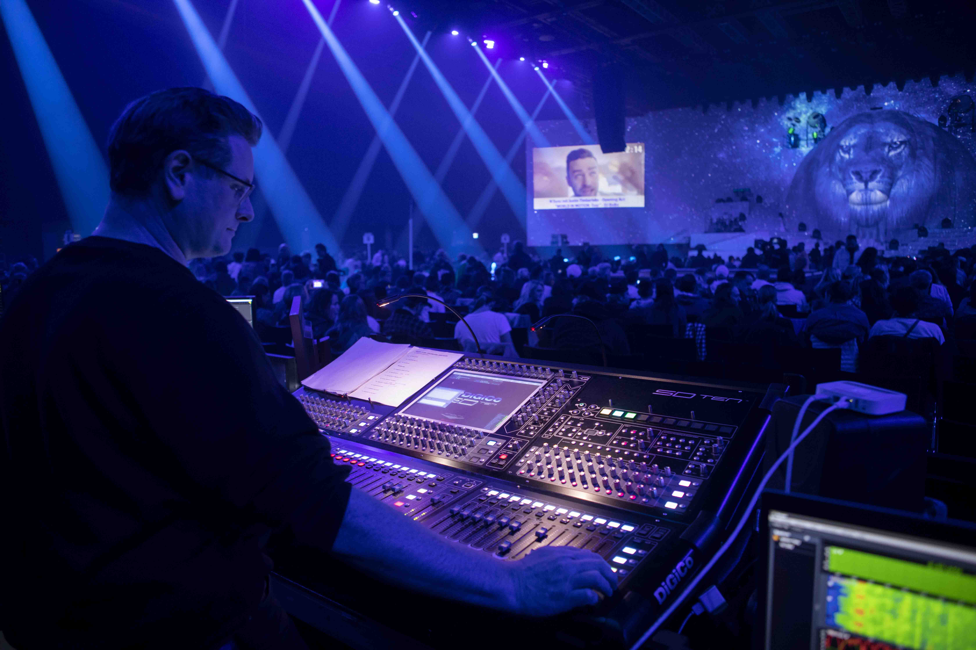 | FOH engineer Andre Mussong  Photo credit: Yes Music / Bôregard Photos

The electric guitars are reproduced in all their fine detail by an e 906, its flat design making it perfect for placement in front of the guitar amp. Ambience signals for the in-ear systems are supplied by two Sennheiser MKE 600 shotgun mics and two MKH 50-P48 radio-frequency condenser microphones.

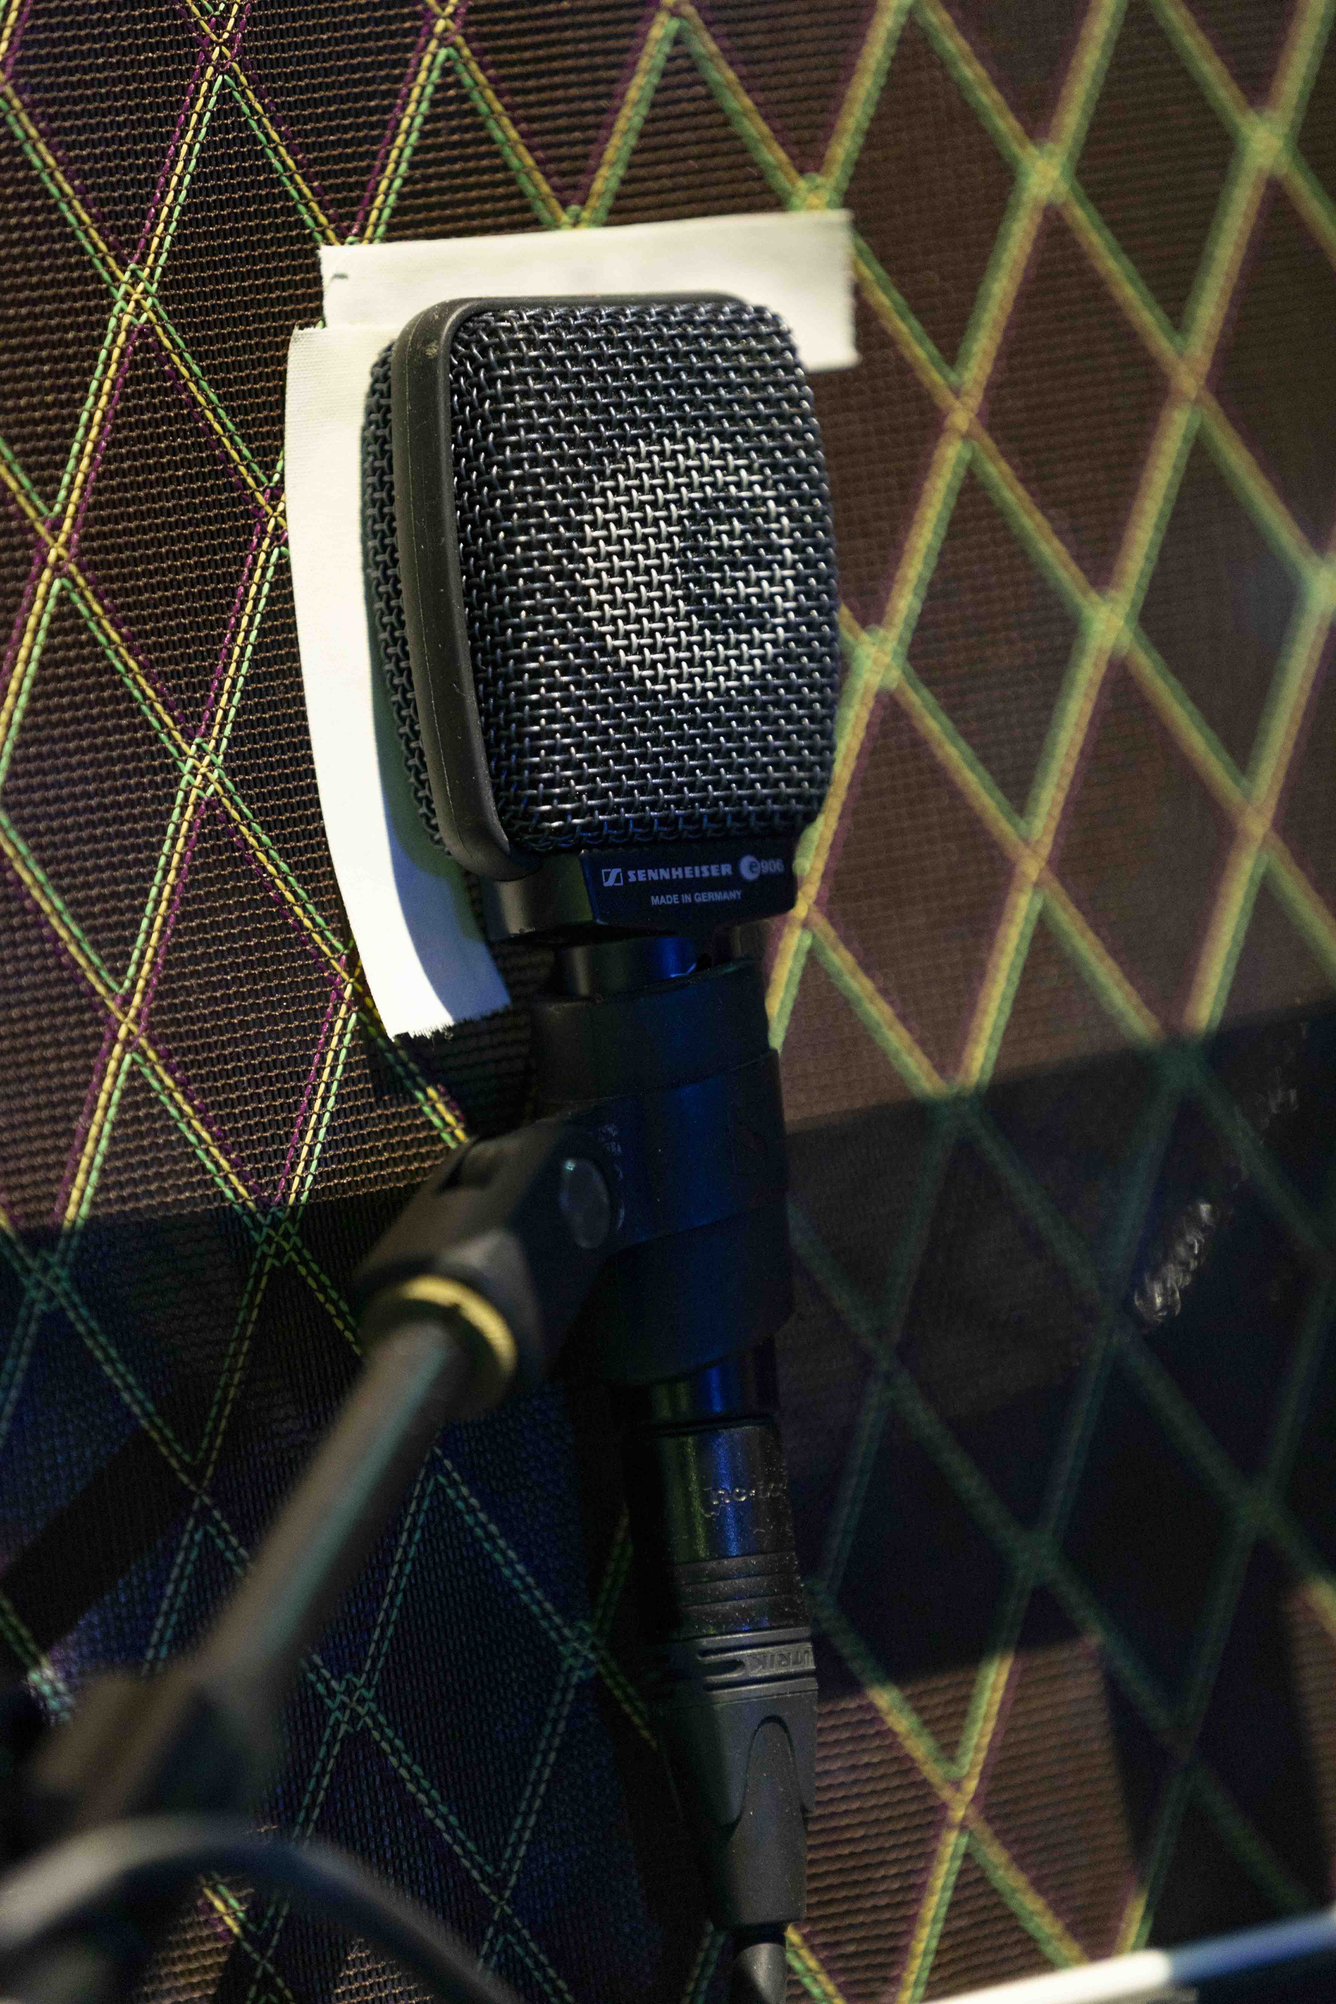 | 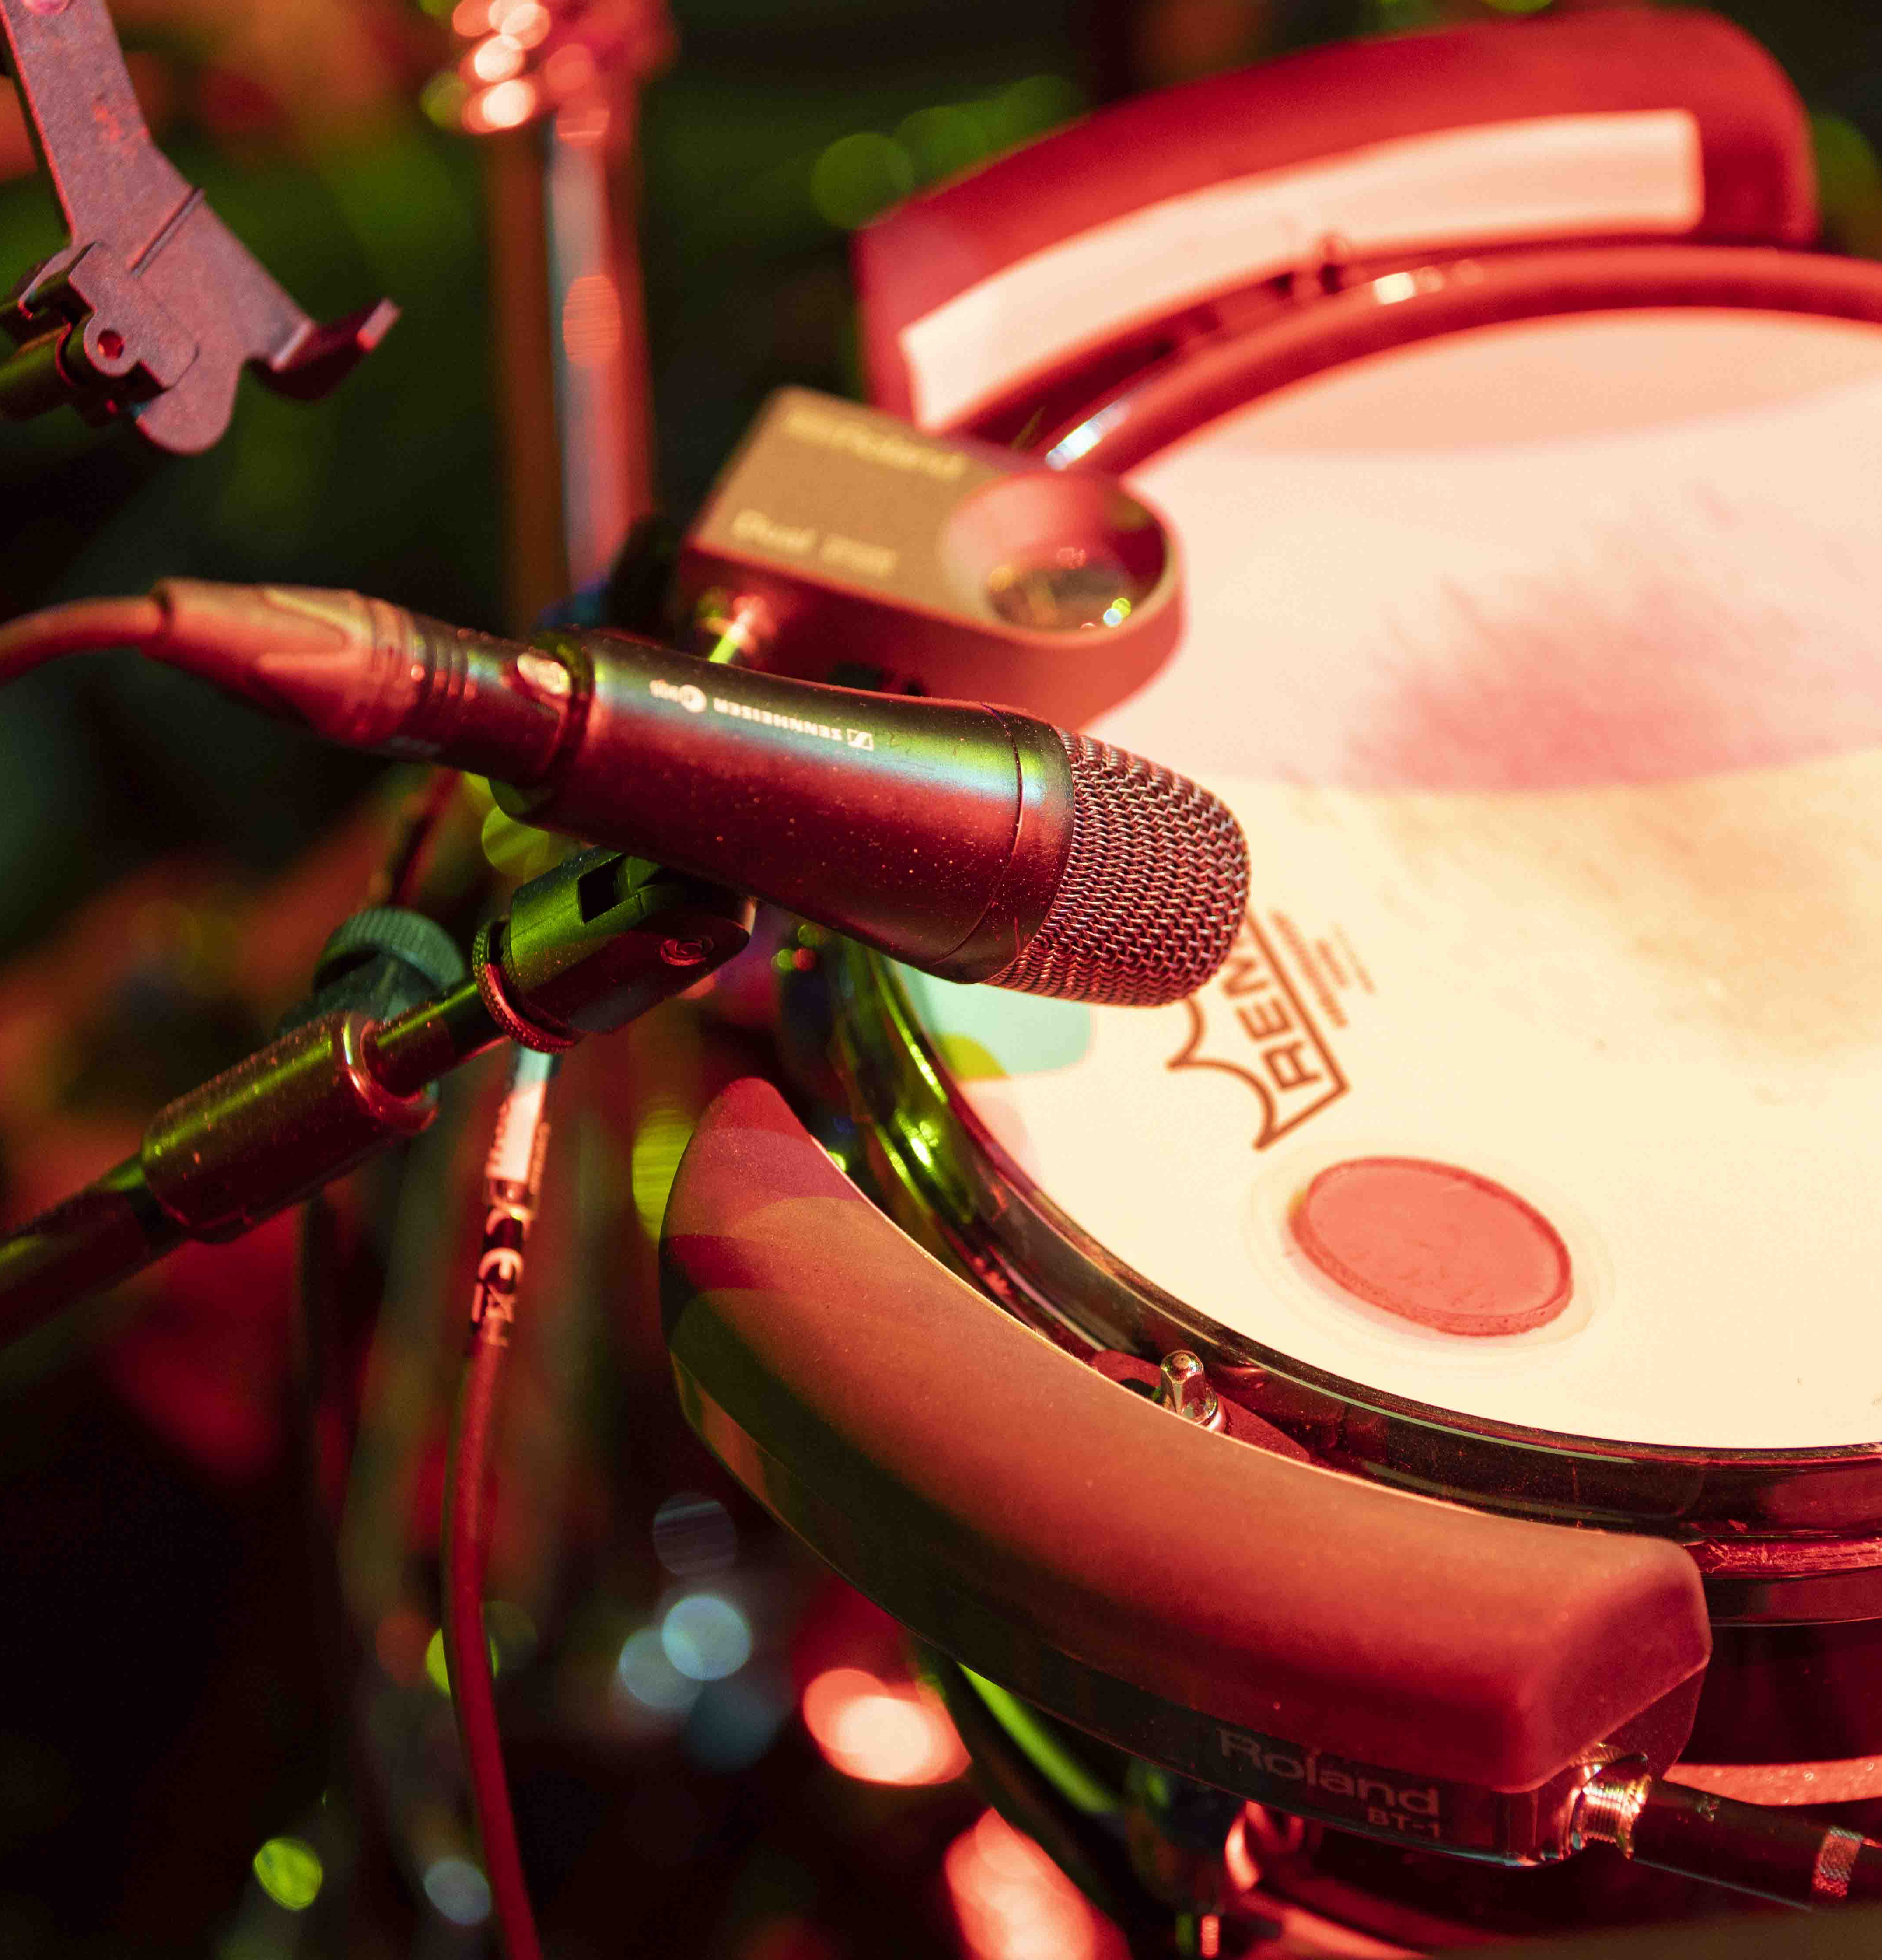 | 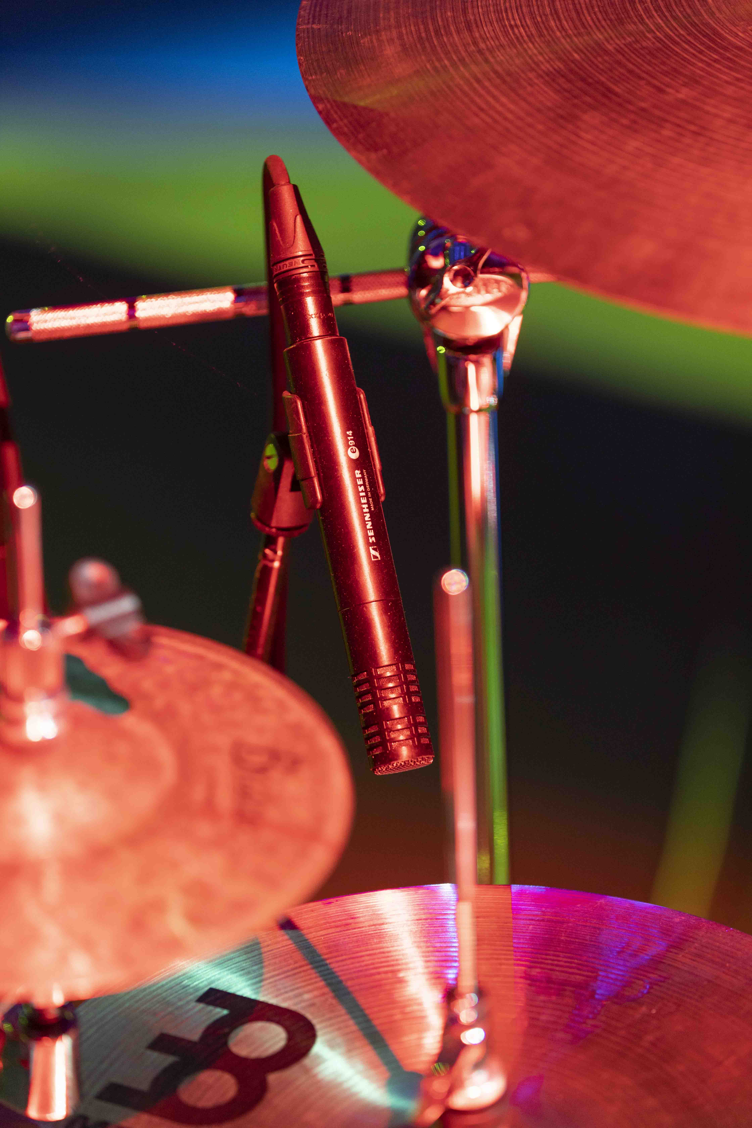
evolution microphones for the EVOLUT30N tour (Photo credit: © Yes Music / Bôregard Photos)

Eye candy with a wow factor
The EVOLUT30N show is fantastically colourful and lively – a top-class audiovisual entertainment spectacle with skilfully applied musical references, dramatic pyrotechnics and impressive choreography in front of a delighted audience that just wants to party. The main stage is dominated by a huge, eight-metre-high 3D lion’s head, which, like the rest of the stage, constantly changes its appearance with the aid of sophisticated video mapping to visualise various EVOLUT30N phases from the artist’s career spanning three decades. The staging of the show has been planned down to the finest detail, with numerous scene and costume changes. Supported by lighting technology that is perfectly matched to the projection, the stunning result is eye candy with a wow factor.

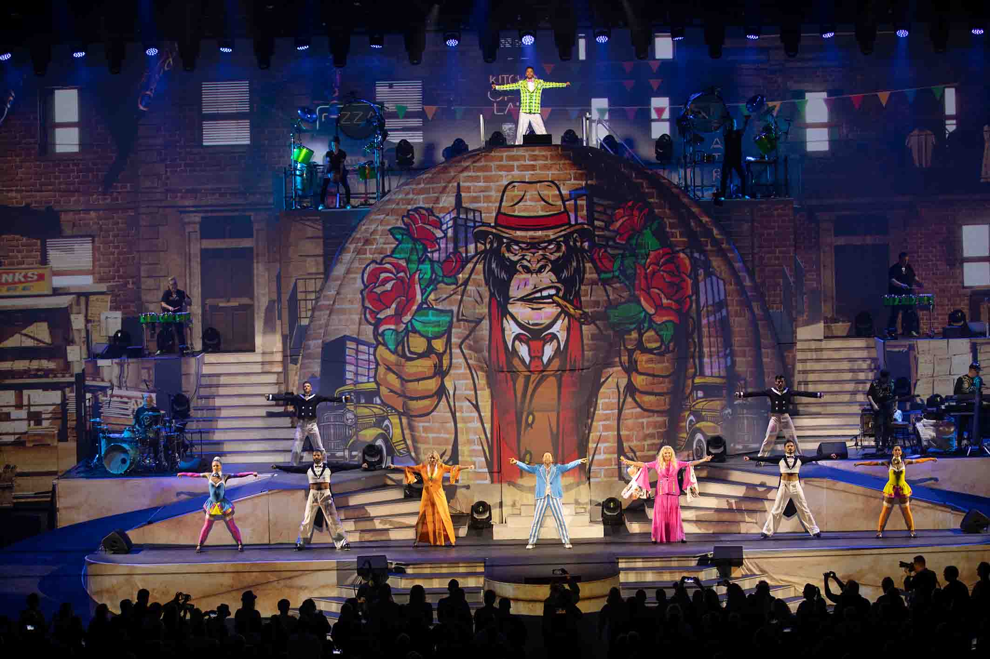 | The EVOLUT30N show is a top-class audiovisual entertainment spectacle  Photo credit: Yes Music / Bôregard Photos

But the show is not only a delight for the eyes but also for the ears, with a key role being played by the excellent sound provided by Sennheiser microphones. Such a spectacular performance across multiple stages would simply not be possible without tried-and-tested wireless technology. Chris Kopp, Trade Marketing Project Manager, comments: “I’m really pleased that DJ BoBo and his team have once again chosen Sennheiser for their extraordinary EVOLUT30N tour project, which is extremely demanding both artistically and logistically, and that solutions from our company are contributing to the success of DJ BoBo’s 30th anniversary.”

The EVOLUT30N show tours Europe in May and June 2023. Visit www.djbobo.com for more information.

(Ends)

The high-resolution images accompanying this media release and additional photos can be downloaded here.

About the Sennheiser brand
We live and breathe audio. We are driven by the passion to create audio solutions that make a difference. Building the future of audio and bringing remarkable sound experiences to our customers – this is what the Sennheiser brand has represented for more than 75 years. While professional audio solutions such as microphones, meeting solutions, streaming technologies and monitoring systems are part of the business of Sennheiser electronic GmbH & Co. KG, the business with consumer devices such as headphones, soundbars and speech-enhanced hearables is operated by Sonova Holding AG under the license of Sennheiser.

www.sennheiser.com
www.sennheiser-hearing.com

Global Pro Audio Press Contact
Stephanie Schmidt
stephanie.schmidt@sennheiser.com
+49 (5130) 600 – 1275

