MUSICAL INSTRUMENT BOOK PUBLISHER BJOOKS CONTINUES GROWTH TRAJECTORY WITH MULTI-REGIONAL MANAGEMENT APPOINTMENTS

Creator of titles ‘PUSH TURN MOVE,’ ‘PATCH & TWEAK,’ ‘PEDAL CRUSH’ and ‘SYNTH GEMS 1’ strengthens its regional and online presence with the hiring of artist relations and U.S. sales managers

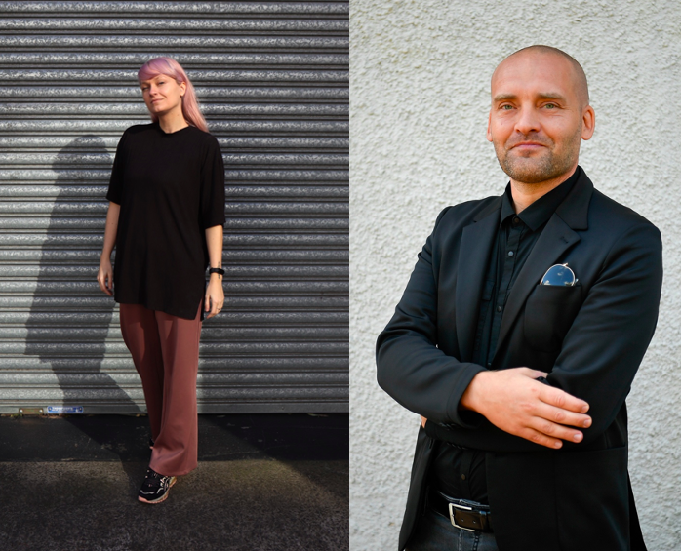

COPENHAGEN, DENMARK — BJOOKS, leading publisher of musical instrument book titles, including PUSH TURN MOVE, PATCH & TWEAK, PEDAL CRUSH, PATCH & TWEAK with Moog and SYNTH GEMS 1, has announced the appointment of Nadia Struiwigh as Artist Relations and Online Events Manager, and Daniel Troberg as U.S. Sales Manager. The newly created positions are a result of Bjooks expansion of new titles and continued international growth.

“We are excited to welcome Nadia and Daniel to the Bjooks family,” said Kim Bjørn, founder and creative director of Bjooks. “While our publishing operation continues to expand internationally, the essence of everything we do hasn't really changed — we maintain the same passion for content, design and craftsmanship in all of our books. We have many exciting projects on the horizon in addition to our most recently published title, SYNTH GEMS 1, which we are very proud of."

Nadia Struiwigh – Artist Relations & Online Events Manager
A native of the Netherlands and a well-known face in the electronic music scene, Struiwigh currently resides in Sydney. In addition to composing ambient and experiment music, performing live and reviewing music software and hardware on YouTube, she is also an experienced marketing manager and graphic designer. In her new role at Bjooks, Struiwigh will be responsible for increasing the company’s international artist relations efforts as well as strengthening its online presence.

“I’m very excited to be working with Bjooks as this role fuses my passion and my talent — music and marketing,” Struiwigh said. “To go from reviewing one of the Bjooks titles to now working alongside Kim and the rest of team is extremely exciting. Seeing the potential of Bjooks and getting to be a part of the growth of the company is truly a dream come true. It makes my nerdy personality really happy.”

Daniel Troberg – U.S. Sales Manager
Daniel Troberg joins the Bjooks family as the new sales manager for the U.S. and Canada. In this role, Troberg will expand Bjooks’ presence in the U.S. and Canada as well as Japan. Troberg started his career at Elektron and is today heavily involved in Ashun Sound Machines as well as Japanese distributor EDG.

“It will be a true pleasure to represent Bjooks in the U.S. and Canada,” Troberg said. “All the titles are true pieces of art, and making them available to a larger network of dealers and specialized outlets will be my goal for these markets.”

With a mission to create informative and beautiful coffee table-style books about music technology, artists and instrument makers, Bjooks has released five titles since its inception in 2017, including its hit-seller and flagship title ‘PUSH TURN MOVE.’ Released last month, its latest title, ‘SYNTH GEMS 1,’ takes readers on a chronological journey through a unique selection of over 60 synthesizers. Ideal for both newcomers to synthesis as well as experienced electronic musicians, ‘SYNTH GEMS 1’ spans the critical historical period from 1970 to 2000 with stunning photography and detailed articles that explain the history, technology, and legacy of each instrument.

Bjooks is an environmentally responsible publisher, with all of its books printed on high-quality, environmentally friendly paper from responsible sources.

For more information on any of the books in the Bjooks portfolio, or to purchase any of the books, please visit http://www.bjooks.com.

-----------

About Bjooks:
Bjooks is the boutique publishing company started and run by author, designer and musician Kim Bjørn. His first book, PUSH TURN MOVE, was published in 2017. This was followed by PATCH & TWEAK in 2018, which has since been referred to as the 'Bible of Modular Synthesis’; PEDAL CRUSH - Stompbox Effects for Creative Music Making in 2019; PATCH & TWEAK with Moog in 2020; and SYNTH GEMS I in 2021. The mission of Bjooks is to create exciting titles about music technology, artists and makers, in order to document, inspire and explore the world of music creation.

Press Contacts:
Katie Kailus
Hummingbird Media
katie@hummingbirdmedia.com
www.hummingbirdmedia.com

Jeff Touzeau
Hummingbird Media
jeff@hummingbirdmedia.com
www.hummingbirdmedia.com

