RME Unveils Flexible ADI-2 Pro FS AD/DA Converter at AES New York 2018
The versatile reference-class converter features a host of devices in one, including a high-quality double headphone amplifier for audio engineers and home recordists alike

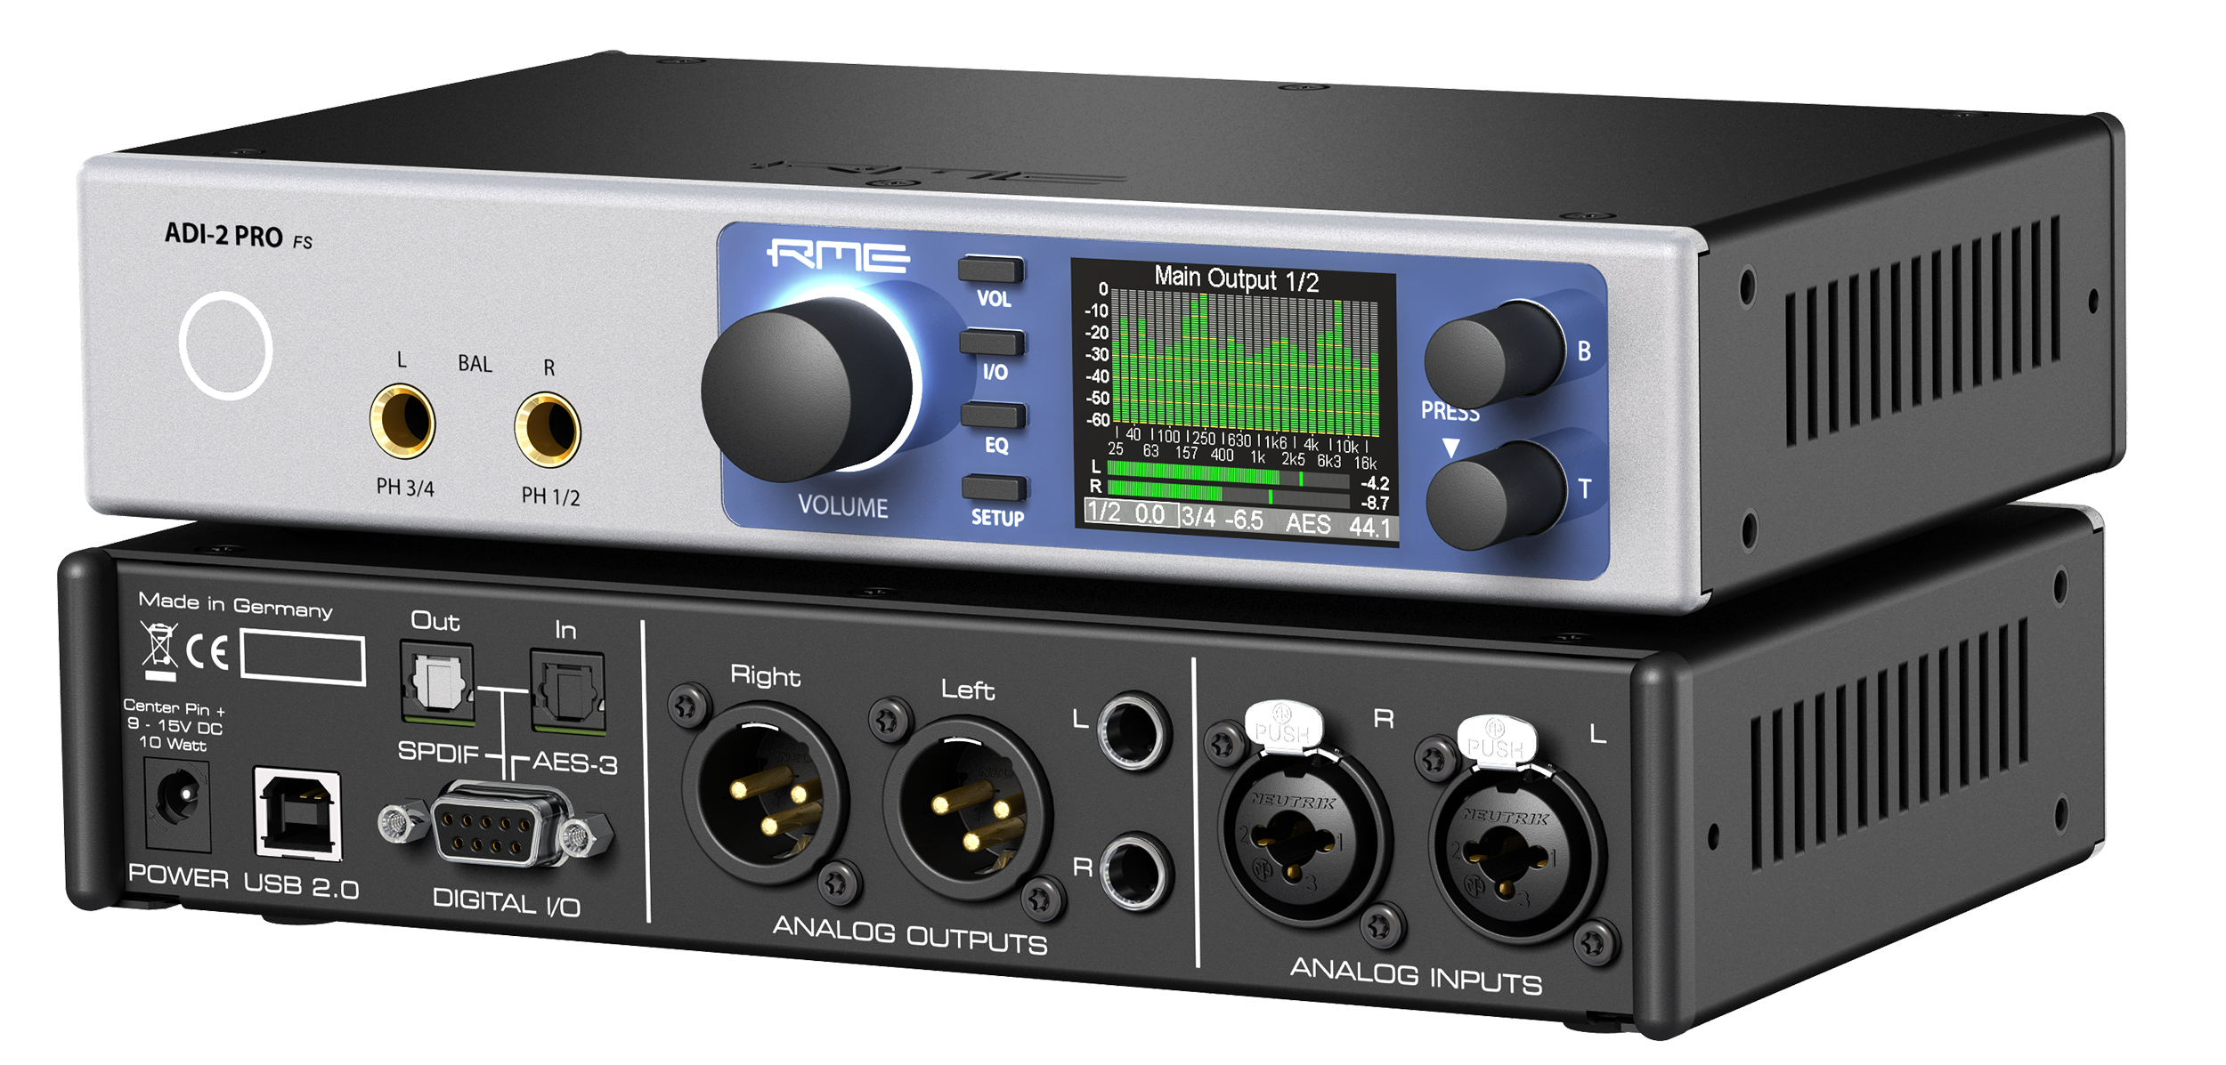
New York, NY – October 16, 2018 – RME Audio, [AES New York 2018 Booth 414], German manufacturer of digital audio solutions for the professional and HiFi sector, has announced that it will showcase its new ADI-2 Pro FS converter during AES New York 2018. The ADI-2 Pro FS is a versatile 2-in/4-out professional studio-quality AD/DA converter that can be used as a USB audio interface, a double headphone amplifier, a high-end AD/DA frontend and headphone amp for iOS devices, a multi-format converter (AES, SPDIF, ADAT) with monitoring function, a DSD record and playback solution, and an AD/DA frontend for audio measurement up to 768 kHZ sample rate.
“The ADI-2 Pro FS is the most flexible converter available on the market,” said Derek Badala, Director of Sales for the Americas for Synthax, RME’s US distributor. “Audio engineers and audiophiles alike will find its pristine audio quality ideal for a wide range of applications for those recording in studios, at home or on the go for mobile applications.”
Endless Options
The ADI-2 Pro FS features 6 input sources and 8 output paths for simultaneous 2-channel AD input conversion and 4-channel DA output conversion. The unit also includes two servo-balanced analog inputs on combo XLR/TRS jack making connecting studio equipment quick and easy. The ADI-2 Pro FS also features two separate balanced and unbalanced outputs on XLR and TS and two stereo Extreme Power headphone outputs on the font, along with an optical SPDIF I/O that also understands ADAT and coaxial SPDIF and AES I/O via the included breakout cable.
The two stereo Extreme Power headphone outputs boast high-end monitoring options optimized for low-and high-impedance headphones. The exclusive Advanced Balanced mode delivers a balanced signal from the DAC straight to the phone with 3 dB gain in Signal to Noise Ratio, smoothed out deviations in components, optimized frequency response, super low output impedance and a maximum output level of +28 dBu.
Boasting a high-resolution LCD display for easy monitoring, the ADI-2 Pro FS also features an AutoDark mode so users can deactivate illuminated elements when needed.
RME’s Ultra-reliable SteadyClock FS Technology
The ADI-2 Pro FS features the ultra-stable SteadyClock FS (FemtoSecond) technology ensuring even lower jitter. With SteadyClock FS, the self jitter of SteadyClock is reduced to even new lows by improving its second, analog PLL circuit and referencing both Direct Digital Synthesis and PLL to a low phase noise quartz crystal. The self jitter measured through DA conversion now reaches levels usually only found in master quartz clock mode, while SteadyClock still always runs in PLL mode — ensuring internal and external clocks sound exactly the same.
The ADI-2 Pro FS is available for $1,999 MAP. For more, visit Synthax at booth 414 during AES New York 2018 or visit rme-audio.de.

About Synthax, Incorporated
Synthax Inc. is the exclusive USA distributor for RME digital audio solutions, Ferrofish advanced audio applications, myMix audio products, and ALVA cableware. We supply a nationwide network of dealers with these products for professional audio, broadcast, music industry, commercial audio, theater, military and government applications. For additional information, visit the company online at http://www.synthax.com.

Media Contacts:
Katie Kailus
Public Relations
Hummingbird Media
+1 (630) 319-5226
katie@hummingbirdmedia.com

Jeff Touzeau
Public Relations
Hummingbird Media
+1 (914) 602 2913
jeff@hummingbirdmedia.com

