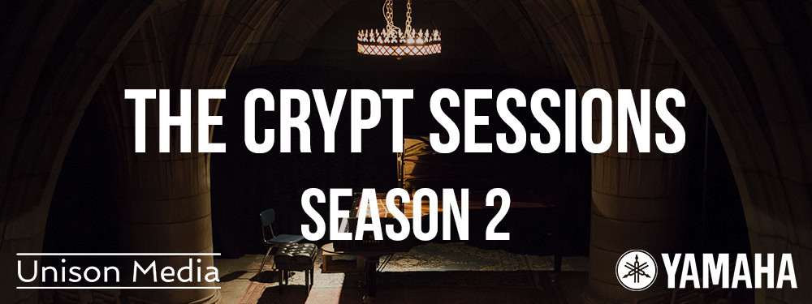

Unison Media presents
The Crypt Sessions Season 2

The second season begins February 1, 2017 with pianist Lara Downes' musical memoir of Harlem, featuring a world premiere by composer/violinist Daniel Bernard Roumain and a spoken word tribute to Langston Hughes by poet Joshua Bennett in honor of the poet's 114th birthday.
Each new Crypt Sessions performance - announced directly following the preceding concert - will feature a tasting of
food and wine specially paired to the music
All proceeds go to the Church of the Intercession.
Season 2 is once again generously sponsored by Yamaha.

Thursday, January 5, 2017 — Unison Media is excited to announce Season 2 of its acclaimed concert series The Crypt Sessions, featuring intimate classical music and opera performances in the remarkable Crypt chapel underneath the Church of the Intercession in Harlem. The season will begin February 1, 2017 with pianist Lara Downes performing a program remembering her father and his Harlem childhood, while also paying tribute to the many artists who made Harlem their home and inspiration. Taking place on both the first day of Black History Month as well as the birthday of Harlem Rennaisance poet Langston Hughes, the concert will feature a world premiere by composer/violinist Daniel Bernard Roumain, music from Downes' new album America Again by Duke Ellington, Billie Holiday, Florence Price, Nina Simone, William Grant Still, and a spoken word tribute to Hughes by poet and NEA Fellow Joshua Bennett.
Due to rapid sell-outs and long waiting lists, each new concert will be announced immediately after the one preceding it, first to the mailing list, then via The Crypt Sessions website (http://deathofclassical.com/) and Facebook page.
Each Crypt Session will feature a pre-concert reception included in the ticket price, where Magnvm Opvs will host a tasting of wines specially chosen to suit the music of that evening's concert, and Ward 8 Events will provide hors d'oeuvrses similarly tailored to the wine and the performance.
All proceeds from ticket sales of The Crypt Sessions are donated to the Church of the Intercession, where the crypt is located. Unison Media gave over $10,000 to the church over the course of Season 1.
The Crypt Sessions will once again be made possible by the extraordinarily generous sponsorship of Yamaha, who provide their wonderful pianos for the performances.

Listing Info
The Crypt Sessions Presents: Lara Downes - A Memoir of Halrem
featuring a world premiere by Daniel Bernard Roumain, composer/violinist
and a spoken word tribute to Langston Hughes by poet Joshua Bennett
February 1, 2017 | Wine Tasting 7PM | Show 8PM
Tickets: $50, including Wine Tasting & hors d'oeuvres (Direct Link)

About The Crypt Sessions
The Crypt Sessions (http://deathofclassical.com/) is a concert series presented and produced by Unison Media (http://www.unison.media/) and curated by Andrew Ousley, located in the crypt chapel underneath the Church of the Intercession in Harlem. The series features intimate performances by some of the world’s top classical music and opera stars, with programs tailored to the crypt’s extraordinary atmosphere and remarkable acoustic.
Season One of the Crypt Sessions was featured in NPR, New York 1, The New York Times, The Wall Street Journal (twice), The Philadelphia Inquirer, The New Yorker, The New York Observer, WQXR (twice), The Christian Science Monitor, Parterre Box, SuperConductor, Berkshire Fine Arts, Voce di Meche, Agence France-Presse and many more.
Season Two, which will begin in January, will incorporate a pre-concert tasting of wines tailored specifically to the music by Magnvm Opvs and themed food prepared by up-and-coming New York City chefs. The first concert will be announced in December, and each subsequent concert will be announced immediately after the preceding one. Every Season One concert sold out, with waiting lists of more than 100 people.
All proceeds from ticket sales of The Crypt Sessions are donated to the Church of the Intercession, where the crypt is located. Unison Media gave over $10,000 to the church over the course of Season 1.
The Crypt Sessions is made possible by the extraordinarily generous sponsorship of Yamaha, who provide their wonderful pianos for the performances.

About Unison Media
Unison Media is a publicity, marketing, digital media and production company committed to exploring new ways to present and promote classical music and the people who make it. We take an open-minded, entrepreneurial approach, recognizing that our world has changed, and that branding, publicity, social media or marketing done in a vaccuum no longer have the same impact they once did. Our mission is to combine these disparate elements into a cohesive, coordinated whole, taking the wonderful music our clients make and getting it out into the world in the most impactful way possible.

About Lara Downes
Lara Downes’ whole life has been a blending of traditions, styles, cultures, races and genres. Not satisfied with being one of the preeminent pianists of her generation, Lara courageously dons and then sheds labels like “classical” or “eclectic" as freely as she engages audiences of all ages with her charismatic presence, intellectual curiosity, and masterful command of her artistic voice. She wants to create experiences that bring 19th and 20th century traditions firmly into the present for 21st century audiences. She is a trailblazer onstage and off. She is also a writer, a broadcaster, a mentor and a role model who understands that music is a dialogue between artist and audience, as everyday life is a balance between speaking and listening, giving and receiving.
Not surprisingly, Lara is comfortable in a diverse range of venues from Carnegie Hall, the Kennedy Center, Le Poisson Rouge (NYC) and Yoshi's (SF), to the club down the street. Her personal journey from student (trained by Hans Graf and Rudolph Buchbinder) to artist has followed a roadmap that seeks inspiration in unexpected places, drawing on the legacies of family, history, art and culture to form an artistic vision that in turn inspires her audiences with a unique style that the Huffington Post has called "addicting - Downes plays with an open, honest heart."
Born in San Francisco and raised in Europe, Downes' interest in connecting music to a wide and inclusive breadth of human experience mines her own mixed African American and Eastern European background and her peripatetic upbringing. As she has shed the stricture of genre in her view of music, the musical press has embraced her distinctive artistry: her playing has been called “ravishing” by Fanfare magazine, "luscious, moody and dreamy" by the The New York Times and her recent chart-topping release, A Billie Holiday Songbook, has been embraced by both jazz and classical critics and listeners, called “possibly the most intriguing Holiday tribute” of this centenary year by Jazz Weekly.
Her newest release, America Again (Sono Luminus, 2016) is in many ways the coming-of-age memoir of an artist who has found her own way and carved her own path through American music. Lara takes inspiration from the musicians that inspire her – from Leonard Bernstein to Nina Simone – to express the diversity of American history and American dreams. In her own words: “I’ve traveled all around this country and played for audiences in small towns and big cities. I’ve learned that my music is a bridge to unexpected friendships with people who come from very different versions of America than my own. There is no such thing as a typical American life, and there are millions of American stories. American music has a complicated history, full of contrasts and contradictions, just like my own, and I’ve learned that what is most beautiful about me comes down to my contradictions and contrasts.”
Lara’s music is available on over 200 digital platforms throughout the world and her performances on YouTube have attracted a cult-like following. A laureate of the 2016 Sphinx Medal of Excellence award, Lara has been recognized as a leader in expanding the reach of the arts, as a performer, an entrepreneur, and a cultural visionary. When not on the road recording or performing, Lara serves as Artist in Residence at the Mondavi Center for the Performing Arts, UC Davis where she mentors the next generation of young musicians as Director of the Mondavi Center National Young Artists Program. She is a Steinway Artist.

