Embargoed until 17 November, 15:00 CET

Sennheiser Expands Its Digital Wireless Microphone Family with the Availability of EW-DX
First components of the next evolution of wireless microphones for corporate and education environments ship this week

Wedemark, November 17, 2022 – Sennheiser, the first choice for advanced audio technology that makes collaboration and learning easier, today announced the availability of the next system from the Evolution Wireless Digital family of radio microphones. Named EW-DX, the new microphone systems simplify professional workflows by utilizing refined technologies to deliver a digital UHF system that can be scaled with ease.

“As the technological successor to our evolution wireless G4, EW-DX is designed for the most demanding business and professional applications,” says Michael Altemark, product manager at Sennheiser. “Our latest digital wireless system solution is scalable, reliable and easy to install. EW-DX has an advance feature set that allows it to easily scale from the smallest meeting space or classroom to the largest business and educational installations.”

Available This Week
This week, the first flight of products started shipping from Sennheiser’s main warehouses in the United States, Europe and the Asia Pacific region. The following components are available as part of these shipments:
• EW-DX EM 2, two-channel digital half-rack (9,5”) receiver
• EW-DX SK bodypack transmitter with 3.5 mm connector and with 3-pin connector
• EW-DX SKM handheld transmitter
• EW-DX SKM-S handheld transmitter with programmable mute switch
• EW-D power distribution cable

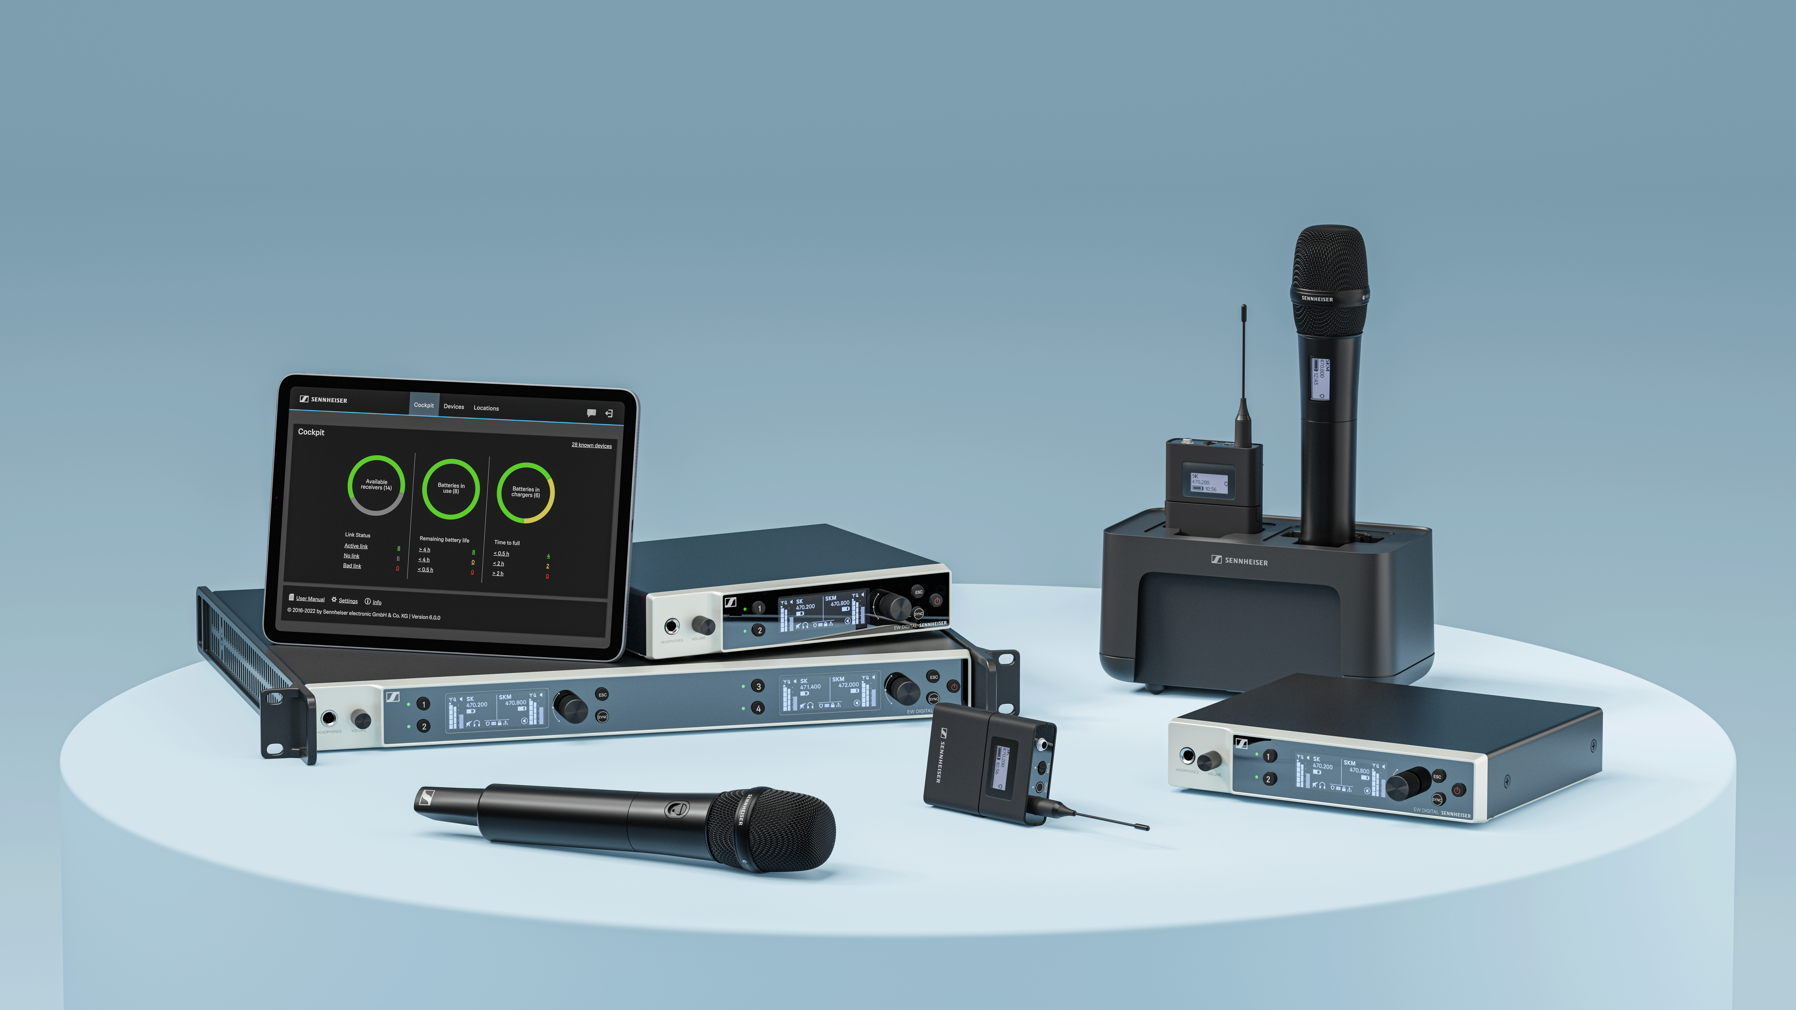
As the technological successor to evolution wireless G4, EW-DX is designed for the most demanding business and professional applications

Frequency Variants Available This Week
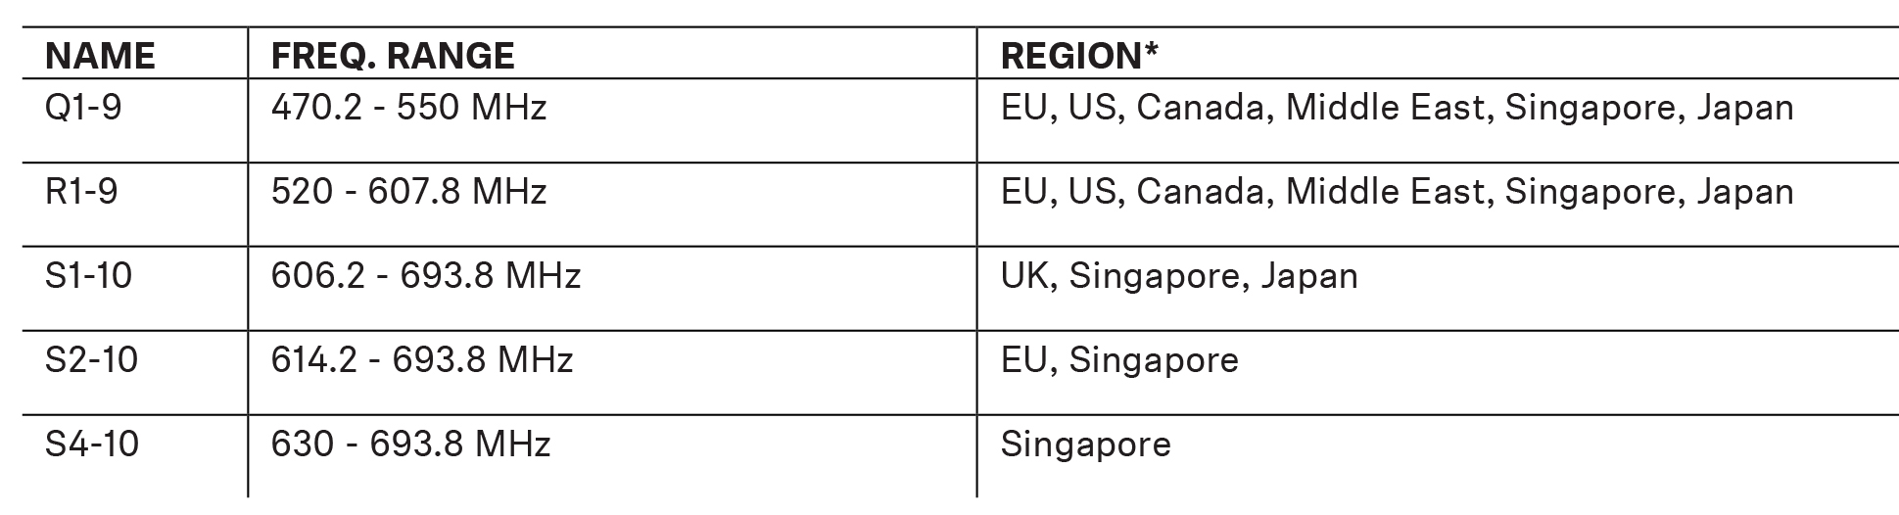
*Please reach out to a member of the Sennheiser sales team for information concerning the frequencies available in your specific region.

Complete Control and Active Monitoring
To coincide with the availability of EW-DX, Sennheiser also released an updated version of the Sennheiser Control Cockpit software this week. With Version 6.0.0, Sennheiser Control Cockpit is now fully compatible with EW-DX, enabling monitoring, control and firmware updates for EW-DX devices. For conformity, consistency and compatibility reasons, it is strongly recommended that the system be updated to the new release of Sennheiser Control Cockpit upon receiving the EW-DX. This will ensure stable firmware upon first use.

The easy-to-use Sennheiser Control Cockpit continuously provides a global overview of all network-enabled devices. It shows all status information at a glance and makes setting adjustments for one or multiple devices at the same time very easy. For more information about Sennheiser Control Cockpit, additional details about the new features and to download the new version, visit https://en-us.sennheiser.com/control-cockpit-software. Please refer to this How-To Guide to follow the steps for downloading Sennheiser Control Cockpit and updating EW-DX firmware.

Peace of mind instead of frequency calculations: EW-DX does not generate any significant intermodulation products and therefore allows transmission frequencies to be simply placed with equidistant spacing

Transmitters and Power Supply
The handheld and bodypack transmitters will be the first on the market to feature e-ink displays. Even when a transmitter is switched off, users will still be able to read essential device data. Both transmitter types will be fitted with in-device charging contacts. Using the dedicated BA 70 rechargeable battery pack, which can be charged using the L 70 USB charger (both BA 70 and L 70 USB are sold separately), the transmitters will have an operating time of about 12 hours.

In early 2023, Sennheiser will add to the Evolution Digital Wireless family charging options with the availability of the network-enabled charger, the CHG 70N, which features two individual charging bays for the EW-DX, one of which can charge EW-DX SKM, EW-DX SK or BA 70.
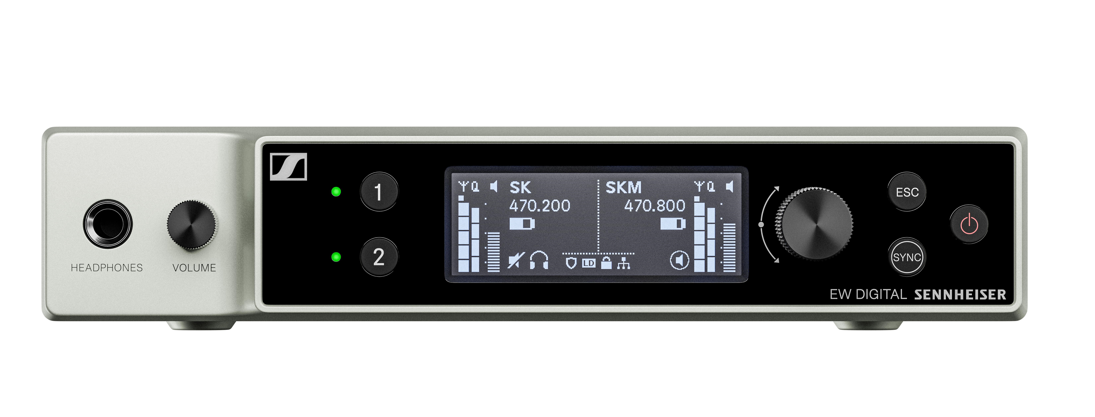 |  | 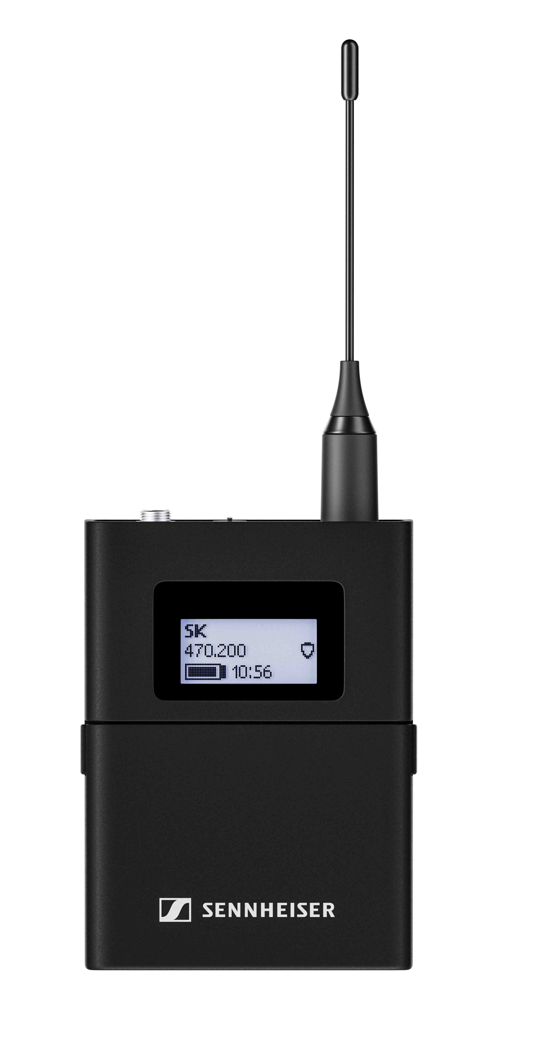
The first EW-DX devices are shipping now

The EW-DX Key Features
Advanced level of Sennheiser Control Cockpit (SCC) integration allows for remote, network-enabled management in installations of all sizes via SCC and 3rd party applications
Network-enabled charging options for handheld and bodypack transmitters with CHG 70N
Secure transmission of confidential content using AES-256 encryption
Worldwide usage (specific frequencies subject to local RF regulations)
Up to 12 hours of battery time
Transmitters with function buttons for convenient on-device control
Transmitters with e-ink display for easy user identification
Automatic RF setup enables easy in-room configuration

An Expanding Family - Shipping from mid-2023
EW-DX EM 2 Dante two-channel receiver, half rack
EW-DX EM 4 Dante four-channel receiver, full rack
EW-DX TS 3-pin table stand transmitter
EW-DX TS 5-pin table stand transmitter with light ring functionality
LM 6070 charging module for the L 6000 rack-mount charger
AWM wall-mount antennas:
AWM UHF (470 – 694 MHz)
AWM UHF (823 – 1075 MHz)
AWM 1G8 (1785 – 1805 MHz)

For more information on these new members of the Evolution Wireless Digital family visit www.sennheiser.com/ew-dx-business

(Ends)

The images accompanying this press release plus additional photos can be downloaded here.

About the Sennheiser brand
We live and breathe audio. We are driven by the passion to create audio solutions that make a difference. Building the future of audio and bringing remarkable sound experiences to our customers – this is what the Sennheiser brand has represented for more than 75 years. While professional audio solutions such as microphones, meeting solutions, streaming technologies and monitoring systems are part of the business of Sennheiser electronic GmbH & Co. KG, the business with consumer devices such as headphones, soundbars and speech-enhanced hearables is operated by Sonova Holding AG under the license of Sennheiser.

www.sennheiser.com
www.sennheiser-hearing.com

Global Business Communications Press Contact
Jeff Horan
jeffrey.horan@sennheiser.com
+1 860-598-7539

