New Tutorial Series on Producing YouTube and Audition Videos for Orchestra Musicians by Neumann and Staatsoper Unter den Linden
11-part series helps musicians with their video production
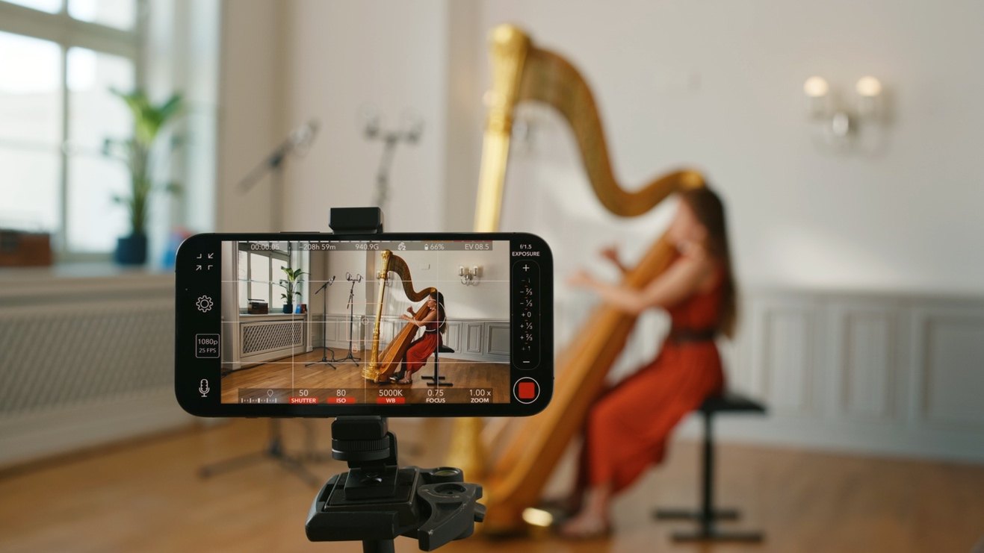

Berlin, April 27, 2023 – When applying for a coveted position in an orchestra, musicians in the classical field are now often faced with the challenge of creating compelling audition videos, not only from a musical perspective, but also in terms of sound and appearance. The Orchesterakademie at the Staatskapelle Berlin and Georg Neumann GmbH have teamed up to produce an 11-part English language series of tutorial videos, covering all aspects, from choosing the right room and selecting microphones as well as other audio hardware, to video technology and proper lighting with simple means.

With the participation of numerous musicians from the Orchesterakademie, different types of microphones and their positioning are demonstrated for a wide range of instruments. Special emphasis was placed on easy explanations, also for those with no prior knowledge of sound and video technology.
Andrea Bautista Pamplona, Organizational Manager of the Orchesterakademie at the Staatskapelle Berlin, summarizes: “We are pleased to provide our musicians with a solid foundation of knowledge in these technical aspects, thanks to this very successful cooperation with Neumann, a world-renowned company in the field of audio technology.”
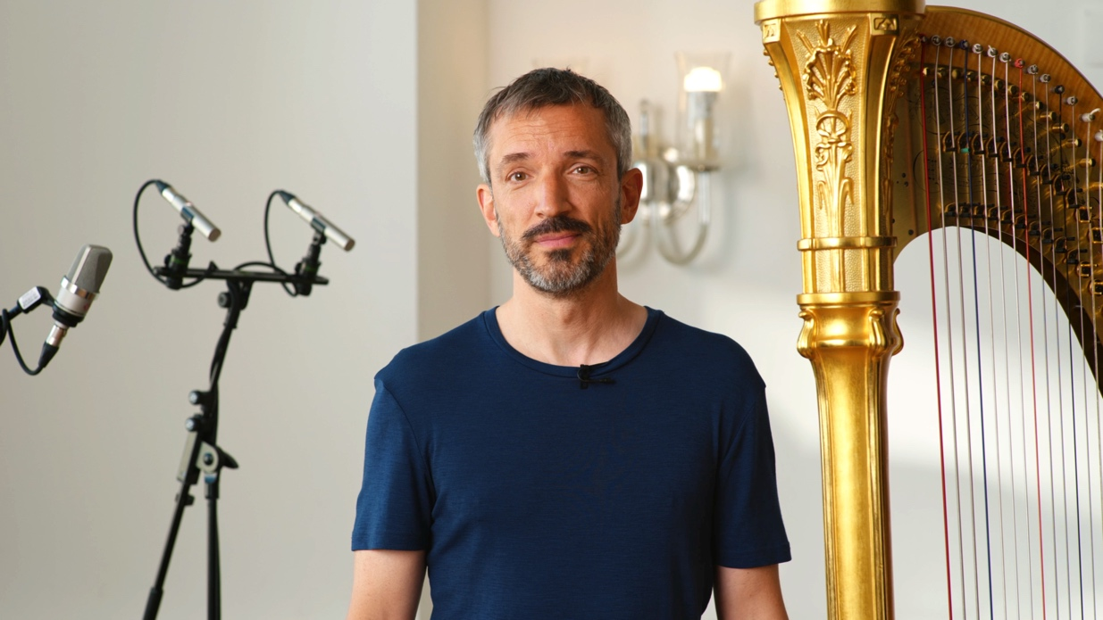

The tutorial series will be published on the Neumann YouTube channel, and will shortly be available on the YouTube channel of the Staatsoper Unter den Linden as well.

Watch the trailer on YouTube

An overview of the episodes

- EP 01 - Recording Spaces - "How To Select the Perfect Room for Audio and Video Recording"
- EP 02 - Audio Hardware - "Choosing the Best Recording Devices for Your Video"
- EP 03 - Microphone Selection - "Picking the Right Microphone for Classical Instruments"
- EP 04 - Recording Strings - " Tips and Secrets for Recording Strings"
- EP 05 - Recording Brass - " Tips and Secrets for Recording Brass"
- EP 06 - Recording Woodwinds - " Tips and Secrets for Recording Woodwinds "
- EP 07 - Recording Timpani - " Tips and Secrets for Recording Timpani"
- EP 08 - Recording Harp - " Tips and Secrets for Recording Harp"
- EP 09 - Recording Soloist & Grand Piano - " Tips and Secrets for Recording Soloists & Piano"
- EP 10 - Filming Yourself "Camera Types and Settings Explained"
- EP 11 - Lighting Setup "Standing in the Spot Light of Your Own Video"
The first three episodes are available now, and the other videos will follow in a weekly rhythm.

Next to classical musicians, musicians of all genres will also benefit from the essential assistance and methods.
The tips & secrets regarding lighting, video settings, and microphone selection help deliver a confident performance when it says, "Please submit a video application".
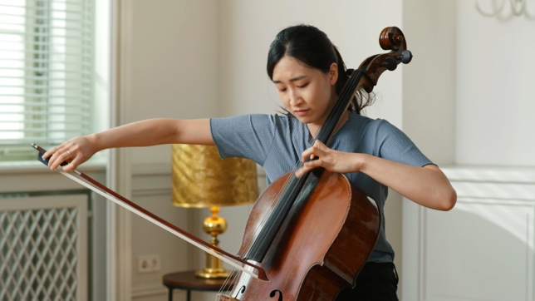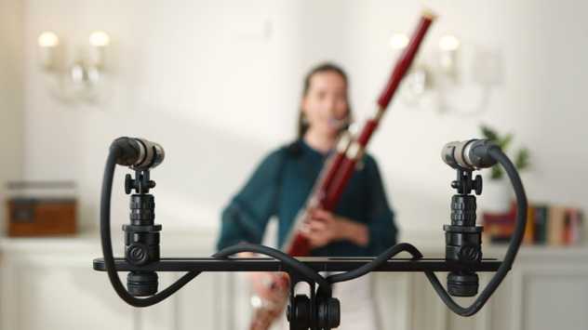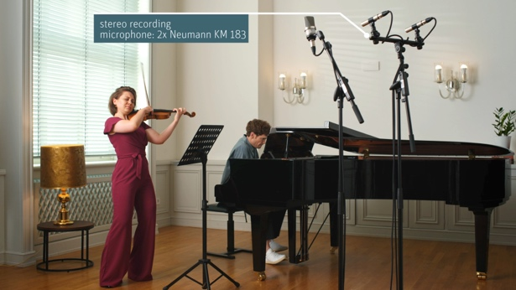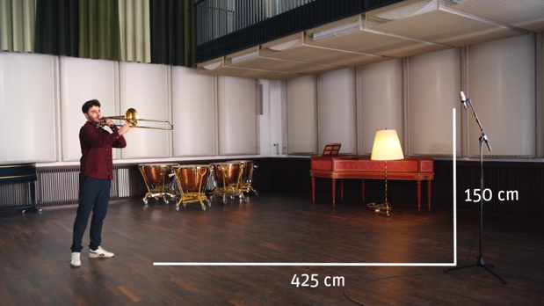

About Neumann
​Georg Neumann GmbH, known as “Neumann.Berlin”, is one of the world’s leading manufacturers of studio-grade audio equipment and the creator of recording microphone legends such as the U 47, M 49, U 67, and U 87.
Founded in 1928, the company has been recognized with numerous international awards for its technological innovations. Since 2010, Neumann.Berlin has expanded its expertise in electro-acoustic transducer design to also include the studio monitor market, mainly targeting TV and radio broadcasting, recording, and audio production. The first Neumann studio headphones were introduced in 2019, and since 2022, the company has increased its focus on reference solutions for live audio. With the introduction of the first audio interface MT 48, and its revolutionary converter technology, Neumann now offers all the necessary technologies needed to capture and deliver sound at
the highest level. Georg Neumann GmbH has been part of the Sennheiser Group since 1991 and is represented worldwide by the Sennheiser network of subsidiaries and long-standing trading partners. www.neumann.

Press Contact Neumann:
Andreas Sablotny
andreas.sablotny@neumann.com
T +49 (030) 417724-19

Raphael Tschernuth
raphael.tschernuth@neumann.com
T +49 (030) 417724-67

