Avenues: The World School Engages WSDG for Acoustic and AV Systems Design of New Shenzhen, China Complex
International School System’s New Campus Serves Pre-K through 12th Grade

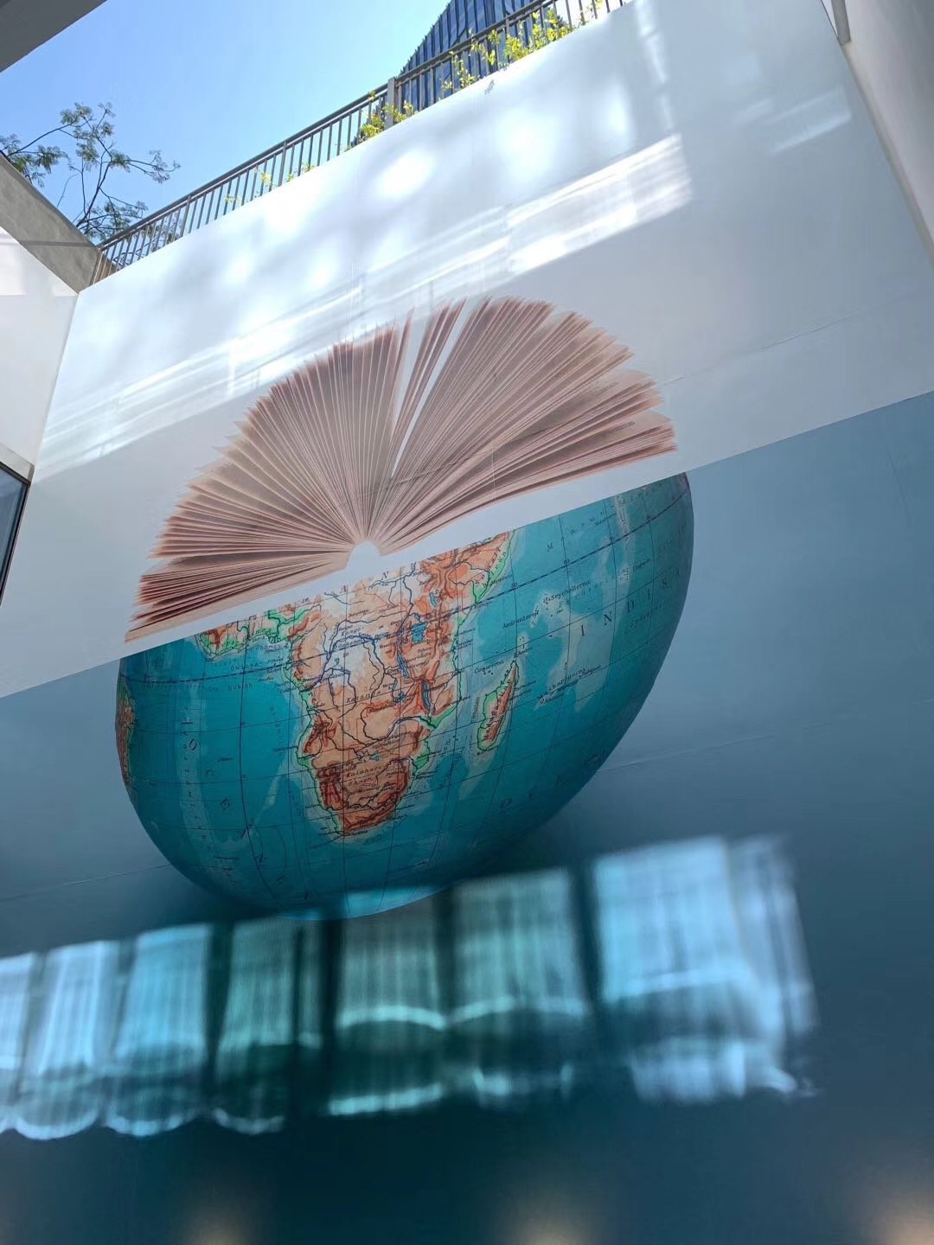
New York, NY, May 7, 2019 — New York-based acoustic consulting and audiovisual integration design firm WSDG (Walters-Storyk Design Group) has completed designs for Avenues: The World School in Shenzhen, China. WSDG provided the international school system with acoustics consultation for both Avenues locations in China's Nanshan District, including the pre-K–12th grade campus in the Tanglang neighborhood, and the Learning Innovation Center in the Sunmax Technology Park, where WSDG provided A/V systems consulting and construction supervision.
Avenues opened its first campus in New York City's Chelsea neighborhood in 2012, with the goal of creating a network of campuses in the world's most vibrant cities. A highly integrated and global learning community connected by a common vision, a shared curriculum, admissions standards and best-in-class facilities. Avenues launched its Small World program for two-year-olds at its Learning Innovation Center in Shenzhen and has announced the projected opening of its Kindergarten program at its campus in Shenzhen's Tanglang neighborhood in Fall 2019, with plans to expand over time to serve students in nursery through 12th grade.

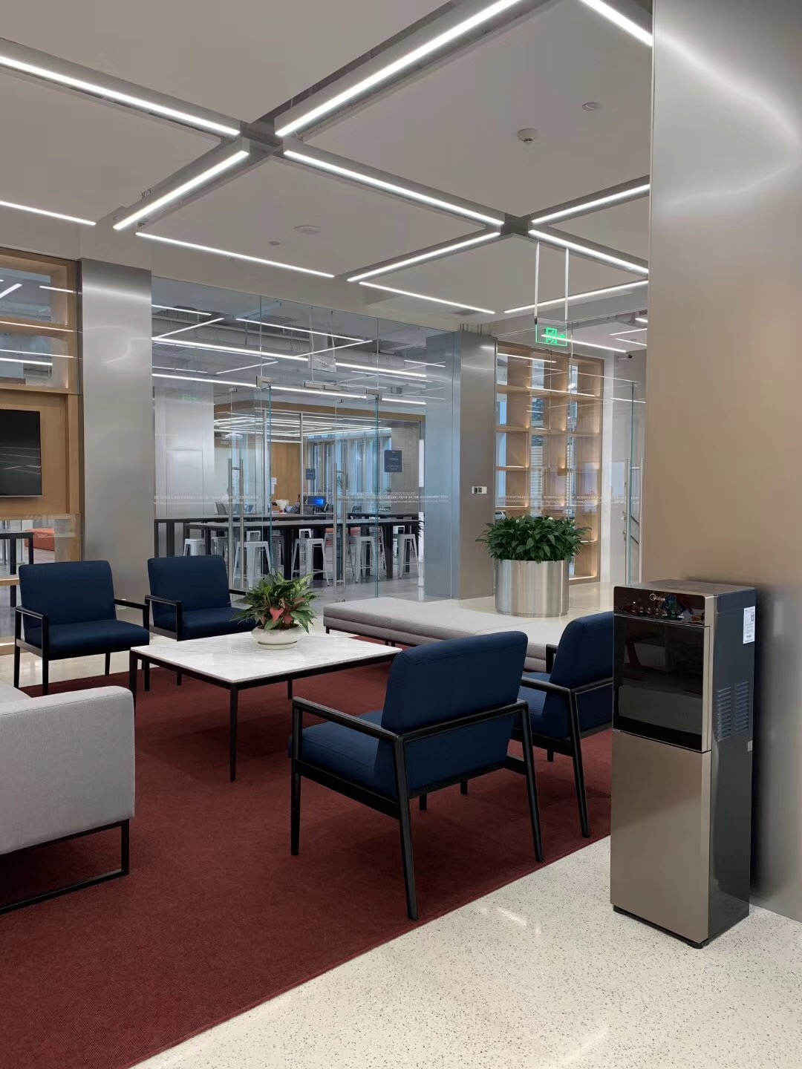
In response to the rapid pace of construction in the region, WSDG assembled a team of acoustic design specialists from its New York office and A/V designers from its Miami-based office, to complete an accelerated design schedule in under six weeks.

“Shenzhen is one of the fastest growing cities in the world right now, and development is quick” said Joshua Morris, WSDG COO, Partner. With designs being completed at WSDG offices on the opposite side of the globe, the time zone change was very complicated, and required a concentrated effort to meet the deadline.”

In addition to time constraints the region's booming development program posed another challenge: noise levels in the surrounding area. “Building construction all over the place around the school,” Victor Cañellas, WSDG China Representative said, “compromised our ability to make acoustic measurements the way we wanted to.” That problem coupled with the need to inhibit external noises made our work as difficult as it was important. Avenues’ emphasis on privacy was another key element in our design considerations for the school, which included specs for not only classrooms, but also for family meeting rooms which required additional sound isolation,” Cañellas said. “We ended up having to specify higher-than-usual isolation solutions to provide a superior level of privacy for families of children in the school.”
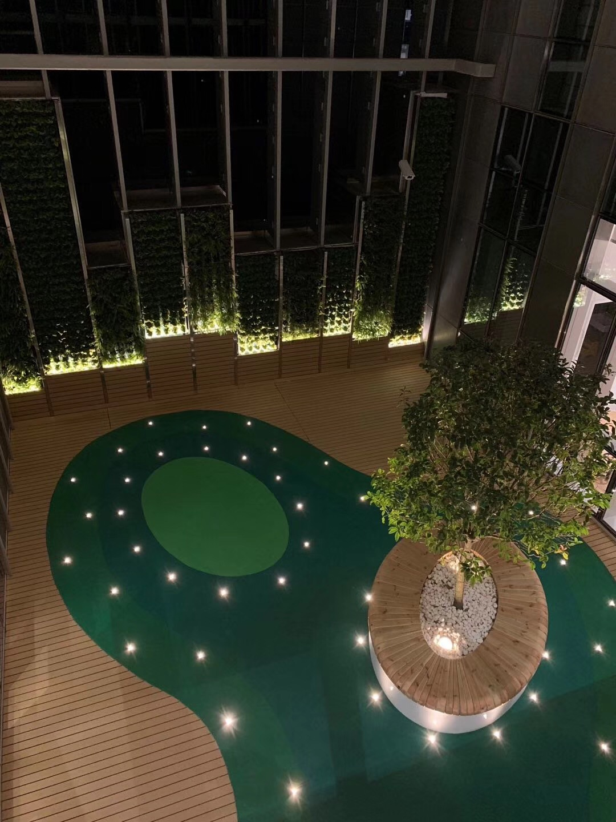
Because the Tanglang campus was built on the site of a former factory that has been renovated and converted into a school, certain structural elements had to be added to improve the isolation. “Many things needed to be fixed,” Cañellas said. “For example, the client wanted to have a basketball court on the top floor, but right below the basketball court, there are classrooms.” So, WSDG again specified higher-than-average isolation in their designs.
Simple A/V Control
When it came to designing the A/V systems for Avenues Learning Innovation Center in Shenzhen, the concept was to have a very simple level of control for a very complex audiovisual system,” Federico Petrone, WSDG Senior Systems Designer said. “Since the Learning Innovation Center houses the Avenues' pre-K Small World program, the teachers required only basic functionality, for using the equipment during instruction. “They just wanted two or three buttons to accomplish their primary requirements for operating the equipment, but the system still needed to work flawlessly,” Petrone adds.

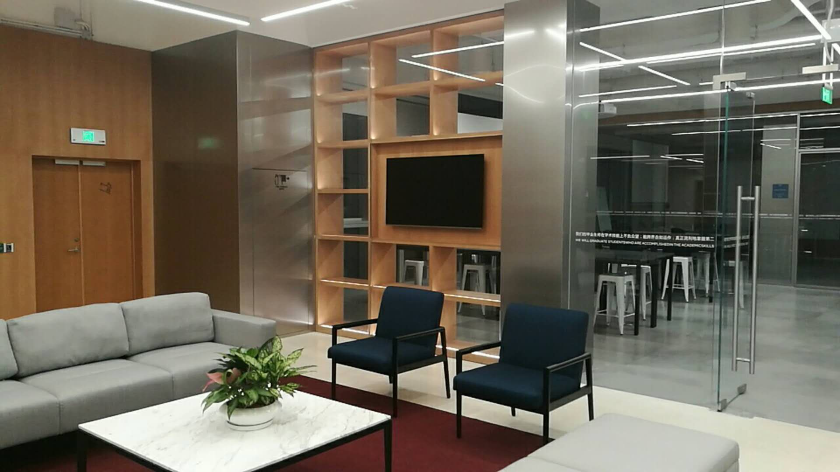
For the main spaces, such as the auditorium, WSDG incorporated tiered levels of functionality for use by more advanced system operators. “For the main auditorium, we designed two separate levels of control — a basic one for people who are less technologically savvy, and a pro level, for important events which would require audiovisual technicians to operate.” Petrone said. “They don't want just one button — they need a complete toolset to program more sophisticated presentations.”

ABOUT WSDG, LLC
For nearly 50 year, acoustic consulting and A/V integration firm WSDG hasbeen designing media production facilities worldwide, over 3500, and counting. Projects range from Jimi Hendrix’s Electric Lady Studio and Jazz At Lincoln Center in New York, to broadcast facilities for The Food Network, CBS and WNET, over twenty teaching studios for The Art Institutes, and corporate clients such as Sony, IBM and Novartis. Recent credits include Jungle City in New York, The Church Studio, in London, private studios for Green Day, Jay-Z, Bruce Springsteen, Alicia Keys and Academy Award-nominated film composer Carter Burwell. WSDG has collaborated with such noted architects as Frank Gehry, Philippe Stark, Rafael Viñoly, Santiago Calatrava, Grimshaw, and Norman Foster. An eleven-time winner of the prestigious pro audio NAMM TEC Award for outstanding achievement in Acoustics/Facility Design, WSDG maintains U.S. offices in New York, Washington, DC, San Francisco and Miami and global offices in Barcelona, Basel, Berlin, Belo Horizonte, Buenos Aires, Guangzhou, Mexico City and Mumbai.

Contact:

Steve Bailey
Hummingbird Media, Inc.
+1 (508) 596-9321
steve@hummingbirdmedia.com

Jeff Touzeau
Hummingbird Media, Inc.
+1 (914) 602-2913
jeff@hummingbirdmedia.com

