Gear up your podcast
Sennheiser presents the ideal podcast equipment – for at home and on the move

Wedemark, November 2018 – Voice, microphone and an entire range of hot topics: Podcasts are a revolutionary trend. Influencers, journalists and celebrities are using this auditory medium to voice their opinions about topics that they are personally concerned about. And the great thing is that producing a podcast is by no means as complicated as one might think – which also motivates many amateur podcasters to express their own views on a topic in the world’s media libraries. But before they start, they are often faced with the huge question of which equipment to use. Which microphone do I need? And how much money should I spend? Whether it is a low-budget headset, 3D audio or a large-diaphragm condenser microphone, whether it is to be used at home or when out and about: Audio specialist Sennheiser has the ideal microphone for every recording situation.

PC 8 USB – low-cost combination of headphones and a microphone
The PC 8 USB is a headset that both plays and records. Here, dynamic stereo sound is combined with noise-cancelling technology. Plug & play ensures that the headset is very easy to use. Simply connect it by USB to a PC or Mac and select it as a recording source in the DAW – and that’s it! A low-cost entry-level solution for all podcast beginners who want to record at home.

MK 4 digital – digital true condenser microphone for optimum voice recordings
This large-diaphragm condenser microphone ensures high-resolution voice recording with special warmth. And connecting this microphone is also child’s play: simply connect it via USB or Lightning to a PC, Mac or iOS device and the podcast sound has studio quality – without any need for an audio interface. The MK 4 digital is a professional choice for home recordings.

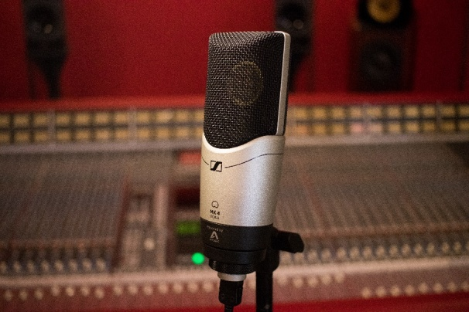 | A professional microphone for home recordings:  The MK 4 digital combines the high-resolution studio sound of a true condenser microphone with the simplicity of digital solutions.

AVX-MKE2 SET – wireless solution for video podcasters
The AVX is a flexible wireless set that comes in different versions: with a handheld microphone transmitter, a bodypack transmitter with a clip-on microphone, in a special professional version with a bodypack transmitter and an MKE 2 clip-on microphone, and as a Combo Set. The speaker simply attaches the clip-on microphone and the sound is transmitted wirelessly to a plug-on receiver – and then fed directly to the camera through the XLR audio input or through an audio interface to the DAW. This solution is perfect for professional documenting podcasters who like to work with video formats.

AMBEO SMART HEADSET – atmospheric 3D audio for podcasts
The AMBEO SMART HEADSET ensures breathtaking 3D sound with great atmosphere – and records the world just as we hear it. The headset can be simply connected to an iOS device and records the speaker and the surroundings through the two microphones in the earpieces. This is the ideal solution for podcasters who spend a lot of time out and about and who want to include the sounds of nature or ambient sound in their recordings.

When the surroundings are to form part of the recording: The AMBEO SMART HEADSET places the listener directly into the sound scenario of the location. | 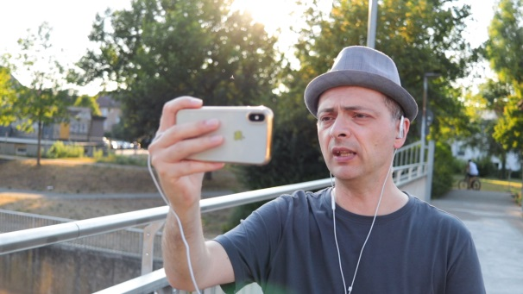

Memory Mic – recording video podcasts with a smartphone
For smartphone podcasters, Sennheiser’s new Memory Mic is a super option for video podcasts. The external wireless microphone can be intuitively controlled using a smartphone app, records at any distance from the device and provides video podcasts with optimum sound. Synchronisation with the phone’s camera is done via the app.

A microphone for smartphone filmmakers: the wireless Memory Mic ensures that your content has excellent sound.

HANDMIC Digital – sturdy handheld microphone for on the move
This handheld microphone is a trusty companion when you are out and about and provides content in broadcast quality. Unaffected by wind and electromagntic interference, it is perfectly suited for outside recordings and interviews. And setting it up couldn’t be easier: simply connect the HANDMIC Digital by Lightning to an iOS device or by USB to a PC or Mac – and it is ready to make digital recordings.

The HANDMIC Digital can be quickly connected by Lightning to an iOS device or by USB to a PC or Mac – and the microphone is ready to record your podcast. | 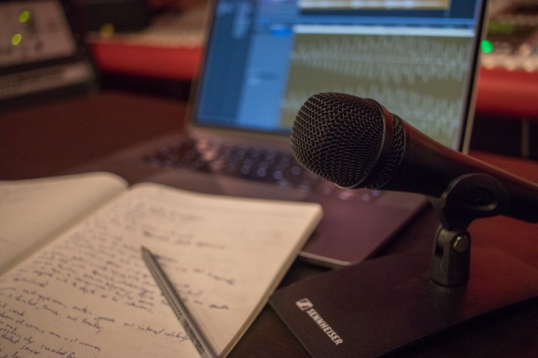

Any questions? Sennheiser’s “How to Podcast” series helps you get started
Step by step to your own podcast: Together with mixing engineer and podcaster Marc Mozart, the audio specialist has developed a YouTube series for podcast beginners – from concept development and tips for making the best recording to marketing your own podcasts.
You can find the series and all other information here: www.sennheiser.com/how-to-podcast

About Sennheiser
Shaping the future of audio and creating unique sound experiences for customers – this aim unites Sennheiser employees and partners worldwide. Founded in 1945, Sennheiser is one of the world’s leading manufacturers of headphones, microphones and wireless transmission systems. With 21 sales subsidiaries and long-established trading partners, the company is active in more than 50 countries and operates its own production facilities in Germany, Ireland, Romania and the USA. Since 2013, Sennheiser has been managed by Daniel Sennheiser and Dr. Andreas Sennheiser, the third generation of the family to run the company. In 2017, the Sennheiser Group generated turnover totaling €667.7 million. www.sennheiser com

Local Press Contact Global Press Contact

Jeff Touzeau Stephanie Schmidt
jeff@hummingbirdmedia.com stephanie.schmidt@sennheiser.com
+1 (914) 602-2913 +49 (5130) 600 – 1275

