For immediate distribution

BAE Announces Drum Recording Bundle with Kenny Aronoff

Bundle includes BAE 1073MPL and 312A preamps for the ultimate studio drum sound

Hollywood, CA, February 17, 2020 – BAE Audio has announced that they are partnering with world-class touring and session drummer Kenny Aronoff [John Mellencamp, John Fogerty, Melissa Etheridge] to offer the ultimate studio preamp package for engineers and drummers looking to take their recorded drum sound to the next level. The Kenny Aronoff Bundle includes a free 6-space lunchbox or rack unit with the purchase of three BAE 1073MPL 500-series preamps and two 312A 500-series preamps -- the heart of Aronoff’s studio signal chain. Customers will also receive a $500 credit towards future BAE purchases. The bundle is available now.
Aronoff has been using BAE preamps and compressors in his studio for the last decade, selecting them for the depth and texture that they bring to his recorded sound. “It’s like the difference between using film and digital when making movies,” he explained. “BAE gear has that added organic quality that brings a warmth and richness to the sounds and makes everything sound more ‘real’.”
“People are always blown away by the sounds I’m able to get, and a big part of it has been BAE,” he continued. “If you want your drums to sound like mine, then get the Kenny Aronoff bundle from BAE.”
https://www.youtube.com/watch?v=IT_ChjW_Wmw

Vintage sound, modern performance
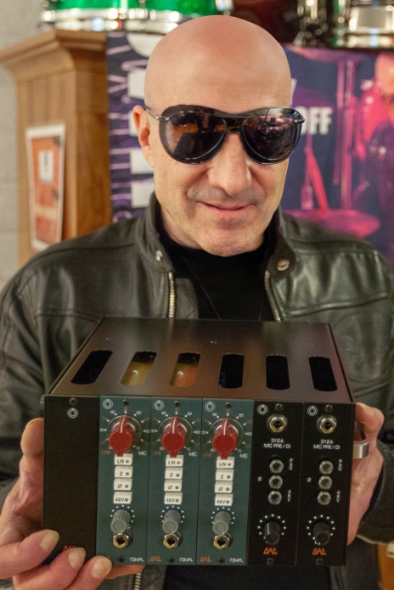
The BAE 312A is a 500-series preamp with extremely fast transients -- perfect for drummers seeking a punchy, responsive attack. The 312a is made with the same attention to quality and longevity as all BAE products, including high-quality Jenson input and output transformers and gold contacts on the switches for reliable long-term performance. Aronoff uses his 312as on his snare and inside the kick for an impactful sound that still retains a musicality and classic flavor. Within the bundle, the BAE 312A retails for $790 apiece.
The BAE 1073MPL is BAE’s version of the classic 1073 preamp in a 500-series module. The 1073MPL uses authentic, high-quality components including Carnhill transformers and is hand wired at BAE’s headquarters in Hollywood, California for years of reliable, trouble-free performance. Aronoff uses them for his overhead and room mics, adjusting the latter for tighter or airier sounds as needed. In the bundle the 1073MPL is available for $950 per unit.
“Kenny is a long-time friend of BAE, and he has some of the greatest recorded drum sounds that we’ve ever heard,” said BAE President Mark Loughman. “We’re thrilled that he uses BAE, and this five-preamp rack bundle is a dream palette of sounds for any drummer.”
For more information please visit http://www.baeaudio.com/
About BAE Audio
BAE Audio is a U.S.-based manufacturer of high-end microphone preamp and equalizers, all of which are faithful to vintage designs of the seventies and before. The company is committed to the vintage philosophy of hand wiring and hand soldering all of its components to achieve a high quality and authentically vintage sound. For more information on BAE Audio, please visit our website at www.baeaudio.com.

Media contact
Jeff Touzeau
Public Relations
Hummingbird Media
+1 (914) 602 2913
jeff@hummingbirdmedia.com

Steve Bailey
Public Relations
Hummingbird Media
+1 (508) 596 9321
steve@hummingbirdmedia.com

