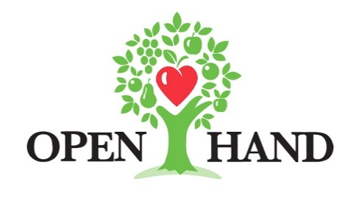

FOR MORE INFORMATION:
Brianna Poplaskie
BRAVE Public Relations
404.233.3993
bpoplaskie@emailbrave.com

FOR IMMEDIATE RELEASE

Open Hand Atlanta encourages the community to dine-in and give back for
Dining Out For Life, April 27

ATLANTA (March 16, 2022) – Annual fundraising event Dining Out For Life returns April 27 to support Open Hand Atlanta. Atlantans are encouraged to dine-in at one of the more than 50 participating restaurants or enjoy take-out, curbside pick-up or delivery.

Since 1993, Atlanta-area restaurants have joined together in raising over $3 million in support of Open Hand’s mission to provide community members with healthy meals and nutrition education. Every year, thousands of supporters have dined out for breakfast, lunch and dinner with the knowledge that participating restaurants would donate a portion of their bill to help Open Hand provide nearly 5,000 nutritious meals daily and support their neighbors battling chronic disease and disability to live healthier, more independent lives.

With recent hardships that continue to affect Atlanta’s food service industry, Dining Out For Life’s generous partner restaurants may not be able to give 25% as in years past, but they are committed to giving what they can to support the cause. With this in mind, restaurant-goers are encouraged to consider making a donation of their own on the restaurants’ behalf. This year’s restaurants include Atlanta favorites such as Guac y Margy’s, The General Muir, Local Three, Max Lager’s, Agave and more. A full list of participating restaurant partners can be found here.

This year, Subaru— a longtime supporter and presenting sponsor of Dining Out For Life— and the national Dining Out For Life leadership has selected Atlanta as a spotlight city. National Dining Out For Life spokesperson Mondo Guerra from Project Runway will be in town to promote the local program and spread awareness about the importance of volunteerism.

Ways to Support Open Hand:
- Donate to Open Hand online at https://donate.openhandatlanta.org/ge/dofl2022
- Connect with Open Hand via Facebook, Twitter and Instagram and share posts, information and more.
- Enjoy restaurant dine-in or takeout on April 27.

For more information on Dining Out For Life and Open Hand, as well as to stay up-to-date on events and volunteer opportunities, please visit www.diningoutforoh.org and www.openhandatlanta.org or connect via Facebook, Twitter and Instagram.
###

About Open Hand
Open Hand Atlanta’s mission is simple: We Cook. We Deliver. We Teach. We Care. As one of the largest community-based nutrition agencies in the country, Open Hand works to help people prevent or better manage chronic disease and improve their quality of life through tailored nutrition interventions. These include a wide variety of health-promoting meal plans as well as nutrition counseling and coaching. With the help of 10,000+ annual volunteers, Open Hand now prepares, packages and delivers 5,000+ meals per day throughout the state of Georgia. To learn more about Open Hand Atlanta programs, call 404-872-8089 or visit openhandatlanta.org. Open Hand is located at 181 Armour Drive, Atlanta, GA 30324.

