For immediate distribution

Taste Test: PortraitXO Refines Sonic Flavors with Sonarworks’ Reference 4
Cutting-edge sonic artist/composer gives listeners a taste of synesthesia
Berlin, Germany, September 6, 2019 – LA-Born, Berlin-based artist PortraitXO is always in the process of finding new experimental musical projects to connect her personal experiences to listeners. What makes PortraitXO’s work so unique is that from a young age she has experienced sound-to-taste synesthesia, a condition which has the artist “tasting” different frequencies of sound. This has given her a singular approach to music and a fascination with creating multi-sensory experiences that can give others a doorway into her creative world, something she has manifested in conventional songwriting as well as interactive installations and live performances. Her continuing efforts in refining this process have found her embracing Sonarworks’ Reference 4 audio calibration plugin, ensuring that her musical projects not only translate on a sonic level across all of these mediums, but on a taste level as well.

Sampling the frequency spectrum
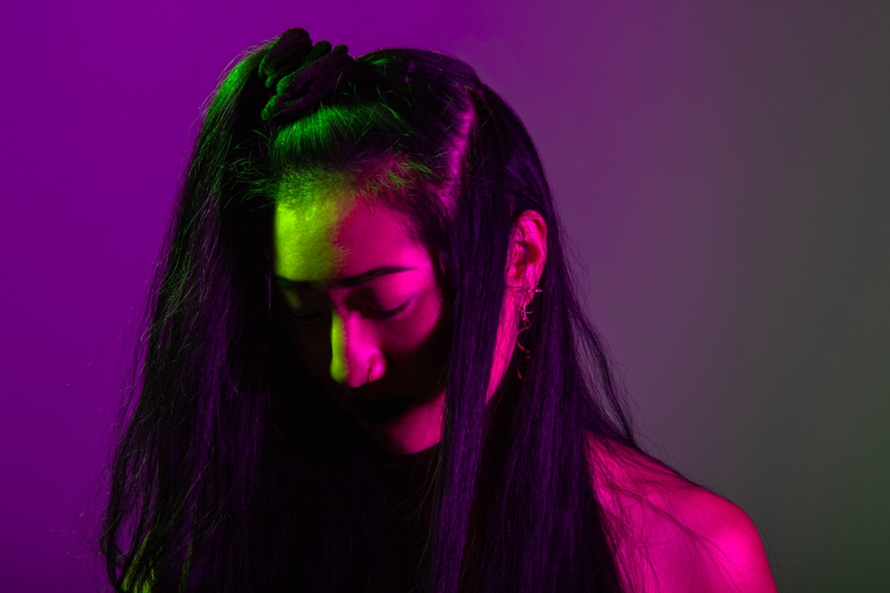
Although only 4% of the population* is reported to experience synesthesia, artists with the condition are not entirely uncommon. Hans Zimmer, Mary J. Blige, and Kristin Hersh are just a few of those that experience it in the more well-known sound-to-color affiliation where certain sounds are also experienced as color hues. For PortraitXO, who has experienced the condition for her entire life, the correlation between sound and taste gave her an appreciation for variety in both from an early age. “It’s always been this intangible experience and I never really questioned it,” she said. “The best way I can explain is that both sound and flavor are two types of senses that are among the hardest to describe, so once I realized how I was experiencing things this way was different from others, I sought to find ways to express that in my work.”

“The highest frequencies are very citric, and they trigger the most dynamic reactions,” she continues. “From there it gets sugary until the middle highs, where it tastes like chili. The very middle are bland flavors like rice and potatoes, while the lows are like unsweetened peanut butter. What this ultimately gave me was an appreciation for all flavors and therefore sounds, which made we want to explore music that would encompass all of these tastes.”

Portrait XO is currently a Resident Artist at Factory Berlin, a think tank of artists, tech innovators, and scientists from across the globe that explore boundary-pushing ideas in arts and science, and part of a 2-week residency for Night Embassy by Jagermeister (CO:QUO x Digi-Gxl) from September 6-17. Portrait XO has used this opportunity to explore and educate others on her condition, creating immersive works that allow her audience to experience sound as she does. Taste components in these have ranged from matching flavored sweets to sound clips in interactive installations, to live experiences like her ‘Sound Tasting’ performance in January 2019 where audience members drank specific wines and beers to accompany the pieces that she performed on stage. “I loved the idea of showcasing work in a different way, that would create a unique experience,” she says, “It allowed me to still use music as my primary language but allow it take on a different role in how someone would experience it.”

Mixing to taste
PortraitXO varies her production setup depending on the end situation, favoring Ableton Live for her sound installations and Logic for her more songwriter-focused recording projects. “They each make me write and produce differently,” she explains. “Logic puts me in a more traditional producing mind frame and I’ll often use it when I want to focus on crafting the structure of a composition. When I want to get more experimental and do more sound designing for an installation, I definitely favor Ableton.” She uses an Apollo Twin interface and a variety of MIDI controllers, including the ROLI Seaboard, MAudio Keystation, and the Akai APC40 to compose a wide range of music influenced by both her singer/songwriter background and her classical piano training.

A key part of her recording setup for the last few years has been Sonarworks’ Reference 4, which has allowed her to ensure that her compositions and songs translate across the variety of mediums that they are heard in, as well as ensuring that she’s mixing them to their optimum potential. “Once I started using Reference 4, I noticed a difference right away because my bedroom studio wasn’t treated at all,” she says. “It was fascinating to see all the trouble spots that Reference 4 pointed out, and having it systematically adjust my monitors was immediately helpful.”

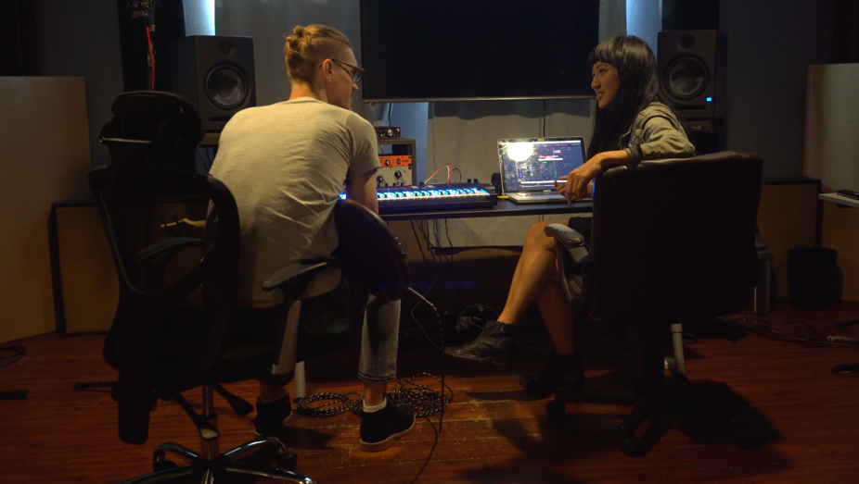
She also uses Reference 4 when working in headphones, something she has to do more often since relocated from Los Angeles to Berlin, favoring a lovingly worn pair of Sony MDR 7506s that she used for over a decade. “I’ve had to bounce between a few different studios, and I’ve found myself missing the calibration when it’s not present, it’s something that creates an overall frequency flatness that makes the mixing side of things much easier.”
Photo Credit: Beat Lab Academy

She notes that although an optimum mix may not correlate to a specific taste -- each piece having its own unique identity in that regard -- she did occasionally find herself influenced by taste, albeit inadvertently. “I used to drink lemon water in the morning while I was working on my mixes, and I kept finding that the mixes would sound muddy when listening back. I didn’t make the connection until later that the lemon juice was making me more sensitive to higher frequencies,” she says with a laugh.

Cutting edge experimentation
Portrait XO is set to release her debut AI album later this year and single launching soon, another experiment that has her challenging listeners perceptions – duetting with AI-generated audio developed from her own voice in collaboration with CJ from Dadabots. Where her previous pieces have been carefully composed, this experiment has her developing musical ideas alongside cutting-edge AI technology, using the computer-generated randomness to spark off new compositional ideas. The work is once again allowing her to present something to an audience that they’ve never experienced before. “All of my creative executions have a strong sonic focus since I’ve always felt that my main communication tool has been through sound,” she says. “This particular project is a fun game of fill-in-the-blanks for me, but it still shares a through line with my other work in that it’s giving the audience a journey through process. I get a lot of joy out of that.” Her next show is on September 17th where she will perform her AI album pre-release in collaboration with a global network of diverse 3D design and animation artists - Digi-Gxl.

* https://www.livescience.com/17156-synesthesia-taste-words-benefits.html
For more information about PortraitXO, please visit: https://www.portraitxomusic.com/
For more information on Reference 4, please visit: https://www.sonarworks.com/reference

About Sonarworks
Sonarworks was founded in 2012 when two music lovers met a scientist and embarked on a mission to deliver the ultimate sound experience for anyone creating or listening to music. Sonarworks is the leading sound calibration company in the sound recording industry. The company’s technology is in use by more than 30,000 recording studios worldwide, including more than 35 Grammy winners who enjoy and endorse Sonarworks. Now we are on a mission to take this even further - deliver the ultimate sound experience to all music listeners, regardless of the device used, be it headphones, speakers, or car stereo.

US Media Contact:
Steve Bailey
Hummingbird Media, Inc.
+1 (508) 596-9321
steve@hummingbirdmedia.com

Jeff Touzeau
Hummingbird Media, Inc.
+1 (914) 602-2913
jeff@hummingbirdmedia.com
Rest Of The World Contact:
Lee Chapman
Sonarworks Ltd
+371 28807601
lee.chapman@sonarworks.com

