Amazing sound for amazing people

Sennheiser gift guide for Father’s Day

Marlow, U.K., April 28, 2020 – They are our everyday heroes, motivators, comforters, mentors – our fathers always have our back. Father’s Day is coming up soon. Even though celebrating the occasion may look a little different this year, it's a perfect opportunity to say thank you to the special people in your life. And what could be more special than surprising your Dad with a magical sound experience? Whether they love watching movies or listening to music, Sennheiser has a selection of perfect presents that will delight the dads in your life.

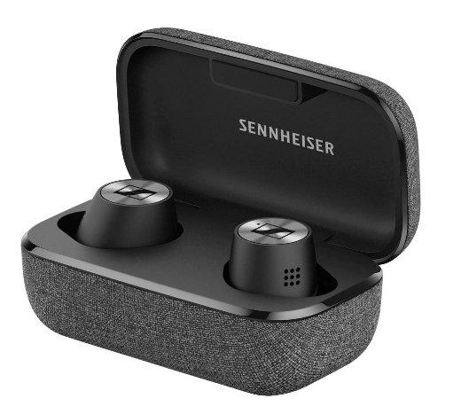
Earbuds that put sound first
MOMENTUM TRUE WIRELESS 2
+ True wireless earbuds with exceptional sound
+ Active noise cancellation blocks out distractions
+ Transparent Hearing feature for greater situational awareness
+ Excellent ergonomics for full day wearing comfort + Customisable touch controls
+ 7-hour battery life (+21 hours via the case)
+ Exquisite craftmanship and premium design
+ Available in black or white
MSRP: 279.00 GBP

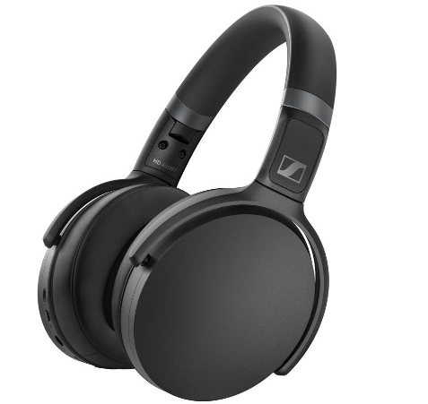
Audio companion for every day
HD 450BT
+ Active noise cancellation for uninterrupted listening pleasure
+ Great sound with deep dynamic bass
+ Intuitive controls including voice assistant button
+ Impressive 30-hour battery life
+ Available in black or white
MSRP: 159.99 GBP

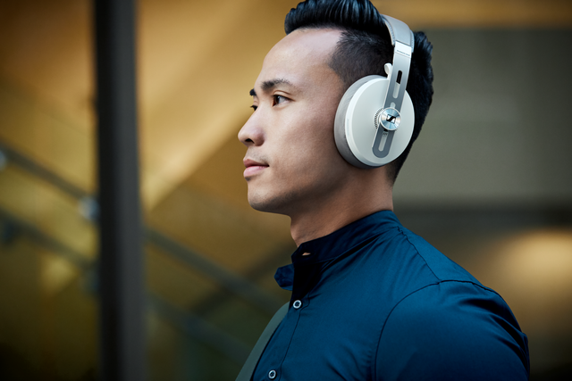
Luxurious sound and style
MOMENTUM WIRELESS
+ Superior sound
+ Creates an oasis of calm with ANC
+ Offers Transparent Hearing
+ Auto On/Off and Smart Pause features
+ A touch of stylish indulgence: soft leather on the earpads and headband
+ 17-hour battery life
+ Almost impossible to misplace thanks to Tile Bluetooth tracker
+ Available in black or sandy white
Current promotional price: 299.99 GBP

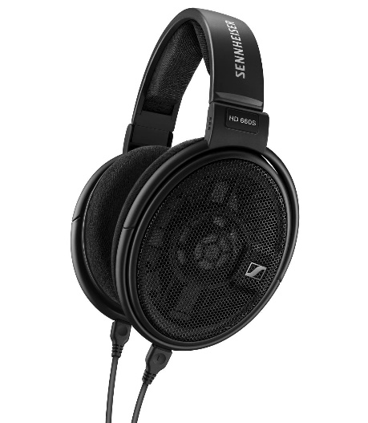
Perfect gift for audiophiles
HD 660S
+ Authentic, lifelike sound with crisp bass, excellent mid-frequency response, and gentle, natural treble
+ Low impedance allows listeners to enjoy the
HD 660S with stationary and mobile HiRes players
+ Created for a lifetime of listening enjoyment thanks to their robust yet lightweight, supremely comfortable design
MSRP: 429.99 GBP

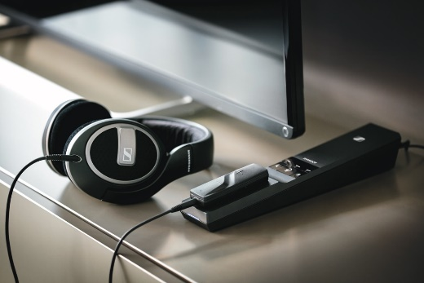
For a more personalised TV listening experience
FLEX 5000
+ Smart listening solution that intensifies TV sound for any pair of wired headphones
+ Dedicated profiles enhance TV, movies or music
+ Speech Intelligibility button dynamically reduces TV background noise for crystal clear dialog
MSRP: 179.99 GBP
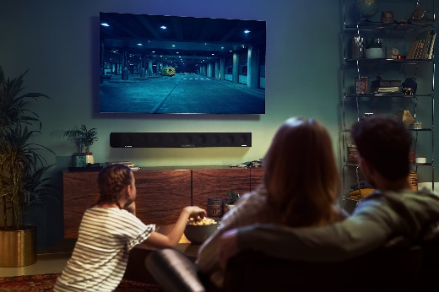
Incredible 3D sound for family movie nights
AMBEO SOUNDBAR
+ Creates immersive 3D sound with powerful bass, without the need for a subwoofer
+ Automated room calibration tailors the sound to the room and preferred seating position – placing the listener in the center of the action
+ Supports 3D audio formats such as Dolby Atmos, MPEG-H and DTS:X and features Upmix Technology to recreate stereo and 5.1 content as a thrilling 3D sound experience
MSRP: 2,199.00 GBP

About Sennheiser
Founded in 1945, Sennheiser is celebrating its 75th anniversary this year. Shaping the future of audio and creating unique sound experiences for customers – this aim unites Sennheiser employees and partners worldwide. The independent family company, which is managed in the third generation by Dr. Andreas Sennheiser and Daniel Sennheiser, is today one of the world’s leading manufacturers of headphones, loudspeakers, microphones and wireless transmission systems. In 2018, the Sennheiser Group generated turnover totaling €710.7 million. www.sennheiser.com

Global Contact
Maik Robbe
Maik.robbe@sennheiser.com
T +44 7393 462484

