Solutions for Modern Productions: RME Debuts New M-32 Pro AVB Series of Converters
to Meet the Needs of Today’s Professionals
The new 32-channel M-32 AD Pro and M-32 DA Pro converters respond to the demands of audio pros requiring high analog channel counts

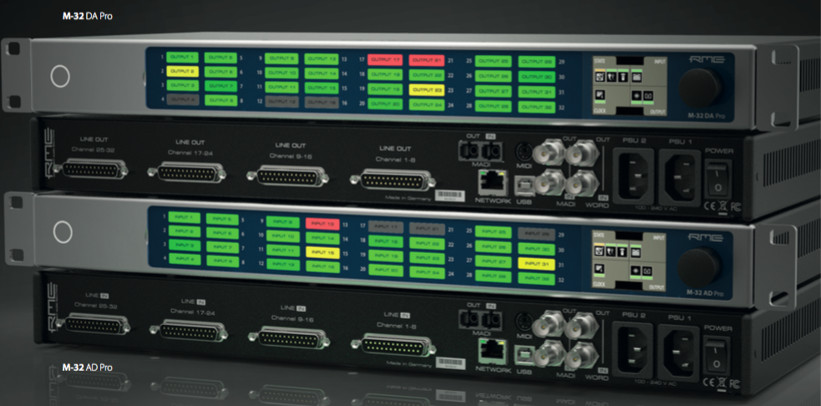
Las Vegas, June 4, 2018 – Synthax [InfoComm 2018 booth C1619], distributor of premium German interface manufacturer RME, will debut its new M-32 Pro AVB Series at InfoComm 2018 from June 6–8, 2018, at the Las Vegas Convention Center. The series includes the M-32 AD Pro and M-32 DA Pro, two high-end, 32-channel 192 kHz converters that meet the requirements of today’s productions and installations that require high analog channel counts.
Based on state-of-the-art, high-resolution converter components and a fully balanced analog circuit design, the new M-Series offers a signal-to-noise ratio of 120 dB(A) with extremely low THD values — placing the converters in the reference class.
“The new M-32 AD Pro and M-32 DA Pro are two new converters taking audio transmission to the next level,” said Derek Badala, Director of Sales, Americas for Synthax, distributor of RME. “These units feature redundant power supplies, more compact housing and network functionality — all features that professionals in today’s industry are looking for. And with an AVB interface included, these converters can be blended into complex network structures.”
AVB — The Future is Here
In addition to the two fully equipped MADI I/Os including separate signal routing, the new M-Series converters boast an AVB interface based on the open network standard IEEE 802.1 and 1722.1, enabling transmission of the 32 analog channels at maximum 192 kHz sampling rate via a single Ethernet cable.
Combined with external AVB switches, the new converters can be quickly, easily and reliably integrated into more complex network structures thanks to the comprehensive time-synchronous signal processing of the AVB protocol.
Seamless Integration & Compatibility
The open AVDECC 1722.1 control protocol as part of AVB allows users to use external controllers from different manufacturers to control almost all device functions. A web interface and a JSON API are also available, both via the network connection and the integrated USB port.
In order to connect with a variety of analog hardware, the individual channels of the M-32 AD Pro and M-32 DA Pro can be operated with different line levels — each with full resolution of the converters. Besides +19 dBu and +13 dBu, the new M-Series is one of the only solutions that also allows working with the SMPTE® recommendation of +24 dBU at 0 dBFS.
Easy Navigation
The combination of level displays and channel labelling fields conveys a familiar analog feeling but proves to be an almost indispensable advantage in daily practice. Using the supplied transparent papers, users can create individual channel labels and securely affix them behind a magnetic cover. This provides a comprehensive overview of analog channel assignments.
Check out the new M-32 AD Pro and the M-32 DA Pro at RME’s booth C1619 during InfoComm 2018 June 6–8.
For more information on RME, visit http://www.rme-usa.com/
About Synthax, Incorporated
Synthax Inc. is the exclusive USA distributor for RME digital audio solutions, Ferrofish advanced audio applications, myMix audio products, and ALVA cableware. We supply a nationwide network of dealers with these products for professional audio, broadcast, music industry, commercial audio, theater, military and government applications. For additional information, visit the company online at http://www.synthax.com.

Media Contacts:
Katie Kailus
Public Relations
Hummingbird Media
+1 (630) 319-5226
katie@hummingbirdmedia.com

Jeff Touzeau
Public Relations
Hummingbird Media
+1 (914) 602 2913
jeff@hummingbirdmedia.com

