Looks like an energetic competition!
Panasonic and Angry Birds for the win

Zellik, 11 May 2016. – In the run-up to the European big screen release on 11 May, Angry Birds fans are busy donning Angry Bird eyebrows, feathers and beaks. Why? To enter the unique Panasonic Angry Birds Lookalike Competition. Contestants are challenged to take pictures of themselves as an Angry Bird in a bid to win one of the fabulous Angry Bird prizes.
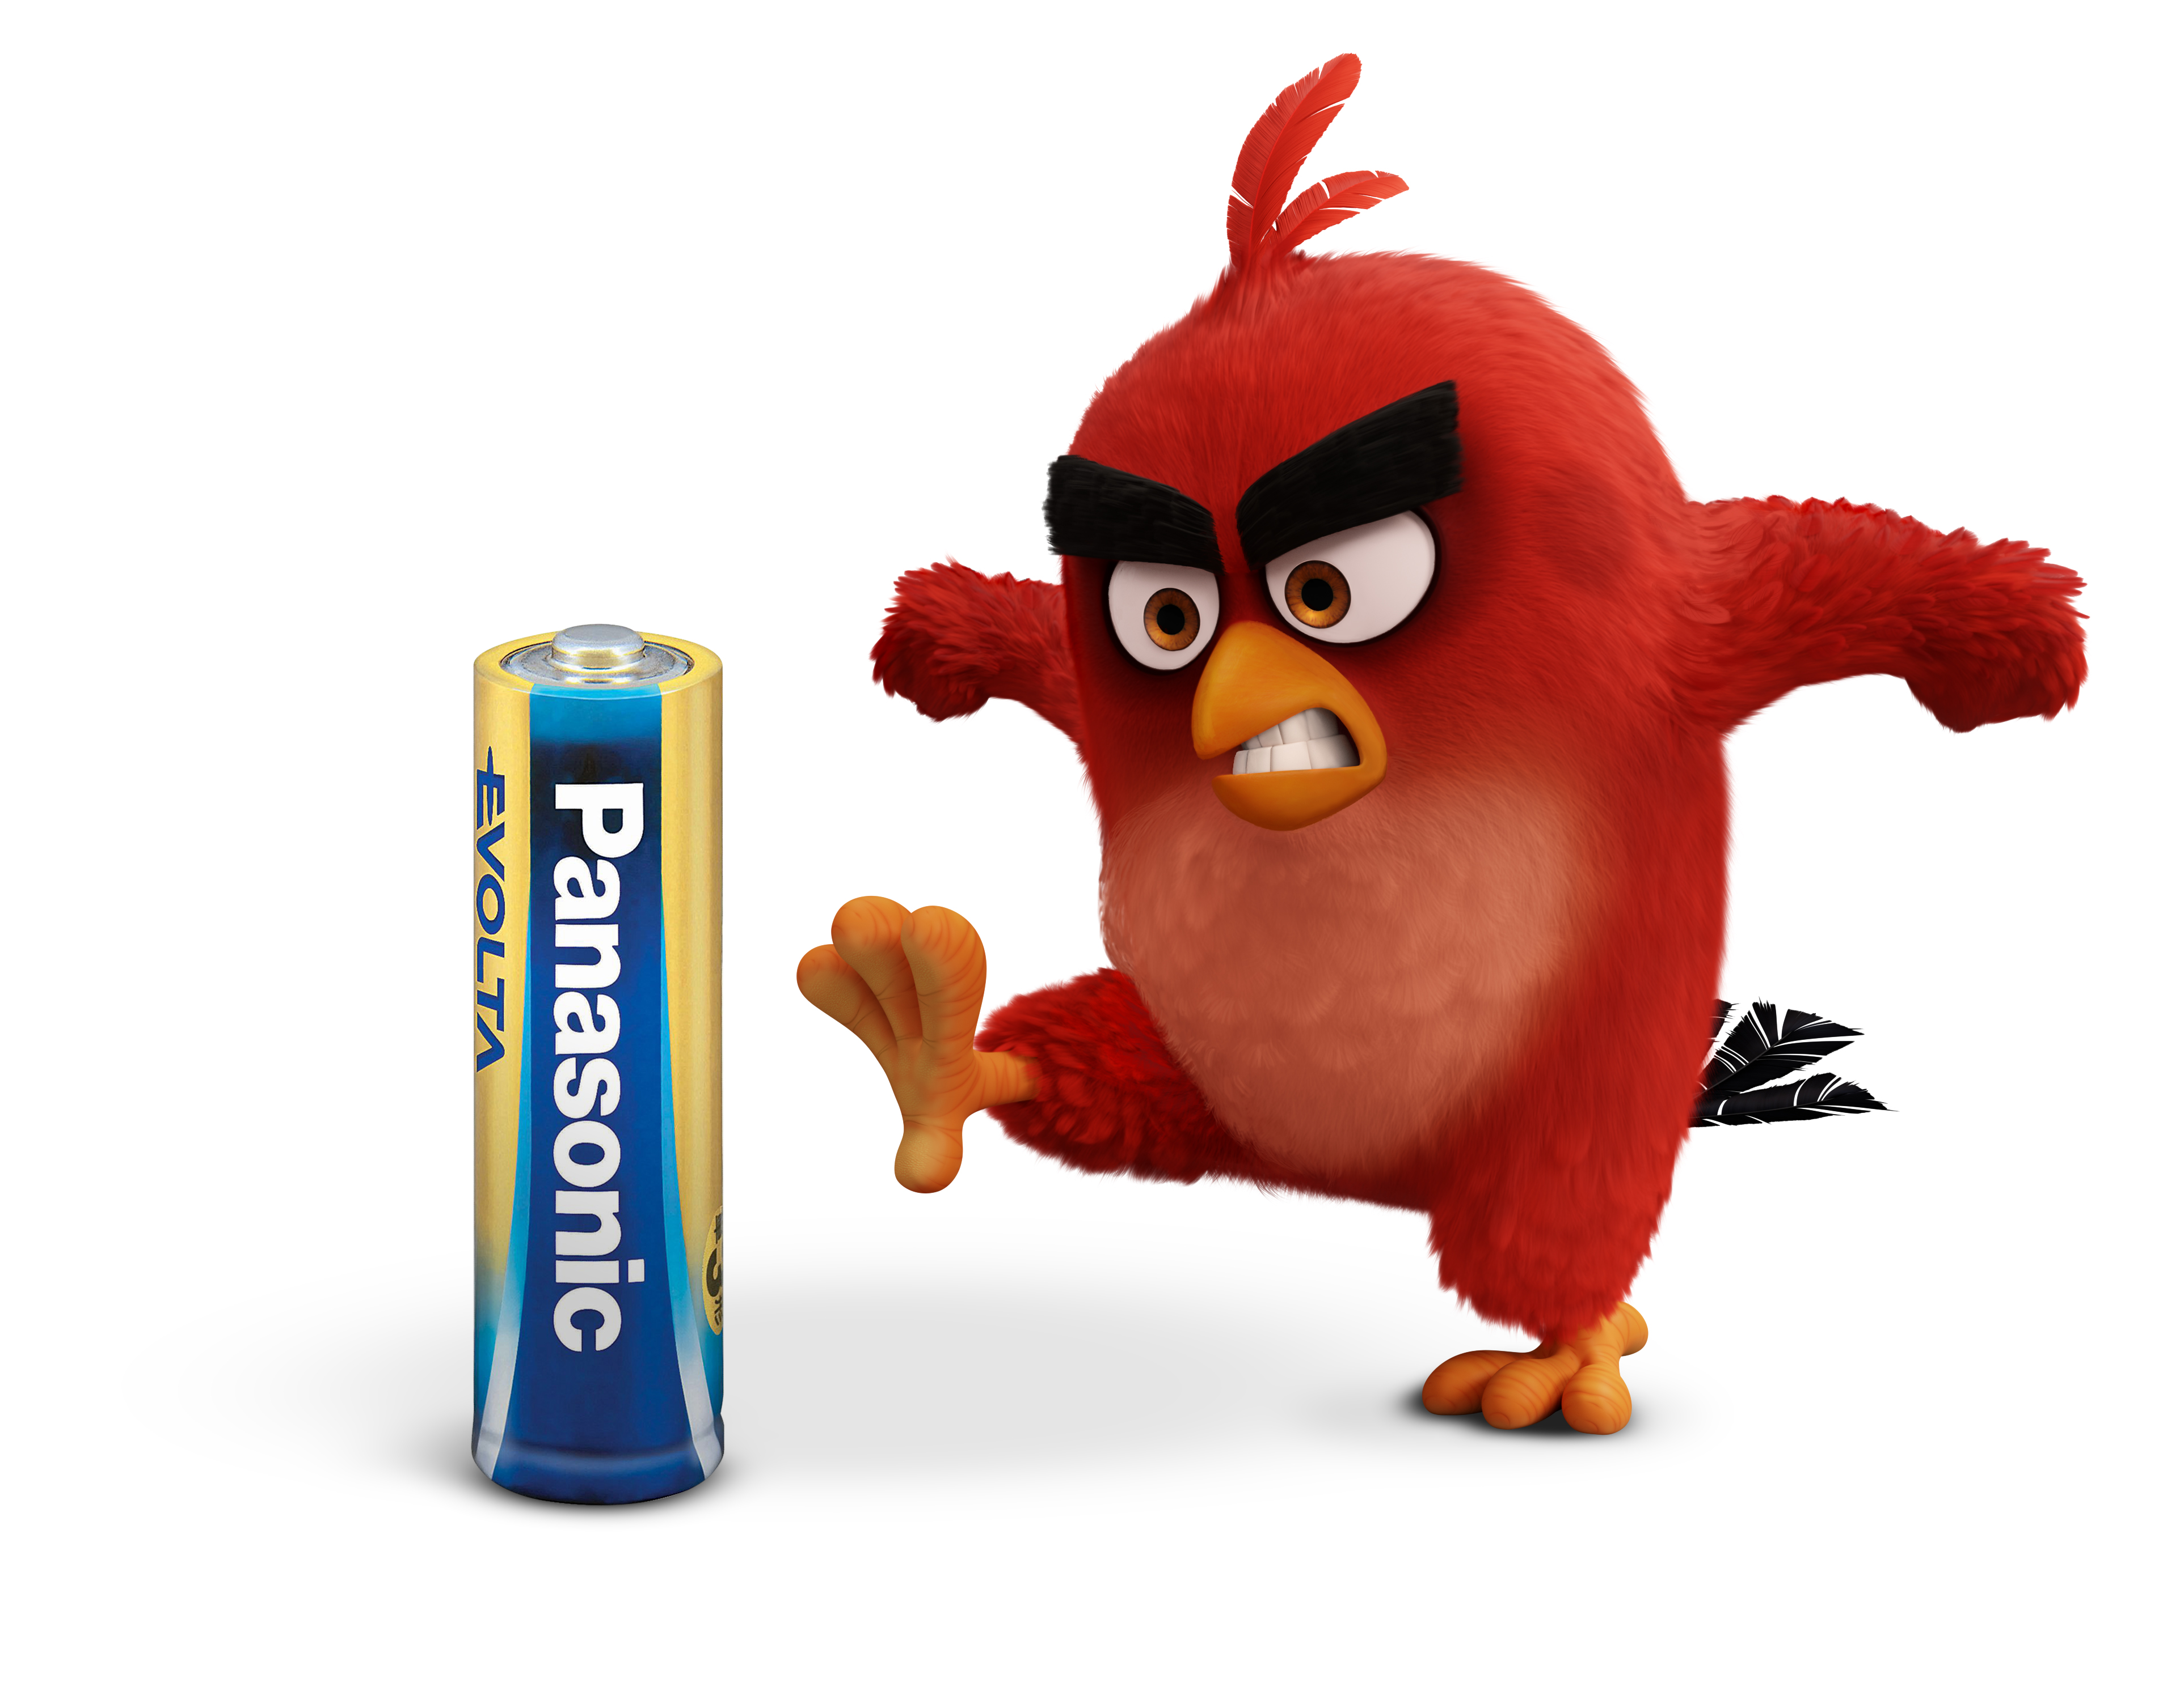
As from 11 May 2016, Angry Birds fans will be able to follow the exploits of all their favourite characters on the big screen. Panasonic has teamed up with Angry Birds to launch a fun lookalike competition with great prizes to win, making the countdown even more exciting. Contestants can either devise their own look or download eyebrows, beaks and other accessories from the competition site to transform themselves into their favourite bird.

First prize is a holiday in Croatia for a family of four. And then there are plenty of terrific Angry Bird merchandise items to be won, going from squeezy Red, Chuck and Bomb stress toys and playsets with which to build and destroy Pig City, to cool Angry Bird themed earphones, glasses, bags etc.

Visit https://angrybirds.panasonic-batteries.com for more details.
Power your day with Panasonic and the Angry Birds
Panasonic’s partnership with Angry Birds offers the company the opportunity to significantly increase consumer awareness of its extensive range of advanced battery solutions. The main characters of the movie - Red, Chuck and Bomb - appear on all current POS material and packaging, conveying Panasonic’s ‘Power your day’ message. Watch the entertaining promotional movies featuring individual Angry Bird characters via the following links:
Wondering why exactly Panasonic Energy is joining forces with Angry Birds?
Curious where speedy Chuck get’s his energy from?
Why Panasonic batteries will take us further than we might imagine?
Or how Panasonic batteries can provide power that (literally) stretches further?

About Panasonic Energy Europe
Panasonic Energy Europe is headquartered in Zellik, near Brussels, Belgium. The company is part of the Panasonic Corporation, a leading global manufacturer of electronic and electrical goods. Panasonic’s vast and lengthy experience in the consumer electronics field has helped make Panasonic the largest battery manufacturer in Europe today. The European production facilities are located in Tessenderlo, Belgium, and Gniezno, Poland. Panasonic Energy Europe supplies ‘mobile’ energy solutions to more than 30 European countries. The company’s diverse product range includes rechargeable, chargers, zinc carbon, alkaline and specialty batteries (such as zinc air, photo lithium, lithium coin, micro alkaline, silver oxide).
For more information, visit: www.panasonic-batteries.com.

About Panasonic
The Panasonic Corporation is a leading company worldwide in the development and manufacture of electronic goods for a wide range of private, trade and industrial uses. Panasonic, based in Osaka, Japan, in financial year ended 31 March 2015 posted consolidated net sales of around 57.28 billion EUR. Panasonic is committed to creating a better life and a better world, continuously contributing to the evolution of society and to the happiness of people around the globe.
More information about the company and the Panasonic brand name at www.panasonic.net.

PRESS CONTACT

ARK Communication
Ann-Sophie Cardoen
Content & PR Consultant
T +32 3 780 96 96

ann-sophie@ark.be
www.ark.be

Panasonic Energy Europe NV

Vicky Raman
Brand Marketing Manager
T +32 2 467 84 35
vicky.raman@eu.panasonic.com
www.panasonic-batteries.com

ARK Communication

Ann Velghe
Content & PR Manager
T +32 3 780 96 96
ann@ark.be
www.ark.be

