

Biuro prasowe better. gaming agency
bettergamingagency.prowly.com

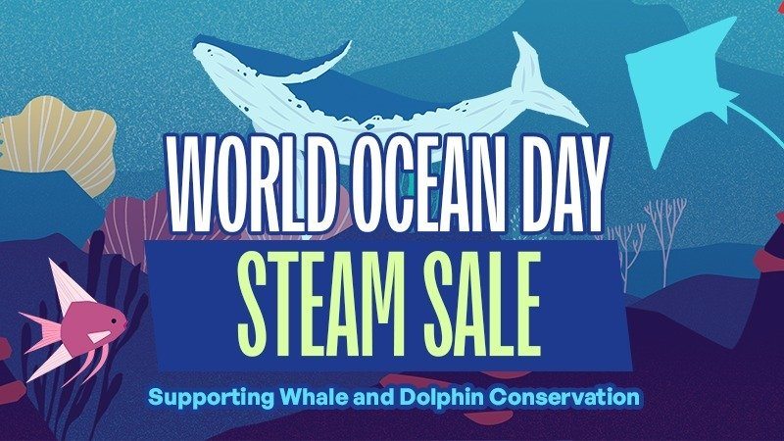

World Ocean Day – play awesome titles and protect the ocean, whales, and dolphins!

World Ocean Day will be celebrated on June 8, and once again, gamers can join in and support the event through a special sale that will take place on Steam. From June 5 to 12, select titles will be available at exclusive prices, and a percentage of the revenue will be donated to Whale and Dolphin Conservation (WDC), an organization dedicated to protecting these magnificent beings and their ocean habitats.

Over 200 titles are participating in the event, with discounts of up to 90%, including games such as:

- This War Of Mine: Complete Edition
- Flooded
- House Flipper
- Spilled!
- Still Wakes The Deep
- The Walking Dead: The Telltale Definitive Series
- Phasmophobia
- Among Us

The Steam sale is part of the World Ocean Day Festival 2025, running from June 5 to June 12. The event will also be endorsed by popular streamers who will be raising funds during their streams to support the cause.

World Ocean Day has been celebrated for over 30 years, and we’re thrilled to see it gaining more significance each year. At Whale and Dolphin Conservation, we've been working with creators, publishers, and streamers to organize the Steam sale since 2022. With each edition of the event, more partners join us in the fight for this important cause. So far, thanks to the Steam sale, we've raised over a million dollars, which helps fund initiatives like WDC’s Safe Seas programme, aimed at reducing threats to whales and dolphins – such as accidental entanglement in fishing gear, pollution, and climate change.

- Sally Ward, WDC’s head of digital partnerships

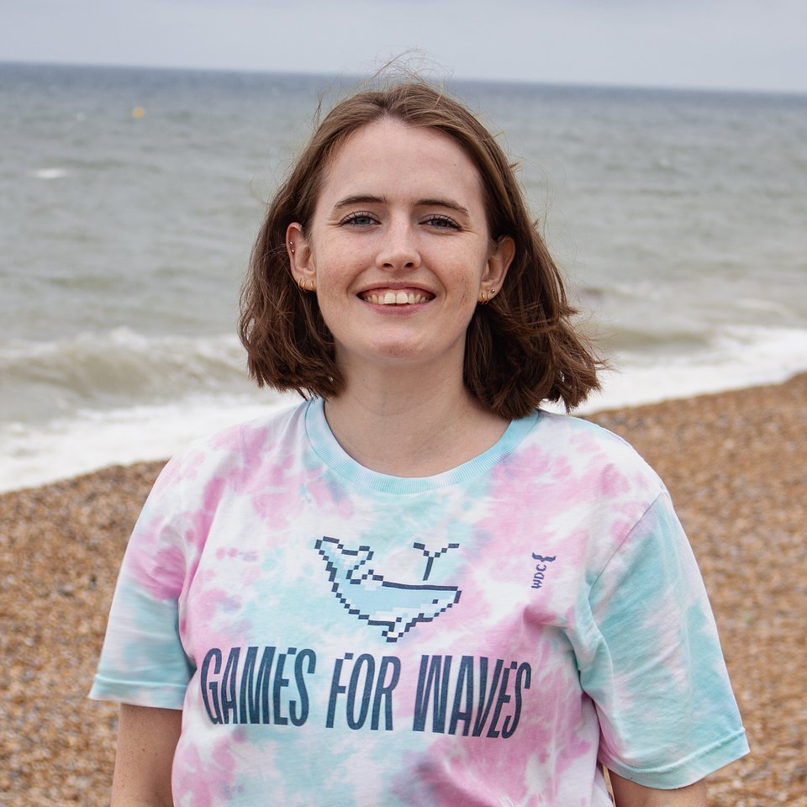

Why is it important to join and help?

🐳 The ocean produces more oxygen and absorbs more carbon than all our forests combined! Thanks to phytoplankton – tiny organisms that produce oxygen and absorb carbon dioxide - and marine plants, the ocean is responsible for over half of the global oxygen production and absorbs a large portion of CO₂ emissions, playing a key role as a climate regulator.

🌱 Whales help keep the ocean the ocean healthy by cycling nutrients and fertilizing phytoplankton. We need a thriving and diverse marine ecosystem to help keep the ocean healthy, which means more whales, not less.

🎣 Around 300,000 whales and dolphins accidentally die each year by getting entangled in active fishing gear, along with sharks, turtles, and seabirds. Abandoned fishing gear, known as ghost gear, also poses a deadly threat to many marine species with an estimated 11,000 tonnes of fishing gear being lost or discarded in European seas every year - that’s the same weight as the Eiffel Tower.

💙 WDC works with fishing communities around the globe to encourage less destructive fishing gear, collaborates with organisations to help remove deadly ghost gear from the sea and influences governments and decision makers to create policy change.

If you’d like to learn more about the efforts of Whale and Dolphin Conservation and discover how you can contribute to a cause that affects us all, be sure to watch the video below.

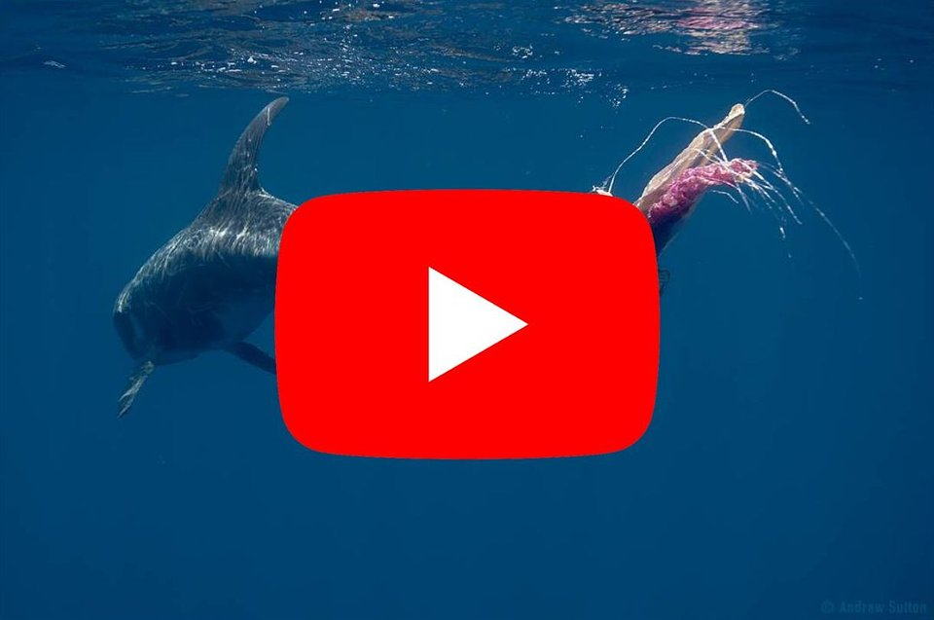
https://www.youtube.com/watch?v=7TmAZSZtikA&ab_channel=GamesForWaves

Our game – Flooded – in a way shows a dark vision of what might await us if we don't start taking care of our planet. We wanted to highlight the issue of the destructive impact of human activity on the environment and rising sea levels in a striking way – in our game, the world is literally being flooded, and the player must constantly escape the encroaching waters. Partnering with Whale and Dolphin Conservation felt like a natural step, so we’re proud to donate the funds from the game's sales to support the organization.

– Tymoteusz Piasek, creator of Flooded

The World Ocean Day Festival on Steam will run from June 5 to June 12. The event will feature a special Steam sale, with a percentage of the revenue going to support Whale and Dolphin Conservation. At the same time, in collaboration with popular streamers, live streams will take place, during which funds will be raised for the foundation.

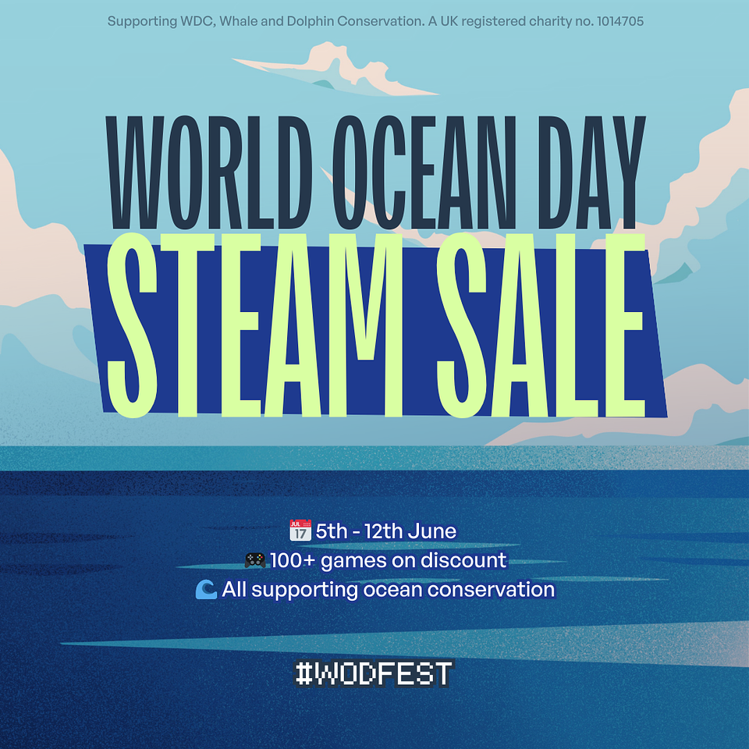

The full press kit is available HERE.

Important links:

More about the World Ocean Day Festival – LINK

More about World Ocean Day – LINK

More about Whale and Dolphin Conservation – LINK

More about Games for Waves – LINK

About Whale and Dolphin Conservation

Whale and Dolphin Conservation is the leading global charity dedicated to the protection of whales and dolphins.
They work to protect whales and dolphins from the many threats they face today, including marine pollution, hunting and whaling, vessel strikes, entanglement in fishing nets, and capture followed by a life in captivity. WDC advocates for the rights of whales and dolphins as intelligent, sentient creatures and promotes their vital importance in maintaining healthy ocean ecosystems, upon which all living beings rely. WDC works globally through campaigns, lobbying, advising governments, conservation projects, field research, rescue, education and much more. They bring together, and work hand-in-hand with, businesses, philanthropists, scientists, NGOs, governments and grassroots communities to find solutions to the problems faced by whales and dolphins. Their vision is a world where every whale and dolphin is safe and free.
UK Registered charity number: 1014705
https://uk.whales.org/
https://games.whales.org/

