Press release. For release as of February 28th, 2021

EVOC PRODUCT HIGHLIGHT FALL/ WINTER 2020/2021:
Next Level PLUS-Protection

A flyweight with perfect fit and the PLUS in back protection: The TRAIL PRO protector backpack with the new LITESHIELD PLUS back protector technology offers ambitious bikers an uncompromising combination of performance, protection and carrying comfort. The backpack as a whole is TÜV-certified and is available in three volumes (10/16/26 litres) as well as two lengths and colourways

- The new EVOC LITESHIELD PLUS back protector (EN 1621-2; level 2) offers increased protection through the higher protection level and simultaneously more protected surface (fullback).
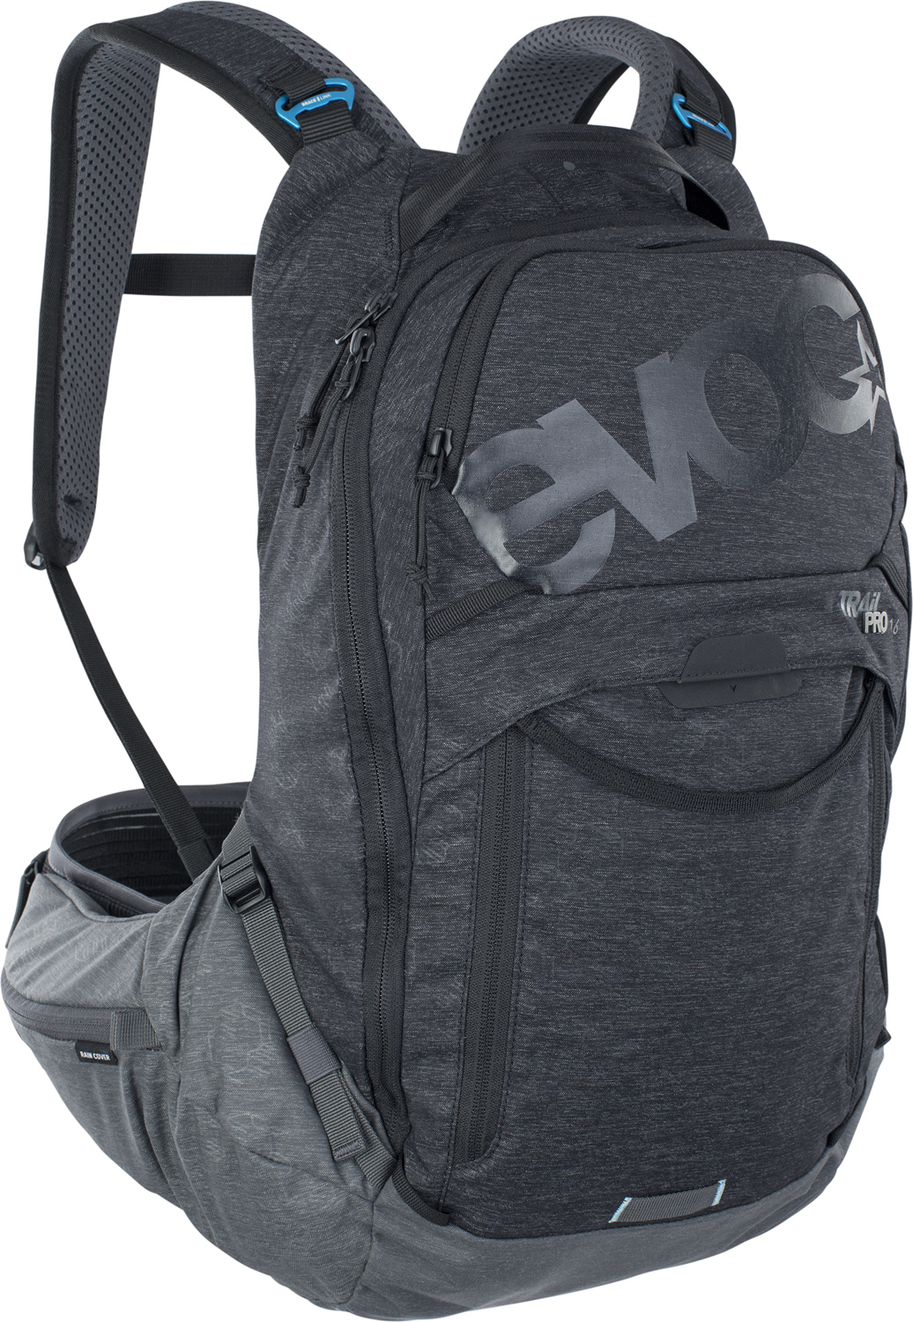
- At 900 Grams, the TRAIL PRO 10 is one of the lightest TÜV certified level 2 protector backpacks on the market.
- FREE PROTECTOR CRASH REPLACEMENT.

The TRAIL PRO protector backpack is a real lightweight offering the latest back protection technology designed by EVOC, and the combination of the highest degree of carrying comfort and flexibility with regards to size and fit.

At its heart is the pre-formed, 168 g super lightweight and ergo-dynamically flexible back protector LITESHIELD PLUS (EN 1621-2). It offers excellent level 2 impact protection properties and absorbs 95% of the impact energy in a crash. Should the protector be damaged in a serious crash, EVOC will replace it free of charge with their FREE PROTECTOR CRASH REPLACEMENT guarantee.

The best of all worlds: innovative feature combinations for improved performance
The TRAIL PRO is EVOC’s first backpack to employ weight-saving, pre-formed 3D pads on the back, which not only improve comfort, but also air circulation by creating space between the backpack and the riders’ back.

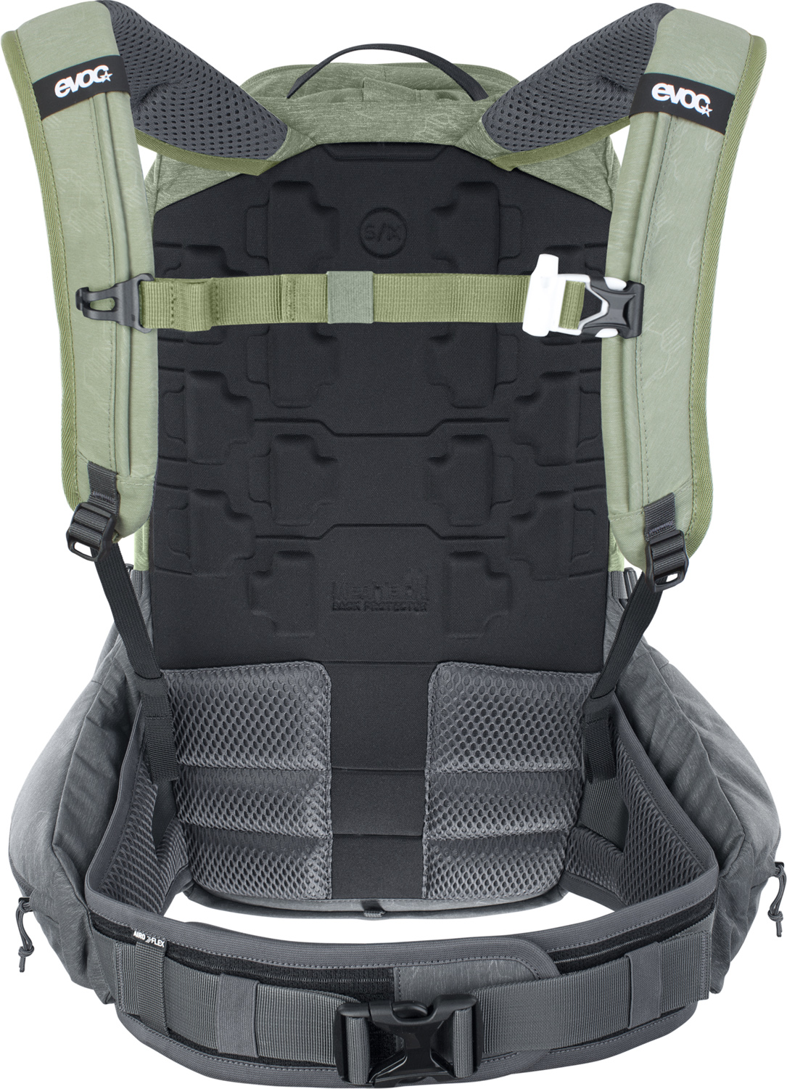
The secret behind the uncompromising fit, aside from the heavily action-focussed neck portion, is the perfect load distribution around the center of gravity via the wide hip wings. They originate from the mesh pads in the lumbar and hip area and literally hug riders without restricting their movement - this is the appropriately named BODY HUGGING effect which is already tried and tested in the touring backpack segment. The fully breathable AIRO-FLEX belt made of flexible, ultra durable material, also used in medical engineering, provides a strong and comfortable fit.

This is also the first time that EVOC is using the Brace Link in a protector backpack. This feature enables the rider to adapt the padded shoulder straps to their individual shoulder width via variable connector elements. The backpack has no seams on the shoulder straps in the neck and upper shoulder area in order to prevent friction or pressure.

The large and easy-to-reach zippered pockets on the hip belt offer ample space for the rain cover, a few snacks as well as your phone. The tool compartment in the front can be opened and closed completely, even with gloves on, which offers quick and easy access to the required equipment. The lateral compression belts help adapting the volume of the backpack individually.

Further convenient features:

- Lateral zippered pocket on the hip belt (TRAIL PRO 10)
- Mesh pocket for small items and keys in the main compartment (TRAIL PRO 16 and 26)
- Rain cover with protection for the lateral compartments in the hip belt pocket (TRAIL PRO 16 and 26)
- Attachment straps for the helmet carrier
- Compartment for hydration bladders up to 3 litres
- Clip to attach hydration system hose
- Height-adjustable chest strap with signaling whistle
- Fleece-lined compartment for glasses
- Emergency plan
- New Nylon material: Nylon-Polyester mix with soft touch surface
- Length S/M (for torso lengths 41-48 cm) or L/XL (for torso lengths 48-53 cm)

Volume, weight and sizes:
10 l, 900 g, 26 x 50 x 9 cm
Colours: Black - Carbon Grey; Light Olive - Carbon Grey
Price: 190 € / 220 USD / 179,99 GBP

16 l, 1000 g, 26 x 50 x 12 cm
Colours: Black - Carbon Grey; Light Olive - Carbon Grey
Price: 210 € / 240 USD / 199,99 GBP

26 l, 1070 g, 26 x 50 x 16 cm
Colours: Black - Carbon Grey; Light Olive - Carbon Grey
Price: 230 € / 260 USD / 219,99 GBP

Material: NYLON, P200D, AIRO FLEX
Not included: Hydration Bladder
Available from Spring 2021.

#EVOCbike

Embargo: For release as of February 28th, 2021
Royalty free photos for download in the EVOC Press Room

Date: August 2020
Subject to changes.

Information for editors:

LITESHIELD PLUS Backprotector Technologie
Its two-component sandwich construction consists of a combination of expanded Polypropylene (EPP) and a TPU carrier layer. The highly compressed, water repellent EPP foam provides the best possible protection for the thoracic spine, the lumbar spine and the coccyx. The side of the protector facing the back is constructed of plus shaped elements. The interjacent sections provide ventilation channels for perfect air circulation. Simultaneously, this segmentation offers flexibility in all directions: the individual protector elements of the back plate move independently. This lets them adapt to every movement and ensures improved protection and comfort by having the protector as close to the back as possible

Media Contact: Dani Odesser | press@evocsports.com | +49 (0)170 3131812

