Sonarworks True-Fi Calibration Software Forays Into the Future
— with Over 200 Headphone Profiles and Counting
Pioneer, Creative, Razer and HyperX are among the latest headphone calibrations
— at no additional charge to existing customers
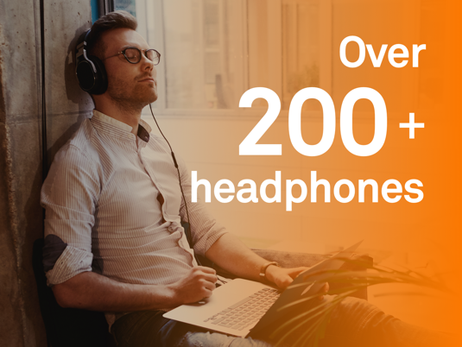
Riga, Latvia, September 18, 2018 – Sonarworks, the revolutionary audio calibration software company, announced that its consumer application True-Fi has achieved a significant milestone, and now supports 232 different headphone models ranging from common consumer models from familiar manufacturers like Panasonic, Pioneer, and Behringer to gaming headsets and wireless earbuds. In addition, this True-Fi update features support of several gaming headsets as the company continues to expand its customer base.
True-Fi enables listeners to experience music as it was intended to be heard, achieving ‘reference sound’ at the push of a button. With a mobile app set to be released in the coming weeks, True-Fi is poised to redefine the mobile listening experience.

Accessibility and versatility are key components of True-Fi, as evidenced by the growing array of headphone profiles currently supported by the software. With new models being added each month and being made available to consumers at no extra cost, Sonarworks customers stand to benefit from the company’s more than six years of research, measurement and calibration expertise.

The new supported models include:
- Apple Airpods
- Behringer HPM1000
- Behringer HPS3000
- Creative Aurvana Live!
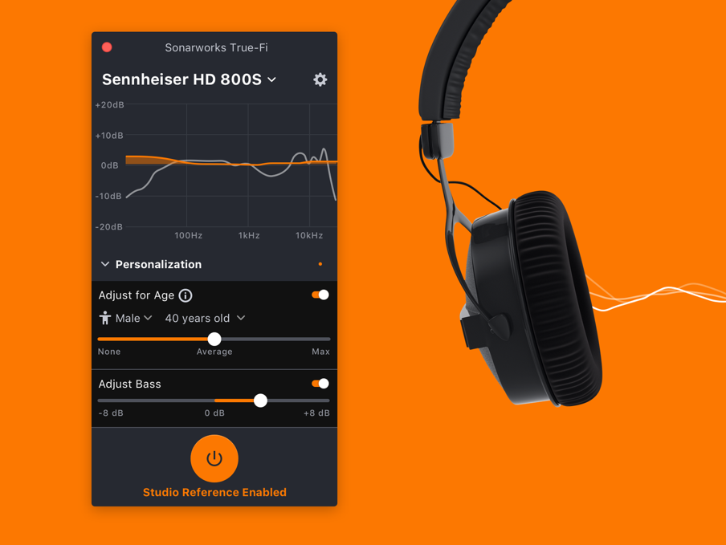
- HyperX Cloud Alpha
- Meze 99 Classic
- Meze 99 Neo
- Monoprice Monolith M1060
- Panasonic RP-HJE125
- Pioneer HDJ-X5
- Pioneer HDJ-X7
- Pioneer HRM-5
- Pioneer HRM-6
- Pioneer HRM-7
- Razer Kraken Pro

A list of all supported models can be found at https://www.sonarworks.com/truefi/headphones.

Sonarworks' True-Fi mobile app, which will support multiple audio formats on both iOS and Android, will be debuting next month and made available to existing customers at no additional charge.

True-Fi is available for purchase on Sonarworks' website. For more information about Sonarworks' True-Fi, please visit https://www.sonarworks.com/truefi.

About Sonarworks
Sonarworks is a Europe-based audio software development company specializing in acoustic calibration and DAW plugins. Accurate sound is our passion. The company was founded in 2013 and entered the pro audio market in 2015. Sonarworks software is relied upon by many Grammy winning artists and engineers around the world.

Media Contact:

Jeff Touzeau
Hummingbird Media
+1 (914) 602-2913
jeff@hummingbirdmedia.com

Steve Bailey
Hummingbird Media
+1 (508) 596-9321
steve@hummingbirdmedia.com

