For immediate distribution

Sound Engineer Brandon Blackwell Simplifies Touring Setup Thanks to Ferrofish A32 Converter
The owner of Blackwell Productions routes all of his analog pieces into a single MADI stream using the A32

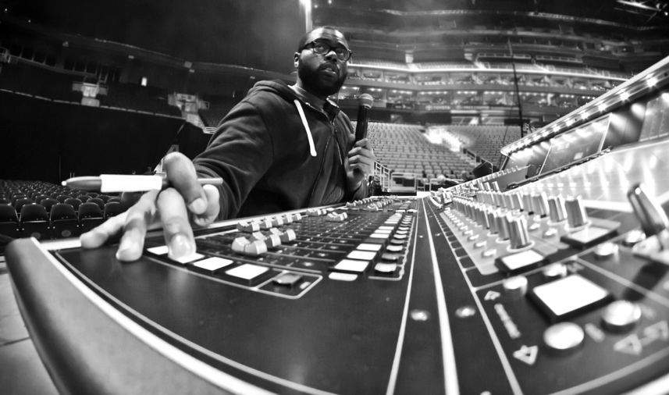
South Orange, New Jersey, December 27, 2018 — Since 2012, Brandon Blackwell, owner of Blackwell Productions, LLC, has been putting his audio production expertise to work in a number of ways, from serving as FOH and monitor engineer for big-name acts like pop star Camila Cabello to providing support services for a wide range of venues, including TV specials, theatrical events, seminars and conferences.
Based in South Orange, New Jersey, but working throughout the globe, Blackwell was in need of a way to convert his entire arsenal of analog outboard gear into multichannel audio digital interface (MADI) format for control at a DiGiCo console — which requires MADI — when mixing FOH or monitors. Last summer, he purchased a Ferrofish A32 AD/DA MADI and ADAT converter at the advice of a colleague, and Blackwell said it’s helped simplify his setup dramatically by being able to route all of his analog pieces into a single MADI stream.
"I'm into using outboard gear, but I have to have a piece of technology that gets it all into my console," Blackwell said. "With the A32, I can insert my gear into a single MADI stream. And, I have to say, the A32's AD/DA conversion is the best I've heard."

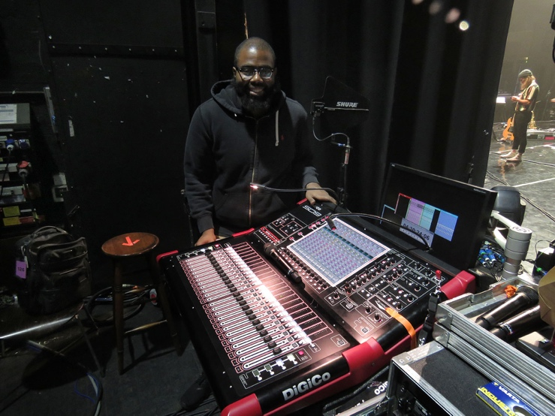
With a major pop tour on his schedule for next summer, Blackwell has been bringing his Ferrofish A32 to all of his gigs. And since he can get all of his AD/DA and MADI conversion out of a single rack unit, he can fit it in his luggage when he travels to one-off gigs.

"Being a one-rack unit, it hardly takes up any space,” Blackwell said. “So, I can just throw it in my suitcase and pack clothes around it."
In conjunction with its transparent conversion and optimal size, Blackwell said that the A32's dual-power supply makes the unit an essential piece of gear he can rely on for any gig.
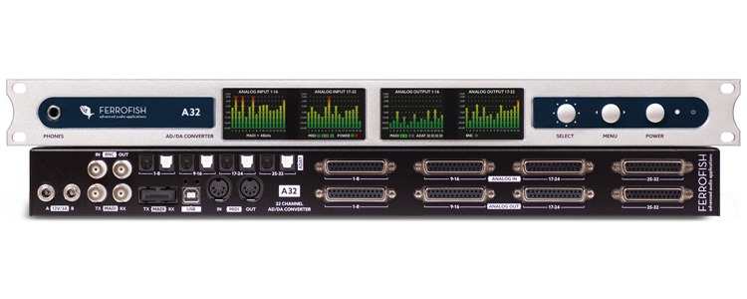
“Having redundancy is very important especially during a live show, because you only get one chance to get it right,” Blackwell said. "Consistency is key to success, so it is nice that I can carry the same audio converter from gig to gig.”
Saving Space & Money
In addition to simplifying his setup, Blackwell has found the Ferrofish A32 saves him much-need rack space which can be in high demand while out on tour.

“A tour I'm going to do next summer calls for some additional pieces of outboard gear,” Blackwell said. “As I continued to look for more outboard pieces for my own setup, potentially getting up to 32 channels into my desk, I would need a 10-stage rack from DiGiCo. The A32 saves space and, more importantly, saves money. As audio professionals, we want all the flashy toys, but if we can get rid of gear to save on the audio budget, we will.”

For more information, visit ferrofish.com.

About Ferrofish
Known for its precision-engineered German technology, Ferrofish manufacturers high quality, innovative advanced audio applications. From its class-leading A16 MK-II and A32 AD/DA converters to its Verto Series of intuitive Dante converters, Ferrofish is known for its premium conversion solutions that are ideal for a wide range of applications. For additional information, visit the company online at http://www.ferrofish.com.

About Synthax, Incorporated
Synthax Inc. is the exclusive USA distributor for RME digital audio solutions, Ferrofish advanced audio applications, myMix audio products, and ALVA cableware. We supply a nationwide network of dealers with these products for professional audio, broadcast, music industry, commercial audio, theater, military and government applications. For additional information, visit the company online at http://www.synthax.com.

Media Contacts:
Jeff Touzeau
Public Relations
Hummingbird Media
+1 (914) 602 2913
jeff@hummingbirdmedia.com

Katie Kailus
Public Relations
Hummingbird Media
+1 (630) 319-5226
katie@hummingbirdmedia.com

