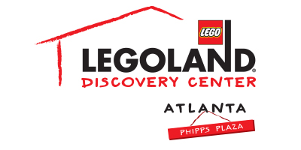

For more information:
McKenzie Riley
mriley@emailbrave.com
404.233.3993

*MEDIA ADVISORY*

LEGOLAND® Discovery Center Atlanta to offer special deals for
International Talk Like a Pirate Day on September 19
Kids who give their best pirate impression will receive a Kids Go Free coupon!

ATLANTA (September 10, 2018) – Ahoy, matey! LEGOLAND® Discovery Center Atlanta invites all pirate fans to celebrate International Talk Like a Pirate Day on Wednesday, September 19. Guests who talk like a pirate at admissions will receive a Kids Go Free coupon* and a pirate eye patch, while supplies last.

Guests can get in the spirit by visiting the Pirate Adventure Island at LEGOLAND® Discovery Center Atlanta, an interactive adventure designed to encourage both children and adults alike to participate in free play and tactile activities. Families can explore treasure island themed build spaces to create their own LEGO® sandcastle or treasure map, construct a LEGO® pirate ship and set sail through an aquatic obstacle course, battling fellow shipmates by setting off air cannons. The exhibit has a soft play element and sends guests on a pirate adventure as they climb the rigging, walk the plank and capture the flag!

Families can also explore the attraction’s rides, new LEGO Ninjago Training Camp, 4D theater and the more than two million LEGO bricks that the attraction has to offer. In addition, LEGO fans can channel their inner Jedi during Star Wars Days throughout weekends in September! Activities include LEGO Star Wars™ build competitions, a LEGO Star Wars™ themed build in the Master Builder Academy and a large-scale LEGO Darth Vader™ group build. All Star Wars™ fans alike are encouraged to dress as their favorite character while exploring the ultimate LEGO Star Wars™ galaxy of fun.

*The Kids Go Free coupon may be used immediately (or at a later date) at admissions.

WHAT: International Talk Like a Pirate Day at LEGOLAND® Discovery Center Atlanta
WHEN: Wednesday, September 19
10 a.m. – 7 p.m.
*last entry at 5 p.m.

WHERE: LEGOLAND® Discovery Center Atlanta
Third Floor, Phipps Plaza | 3500 Peachtree Road in Buckhead

HOW: Guests who talk like a pirate at admissions will receive a Kids Go Free coupon* and a pirate eye patch, while supplies last

For more information, visit www.facebook.com/LDCatlanta or atlanta.legolanddiscoverycenter.com.

###

