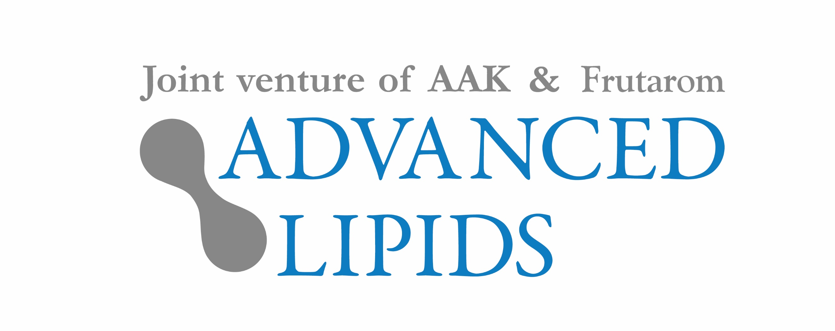

Scientific research drives demand for
OPO in China’s formula market

A growing body of scientific research is behind the popularity of OPO in China’s infant formula market, according to Advanced Lipids, one of the leading providers of the ingredient.

OPO, also known as SN-2 palmitate, is a premium quality ingredient that mimics the fatty acid profile of human milk. Demand for infant formula containing OPO has soared over the past decade. In 2007, there were only five brands containing INFAT®, Advanced Lipids’ OPO product. Today there are over 150.

OPO is particularly sought after in China, which accounts for almost 40% of the retail value of the $48 billion global formula market. At Food Ingredients China (22 to 24 March in Shanghai) Advanced Lipids will highlight the growing body of clinical research that is driving the popularity of OPO in China.

Dr Sigalit Zchut, the company’s Chief Scientist, will present the results of a recent pre-clinical study showing that INFAT® may have a beneficial effect on the length and quality of bones. This is in addition to the product’s many other clinically proven benefits, which include longer sleep duration, reduced crying, and better fat and calcium absorption.

Dr Sigalit Zchut, Chief Scientist at Advanced Lipids, said: “Quality is extremely important in China’s formula market where the two biggest factors driving choice of product are nutritional value and safety. Consumers actively seek out formula that contains OPO, which they know offers many benefits that are substantiated by clinical studies. The more we have learned about the clinical benefits of OPO, the more demand has risen in China. At Advanced Lipids, we are leading much of the scientific research and innovation contributing to the success of OPO.”

Political and demographic changes are expected to lead to further growth in demand for premium quality formula ingredients in China. The recent relaxation of the country’s single child policy has sparked a mini baby boom, while new regulations have placed greater emphasis on quality.

To arrange an interview at Food Ingredients China with a member of Advanced Lipids’ management team, contact steve@ingredientcommunications.com.

About Advanced Lipids
Advanced Lipids is a joint venture established by Enzymotec, a member of the Frutarom group and a leading biotech company specializing in lipid-based bio-functional ingredients; and AAK, a global producer and supplier of speciality vegetable fats and oils for the infant formula industry. Combining Enzymotec’s clinical and chemical expertise in lipid technologies with AAK’s international strength in food safety, production and logistics, Advanced Lipids offers a unique package of clinical research, development, flexible blending, quality and logistics. Find out more at www.advancedlipids.com.

