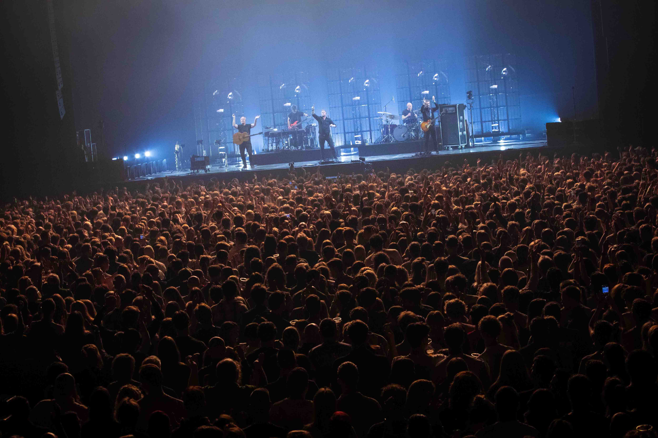

# New album, new tour, new gear – Racoon chooses Spectera to experience a whole new level of wireless monitoring

**Audio engineers Jelmer Dijkstra and Marty Brugmans rekindle the fun and joy in live music**

***Wedemark, 30 September 2025* – Passion for music and a constant strive for technical excellence are the hallmarks of Netherlands rock and pop band Racoon, and this attitude extends to their audio team: For many years, monitor engineer Jelmer Dijkstra and FOH engineer Marty Brugmans have supported the chart-topping band in their musical endeavors and introduced the latest and greatest tools for their craft. Ahead of another string of concerts for the band’s latest album “It Is What It Is”, Dijkstra and Brugmans share their experience with Sennheiser’s Spectera wideband wireless ecosystem.**

|  |  |
| --- | --- |
|  | Monitor engineer Jelmer Dijkstra (left), Sennheiser technical application engineer Vincent Tilgenkamp (middle) and FoH engineer Marty Brugmans (right) |

**Chart-toppers with a passion for sound**

This spring, Racoon’s “It Is What It is” tour sold out the Netherlands’ most iconic venues, such as MartiniPlaza, Rotterdam Ahoy, Mainstage Den Bosch, and AFAS Live. After a short summer break, they embarked on the second leg of the album tour at the end of August, before the start of their theatre tour in October.

Racoon are Bart van der Weide (vocals, harmonica), Dennis Huige (guitar), Maarten van Damme (bass), Paul Bukkens (drums) and Manu van Os (keys) – all are long-time Sennheiser users. However, the spring tour stood out as something special, because the band acquired a Spectera wideband ecosystem for in-ear monitoring.

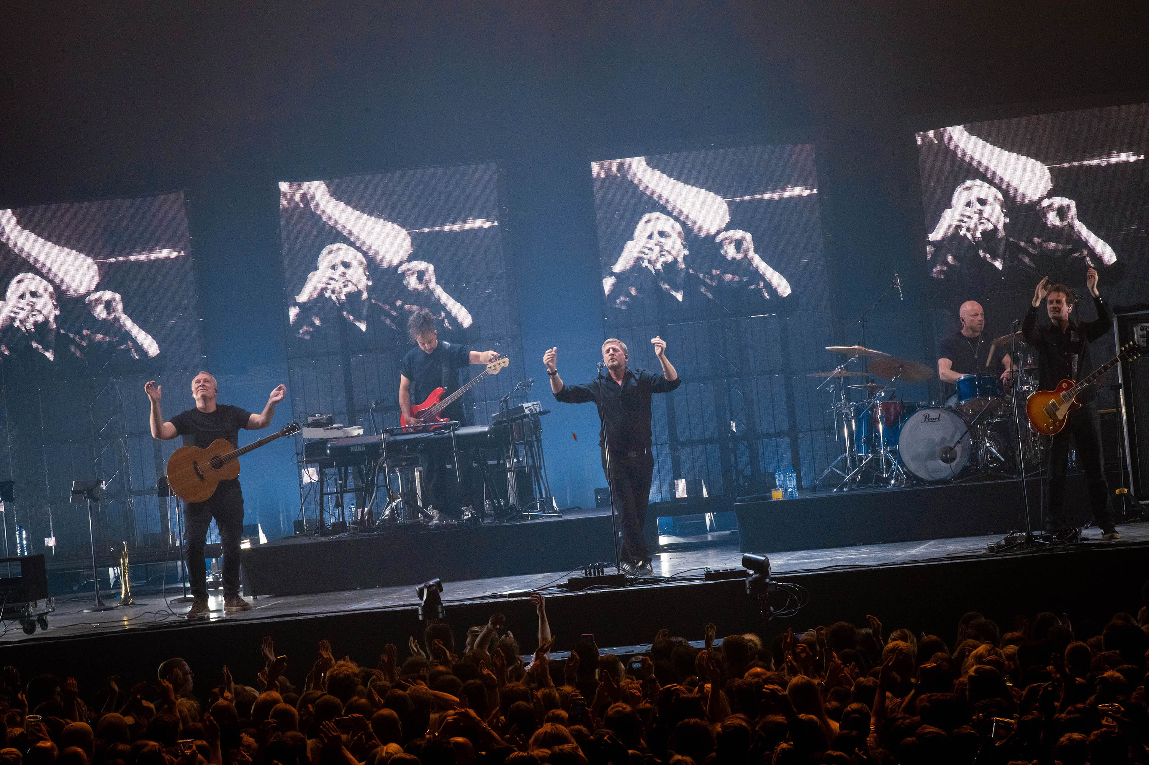

Racoon are (from left to right): Dennis Huige (guitar), Manu van Os (keys), Bart van der Weide (vocals), Paul Bukkens (drums) and Maarten van Damme (bass guitar)

Dijkstra and Brugmans are as keen on refining musical nuances with heart and soul as the band is, and have been part of Racoon’s musical journey since 2012 and 2009, respectively. They have known each other for 21 years, and have both been into music and sound “like forever”. They are definitely people who have turned their greatest passion into their job.

**Technical rehearsals – enter Spectera**

Brugmans recalls how in 2024, Vincent Tilgenkamp, technical application engineer with Sennheiser, introduced them to Spectera. “After three seconds of listening in I said: OK, we need two of them. And that’s what it’s all about, it’s all about sound, happy people on stage, backstage, and in the audience!”

|  |  |
| --- | --- |
| The Spectera Base Station and L 6000 charging unit in the rack |  |

A key moment were the technical rehearsals with Racoon, and the authentic impressions of the engineers and the band, who had previously been using 2000 series in-ears. Dijkstra tries to compare the in-ear sound. “But you can’t compare Spectera with the old system, it’s just so completely different,” he says. “It sounds very, very open, left is left is left and right is right, and this is something we’ve never had. The same goes for the ambience. It was indeed a bit shocking to hear the atmosphere; it was completely different in a very positive way. Of course you always had applause mics, but they didn’t sound like they should. At the rehearsals, when we played with an audience for the first time with the new system, I pushed the faders for the audience mics, and wow, you could put them around the band for them to experience the atmosphere and not just to listen to it. You are there, you are not just listening. That’s a big difference.”

|  |  |
| --- | --- |
| Drummer Paul Bukkens, pictured during soundcheck, is an accomplished musician who loves to finetune his performance |  |

Brugmans adds, “During rehearsals, I looked at the faces. We have two musicians who are very critical, as in VERY critical. Paul, the drummer, has tried everything with monitors and has always been searching for the best equipment. At the time, he was on wired in-ears with pre-amps. When Vincent and Jelmer connected Spectera, he put his in-ears in and started drumming, and soon began to thoroughly enjoy what he was hearing. Afterwards, he said to Jelmer: ‘OK, I don’t need this stuff any more, I’ll take the Spectera.’ That says enough to me.”

“The other musician, Manu, plays everything but drums, he’s on keyboard, contrabass, keys, you name it,” continues Brugmans. “He’s very critical, too, and he had the same praise: ‘Wow, wow, wow, wonderful, very, very good.’ Our frontman Bart is an extremely good singer, he’s happy, our guitar player, our bass player, everybody’s happy. But the faces of those two guys, Manu and Paul – they said everything, that was marvelous.”

|  |  |
| --- | --- |
|  | Multi-instrumentalist Manu van Os during soundcheck |

Dijkstra notes: “At that moment, we hadn’t changed anything with the mix. It was still the same as before, just through Spectera. And that was already huge, a huge difference.”

**With a little help from the friends at Flowsound**

The decision was made to go with Spectera for the tour, but the ecosystem was not readily available at the time. Help came from Flowsound, who specialize in the rental and sales of pro AV gear, and whose owner Floris van den Berg had ordered Spectera right at the unveiling of the ecosystem during IBC 2024. Between Tilgenkamp’s demo system and Flowsound taking the first Spectera delivery and prioritising the band, they managed to have Racoon on Spectera during the entire spring tour.

|  |  |
| --- | --- |
| Ein Bild, das Kleidung, Person, Menschliches Gesicht, Anzug enthält.  KI-generierte Inhalte können fehlerhaft sein. | Floris van den Berg (right) with Andreas Sennheiser during the Spectera unveiling at IBC 2024 |

Dijkstra employed Spectera as an IEM for the entire band as well as the stage techs, the guitar tech and the drum tech. The saxophone, baritone saxophone, trombone and trumpet used Spectera bidirectionally, receiving in-ear audio and transmitting the instrument audio picked up by Neumann MCM 114 miniature clip microphones.

|  |  |
| --- | --- |
|  | Woodwind and brass were fitted with bidirectional Spectera bodypacks for IEMs and instrument pick-up via Neumann MCM 114 mics |

Brugmans had miked the drums with Sennheiser evolution e 901, e 908B, e 904, and Neumann KM 184 and MCM 114. Cabs were picked up by e 905 and MD 421, while the e 935, e 945, and e 965 served as vocal microphones for the band. For talkback purposes, Dijkstra and Brugmans employed the evolution e 835 PTT, a mic that Sennheiser has recently brought back to the portfolio.

**Different worlds**

Where an analogue in-ear presents a compromise between clarity and the audio sources that can be represented in the mix, Spectera allows for everything to be included.

|  |  |
| --- | --- |
|  | Dijkstra (r) at the monitor position: “You can make the mix so precise that everything has its own place.”  (Photo credit: Jessie Kamp) |

Dijkstra confirms that “you can make the mix so precise that everything has its own place, it’s not the muddy sound of the old analogue equipment. Spectera is really the next level. There’s no more companding, I don’t have the pressure to put everything in the same bandwidth, in a small window. There are no more phasing issues. Everything is more natural. Paul told me that it’s just so much fun and joy to play now, and I like it when people say it’s fun to play!”

Brugmans adds, “As the FOH engineer, I must say that the whole band plays better with Spectera, they’re more ‘together’, and that’s a very important thing to the band and to me. There’s more definition, a wider sound stage, the position of everything is clear and precise, and that’s what I hear from everybody. To use the words of the band and Jelmer: With the old system you had a 100, maybe 120-degree view, and now it’s 160 and more.”

|  |  |
| --- | --- |
| Brugmans at FoH: “The whole band plays better with Spectera, they’re more ‘together’, and that’s a very important thing to the band and to me.”  (Photo credit: Jessie Kamp) |  |

When asked to compare the mixing process now with that of the past, Dijkstra notes that in former times, he had to “concentrate more on what the band needed to make music, like the rhythm, all that kind of things. But now – and that also applies to the singer – I can put them more in the mix, it’s easier for them to sing, and also how they experience the venue. With ambience, they are part of the place, in contact with the audience. Bart used to have to concentrate on singing, listen to where he is and what he needs, and now he can be natural and make music with the audience.”

The setup has changed for Dijkstra. The frequency coordination is much easier and faster, but he now needs to put more diligence into placing the antennas, where it was just one before. Overall, he sees time savings, a smaller footprint, and Spectera also gives him peace of mind: “It’s working, you don’t have to look at it. With the old system you always had noises or little hisses or breaks, but now it’s quiet. It’s steady, that’s one of the big advantages I find. For the artists, however, I now need to add some ambience so they know the system is working – they’re not yet used to everything being quiet,” he laughs. “With a good pair of in-ears, it’s as if you’re listening to some studio monitors. It’s that honest.”

The band’s feedback is equally enthusiastic. Lead vocalist Bart van der Weide says: “With the Spectera system, I feel like I can really play music now. It’s not just audio coming to our ears; it’s music. The difference is incredible, and it has made our performances so much more dynamic and engaging.”

|  |  |
| --- | --- |
| Bart van der Weide, lead vocalist of Racoon |  |

Drummer Paul Bukkens adds, “The Spectera system has been a gamechanger for me. As a drummer, it’s crucial to hear every nuance of the music, and Spectera delivers that perfectly. The clarity and precision of the sound allow me to stay in sync with the rest of the band effortlessly. The sound now really has depth and definition, where everything has its own place in the sound image.”

“The best thing for us is if the band are happy and the sound is great, with good vibes from the audience, then we have a perfect evening. That’s what Marty and I are working for,” concludes Dijkstra.

[www.racoon.nl](http://www.racoon.nl), [www.flowsound.nl](http://www.flowsound.nl), [www.tintaan.nl](http://www.tintaan.nl)

Ein Bild, das Konzert, Darbietung, Musikinstrument, Unterhaltung enthält.

The entire Racoon team (Photo credit: Jessie Kamp)

(Ends)

The high-resolution images accompanying this media release plus additional images can be downloaded [here](https://brandzone.sennheiser-group.com/share/uJL8cV8yBeQpTBd84qnZ). For highest resolution and largest pictures, please reach out.

**About the Sennheiser Brand – 80 Years of Building the Future of Audio**

We live and breathe audio. We are driven by the passion to create audio solutions that make a difference. This passion has taken us from the world’s greatest stages to the quietest listening rooms **–** and made Sennheiser the name behind audio that doesn’t just sound good: It feels true. In 2025, the Sennheiser brand celebrates its 80th anniversary. Since 1945, we have stood for building the future of audio and bringing remarkable sound experiences to our customers. While professional audio solutions such as microphones, meeting solutions, streaming technologies and monitoring systems are part of the business of Sennheiser electronic SE & Co. KG, the business with consumer devices such as headphones, soundbars and speech-enhanced hearables is operated by Sonova Holding AG under the license of Sennheiser.

[www.sennheiser.com](http://www.sennheiser.com)

[www.sennheiser-hearing.com](http://www.sennheiser-hearing.com)

**Global Pro Audio Press Contact**

Stephanie Schmidt

stephanie.schmidt@sennheiser.com

+49 (5130) 600 – 1275