Sennheiser @ ISE 2023
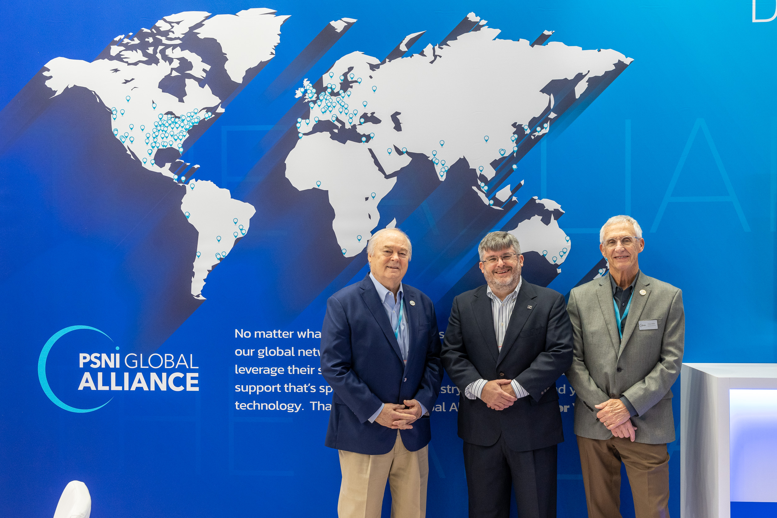

PSNI Global Alliance welcomes Sennheiser as a Global Preferred Vendor Partner

Wedemark, February 10, 2023 – PSNI Global Alliance, the leading global network of premier technology integrators and service providers, is pleased to announce a strategic partnership with Sennheiser, the first choice for advanced audio technology that makes collaboration and learning easier, as its latest Global Preferred Vendor Partner (PVP).

Sennheiser is driven by the passion to create audio solutions that make a difference. For over 75 years, Sennheiser has focused on building the future of audio and bringing remarkable sound experiences to its customers. Sennheiser Business Communication creates solutions to optimize working and learning environments. With its market-leading products for touchless audio and digital wireless technology, as well as its traditional solutions, Sennheiser is a strong partner for its network of global partners by offering the freedom and flexibility to design ecosystems without restrictions.
With this new partnership, Sennheiser has become a global strategic manufacturing partner of The Alliance, granting access to its Certified Solution Providers (CSPs) to pursue new market opportunities and enable worldwide, standardized solutions for their customers.

“We are honored to have been selected as a PSNI Preferred Vendor Partner,” said Charlie Jones, Global Alliance & Partnership Manager, Business Communication, Sennheiser. “As PSNI continues to grow globally, there is need for partners that can deliver in a timely fashion to every corner of the globe, which was one of the key considerations when we began our discussions. We are excited to work with the CSPs to deliver world-class audio solutions to their customers, wherever they may be.”

“We welcome Sennheiser as a valuable addition to our growing network of PVPs,” said Tom Roberts, director of vendor programs for The Alliance. “Their growing portfolio of market-leading audio solutions for corporate and educational environments, as well as their position as an audio industry innovator, gives our CSPs a strong asset within PSNI’s portfolio.”

The PSNI Global Alliance Preferred Vendor Partner program is available to an exclusive group of manufacturers, distributors, and service providers in the audio-visual, unified communications, and professional audio and video industry. All vendors within the PSNI PVP program are pre-screened by the Certified Solution Providers (CSPs) of The Alliance to ensure that only the best technology providers are represented. Customers who engage with The Alliance are assured seamless installation and support, benefiting from the collective expertise of PSNI’s integrators and vendors alike.

About PSNI Global Alliance
PSNI Global Alliance is the world’s most recognized network of AV integrators, manufacturers, distributors, and service partners, with a presence in more than 200 cities worldwide. Its innovative model allows best-in-class providers to work as one, bringing scalable, standardized technology solutions and managed services to organizations everywhere. With proprietary global deployment and services certifications, and truly localized support, The Alliance improves the integration and optimization of technology solutions so organizations around the world can transform the ways we work and live.

www.psni.org

About the Sennheiser brand
We live and breathe audio. We are driven by the passion to create audio solutions that make a difference. Building the future of audio and bringing remarkable sound experiences to our customers – this is what the Sennheiser brand has represented for more than 75 years. While professional audio solutions such as microphones, meeting solutions, streaming technologies and monitoring systems are part of the business of Sennheiser electronic GmbH & Co. KG, the business with consumer devices such as headphones, soundbars and speech-enhanced hearables is operated by Sonova Holding AG under the license of Sennheiser.

www.sennheiser.com
www.sennheiser-hearing.com

Global Press Contact

Jeff Horan
+1 860-598-7539
jeffrey.horan@sennheiser.com

