As Immersive Mixing Projects Continue to Grow, Portia Street Studios Anchor its Systems on Neumann KH Series Monitors
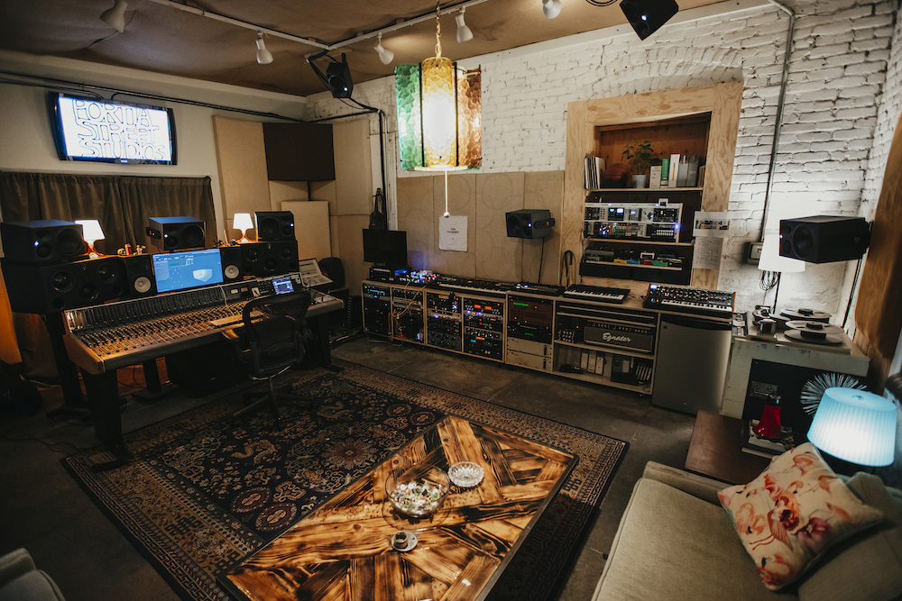
Los Angeles, California, January 20, 2022 — Portia Street Studios in the Echo Park neighborhood of Los Angeles recently upgraded its main control room with an 11-speaker Neumann KH series monitor system. The new speaker system was installed at the multi-room facility in response to immersive music’s growing listenership and is being used to mix back catalog material as well as new projects into the Dolby Atmos and Sony 360 Reality Audio formats.

The new 7.1.4 immersive setup comprises seven Neumann KH 310 tri-amped near field monitors for the front, side and rear zones with four Neumann KH 120 bi-amped near field speakers delivering height information. The new Neumann speakers have been integrated with two existing 18-inch subwoofers in the room.

A seamless translation
According to producer and mixer Dylan Ely, who founded Portia Street Studios in 2017 with Don Andes, “Once we got the Neumann system dialed in it was amazing — I couldn’t stop listening. Everything we listened to, even in stereo, not just immersive, translated really well from stuff I had mixed on other speakers.”

A veteran of nearly 25 years in the music industry, Ely previously worked for extended periods on staff at major studios in Chicago and New York with a long and diverse list of artists that includes Linkin Park, Jennifer Lopez, Ministry and Ludacris. “Overall, I’m really happy with the speakers,” he says of his facility’s new Neumann KH series system. “I think they’re in between a nice, transparent speaker and something that has a little edge to it, which I like. I like to have something that I can dig into a little bit, and the Neumanns work really well for that.”

Neumann’s compact KH 310 incorporates a specially designed fabric midrange dome driver that has been tailored for precise work with speech, vocals, guitars and other instruments with a midrange emphasis. “They have a presence in that range,” says Ely. “But it translates, and it isn’t hyped in any way. It gives some more detail to the mid-range and keeps everything smooth and transparent.”

The seven KH 310 speakers in the horizontal plane work well with the four overhead KH 120 models, he says: “It’s a seamless transition between the 310s and the height speakers. I don’t feel like there’s a disconnect between the two models of speaker and their frequency responses.”

Despite having so many speakers aimed at the listening position, Ely adds, “Another thing that stands out to me is that you can listen for a long time on them. I’m not cranking them up super-loud, but I don’t feel fatigued after listening to them, especially considering there are 11 of them blasting at my head.”

While a monitor system for today’s immersive music formats requires low frequency extension support, the KH 310s are capable of generating plenty of low end on their own, Ely reports. “I’ve listened to the 310s without subs and they have an unexpected low frequency response for their size and appearance.” While the dimensions of his control room dictated the integration of subwoofers into the immersive monitor system, he says, “In smaller spaces you wouldn’t have to supplement them as much.”
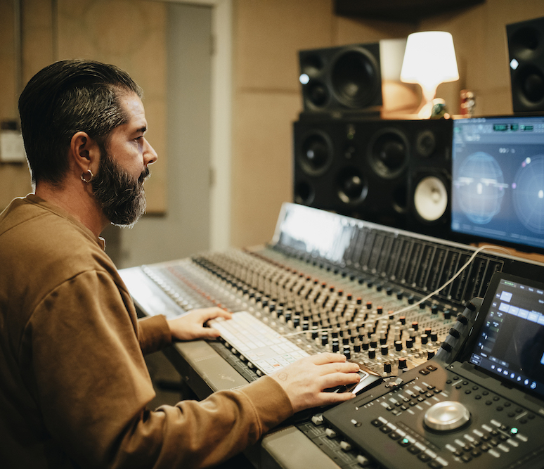
The impetus to upgrade Portia Street Studios for immersive mixing work came from engineer and mixer Abel Garibaldi, Ely says. “We’ve known each other in different capacities over the years and he’d just relocated to Los Angeles and was really into this immersive stuff. I’ve done quite a bit of mixing in 5.1 surround over the years and I liked the format but immersive in general was intriguing,” he says.
Producer and mixer Dylan Ely founded Portia Street Studios in 2017. The studio recently upgraded its main control room with an 11 speaker Neumann KH series monitor system (Photo credit: Michelle Shiers)

Harnessing an emerging market
When Apple Music announced its new Spatial Audio streaming service earlier this year, which delivers Dolby Atmos music to listeners in binaural. “Abel lit the fire under my butt and said, ‘We should jump on this.’ I had a space that could accommodate it, so we decided to go for it,” says Ely. Portia Street’s Studio A features a 700-square-foot control room outfitted with a vintage Sound Workshop analog mixing console, several tape machines and a collection of analog and digital outboard gear, as well as a collection of instruments and amplification.

“So far, from what I’ve seen, the labels and other engineers that I know that have immersive systems are staying busy. I don’t think it’s going away anytime soon," Ely says.

Indeed, as he discovered once they got the new Neumann system up and running at the studio, work soon started to roll in and the immersive mix projects are showing no sign of slowing down. In just the first few months since the speakers were installed, Ely reports, he and Garibaldi have used the system to produce immersive mixes for a new Chainsmokers release, tracks for Chicago house music innovator Vince Lawrence and material from the Nettwerk label. In an ongoing project, they are also working through the back catalog of War, the veteran multi-genre Southern California band, to create new immersive mixes.

Top tier talent and audio performance
Neumann’s KH series monitors were already on his radar for a couple of different reasons, says Ely, who also has a company that provides playback, programming, broadcast, staffing and consulting services for live touring. “My main client for the last seven years has been Justin Bieber,” he says, and front-of-house engineer Jim Ebdon used a pair of Neumann speakers to mix several of the artist’s streaming broadcasts during the pandemic. “I liked the way they sounded, and Jim had nothing but great things to say about them. The more I was around them the more I was interested in them.”

In the end, Ely says, “It was a combination of seeing them in use, being on my radar and hearing really good things about them from people that I respect that were using them. I have a larger control room, so we wanted something that could fill the room quite easily but didn’t have a massive footprint. The Neumann speakers fit all the specs for what we wanted — and they’ve been great.”

About Neumann
Georg Neumann GmbH, known as “Neumann.Berlin”, is one of the world’s leading manufacturers of studio-grade audio equipment and the creator of recording microphone legends including the U 47, M 49, U 67 and U 87. Founded in 1928, the company has been recognized with numerous international awards for its technological innovations. Since 2010, Neumann.Berlin has expanded its expertise in electro-acoustic transducer design to also include the studio monitor market, mainly targeting TV and radio broadcasting, recording, and audio production. The first Neumann studio headphone was introduced at the beginning of 2019. Georg Neumann GmbH has been part of the Sennheiser Group since 1991, and is represented worldwide by the Sennheiser network of subsidiaries and long-standing trading partners. www.neumann.com

Local press contacts USA:
Jeff Touzeau Daniella Kohan
jeff@hummingbirdmedia.com daniella.kohan@sennheiser.com
+1 (914) 602-2913 +1 (860) 222-4226

Global press contact:
Andreas Sablotny
andreas.sablotny@neumann.com
+49 (030) 417724-19

