Timbaland’s WSDG-Designed Thomas Crown Studio Complex Sold
Engineer Josh Haddad continues musical legacy of celebrated studio in Virginia Beach

Virginia Beach, VA, April 3, 2019 — Since Timothy “Timbaland” Mosley's fabled Thomas Crown Studio complex was completed in 2007, Virginia Beach has been a recording destination for some of the music industry's top recording artists. The studio, designed by New York-based acoustic consulting and A/V integration firm WSDG (Walters-Storyk Design Group) has seen the likes of Justin Timberlake and Pharell Williams pass through its doors for the last decade, but was put up for sale last year when Mosley decided to move his operation down to Miami. The studio was purchased by engineer Josh Haddad, who has renamed it Virginia Beach Recording Arts.

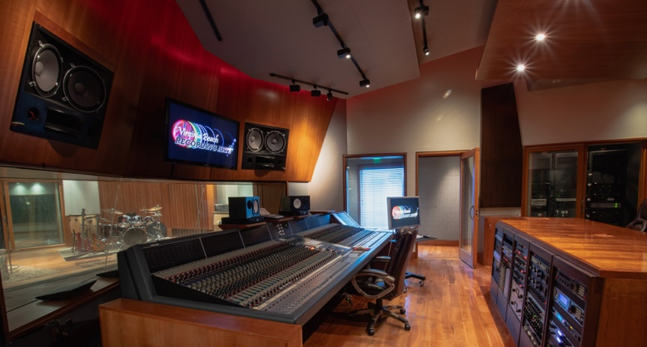
Haddad had already been planning to move his family back to his hometown, following a 10-year career stint in Chicago, first as a recording engineer at a Chicago studio, and later handling hotel A/V systems for events featuring high-profile speakers. When he read about Thomas Crown Studios being put up for sale, he knew he had to have it.“Timbaland’s incredible track record with artists like Kanye West, Missy Elliott, Beyonce, Snoop Dogg, Katy Perry and Justin Timberlake, coupled with the fact that the studio has a WSDG Walters-Storyk Design Group pedigree, convinced me that high caliber artists would continue wanting to record in these great sounding rooms,” Haddad said.

From Thomas Crown Studios to Virginia Beach Recording Arts
Hailing from Norfolk, Virginia, just west of Virginia Beach, Mosley was instrumental helping to grow the region's reputation in the hip hop and R&B scene, along with acts like The Neptunes (Pharrell Williams, Chad Hugo) and Missy Elliot. After accumulating a steady stream of hits, Mosley built his a state-of-the-art Virginia Beach recording studio and post-production facility, which was designed by WSDG specifically for Mosley's production needs — with input from legendary studio engineer Jimmy Douglass — and features three recording studios, a sound room, two bedrooms, four bathrooms and a commercial kitchen.

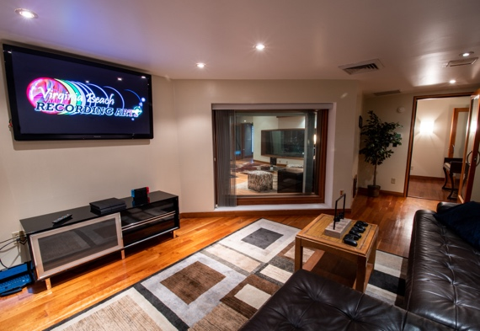
Haddad preserved much of WSDG's meticulous design work, maintaining the studio's particular character and ambience. “I called John Storyk before I completed the purchase negotiations," Haddad said. "He provided me with schematics, and with insights into design innovations and other details, and that greatly informed our due diligence. John’s enthusiastic commitment to a studio he created over a decade ago confirmed my faith in its hit-making potential."

“I was very pleased to learn that Josh Haddad was committed to keeping this studio from being repurposed as a tattoo parlor,” John Storyk remarked. “We’ve always been extremely proud of the terrific music that Timbaland created in those rooms. Virginia Beach attracts many musicians and recording artists, and we’re certain that Josh and his team will keep the music flowing from his new Virginia Beach Recording Arts studio.”

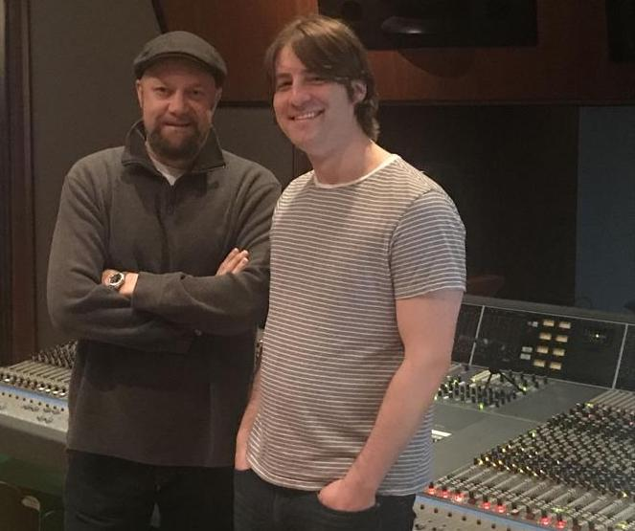
Keeping the Music In Virginia Beach
To boost the studio's credentials, Haddad connected with recording/mixing engineer Andrew Coleman to be his mentor and gear guru, as well as freelance engineer. “A longtime Neptunes/Pharrell Williams, engineer, and multi-Grammy winner, Andrew quickly brought in some initial dates that, Number One, got us moving in the right direction and Number Two, are helping us get the word out that the Virginia Beach Recording Arts vibe is the real deal,” Haddad said.

Already boasting sessions with Pusha-T, Cartel, and local hip-hop artists like Rick KRK, Backpack Johnny, and Rozwell Fitzroy, Virginia Beach Recording Arts is continuing the musical legacy that preceded it when it was Thomas Crown Studios. “Word of mouth is definitely positive so far,” says Haddad. “And we’re just getting started.”

For more information on Virginia Beach Recording Arts, visit https://www.vbrecordingarts.com/

For more information on WSDG, visit https://wsdg.com/

ABOUT WSDG, LLC
For nearly 50 years, acoustic consulting and A/V integration firm WSDG has designed approximately 4,000 media production facilities worldwide and counting. Projects range from Jimi Hendrix’s Electric Lady Studio and Jazz At Lincoln Center in New York, to broadcast facilities for The Food Network, CBS and WNET, over twenty teaching studios for The Art Institutes, and corporate clients such as Sony, IBM and Novartis. Recent credits include Jungle City in New York, The Church Studio, in London, private studios for Green Day, Jay-Z, Bruce Springsteen, Alicia Keys and Academy Award-nominated film composer Carter Burwell. WSDG has collaborated with such noted architects as Frank Gehry, Philippe Stark, Rafael Viñoly, Santiago Calatrava, Grimshaw, and Norman Foster. An eleven-time winner of the prestigious pro audio NAMM TEC Award for outstanding achievement in Acoustics/Facility Design, WSDG maintains U.S. offices in New York, Washington, DC, San Francisco and Miami and global offices in Barcelona, Basel, Berlin, Belo Horizonte, Buenos Aires, Guangzhou, Mexico City and Mumbai.

Contact:
Steve Bailey
Hummingbird Media, Inc.
+1 (508) 596-9321
steve@hummingbirdmedia.com

Jeff Touzeau
Hummingbird Media, Inc.
+1 (914) 602-2913
jeff@hummingbirdmedia.com

